Ends and Beginnings:
Late 19th and Early 20th Century Literature and Culture

London and the Experience of Immigration

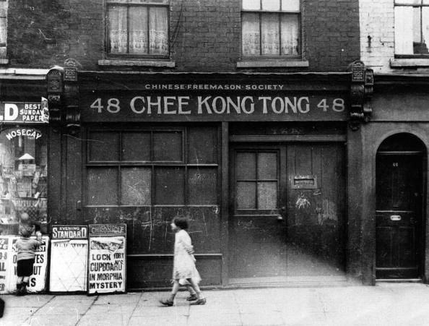

Israel Zangwill: Children of the Ghetto (1892)
Thomas Burke: Limehouse Nights (1913): ‘The Chink and the Child’; ‘The Paw’
Henry Nevinson: ‘Sissero’s Return’ (1895)
Grant Allen: ‘Mr Chung’ (1882)
Arthur Conan Doyle: ‘The Man with the Twisted Lip’ (1891)
Joseph Salter: ‘The East in the West’ (1896)

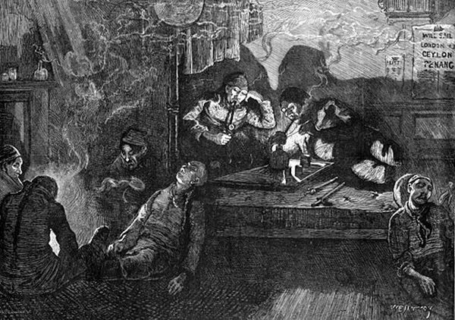
Key Themes:
- Sexual attraction
- Interracial love
- Miscegenation
- Urban Poverty
- Religion
- Commercial Trade
- Domestic violence
- Cultural Hegemony
- Exoticism/Orientalism
- Cosmopolitanism
- Aestheticism
- Degeneration

In exploring the ideological construction of Chinatown, we are dealing with an imaginary cartography, which projects onto the real cityscape its own shadowy ideological antagonisms and fears. ‘Ideology’ as Althusser put it, ‘represents the imaginary relationship of individuals to their real conditions of existence’.

…the interplay of sexuality, Empire and drugs; about anxieties surrounding inter-racial sex; about some kind of historically specific crisis of masculinity […] and about how these intersected with fears and frustrations about unemployment, low wages, and housing shortages in working-class districts like Limehouse and Poplar. This potent ideological mix of fear and resentments was the brew out of which the writings of Sax Rohmer and Thomas Burke emerged and to which they in turn contributed.

---John Seed, 'Limehouse Blues: Looking for 'Chinatown' in the London Docks, 1900-40’ History Workshop Journal 62 (2006): 76.

Battling did not like men who were not born in the same great country as himself. Particularly he disliked yellow men. His birth and education in Shadwell had taught him that of all creeping things that creep upon the earth the most insidious is the Oriental in the West. It was—as you might say—so—kind of—well, wasn’t it? He bellowed that it was “unnacherel”. The yeller man would go through it. Yeller! It was his supreme condemnation, his final epithet for all conduct of which he disapproved. (The Chink and the Child, 86)

“And another thing as showed ‘e wasn’t white same as us, was ‘is bein’ always on the laugh. No matter what ‘e was doin’ or sayin’, not what sort of day it was, you’d only got to look at Sissero and ‘e’d start laughin’. ‘E seemed to ‘ave a kind of ‘appiness always brewin’ and workin’ inside of ‘im, as if ‘e was just a-goin’ to bust with it. And my mother said it came of ‘is ‘avin been so near born a lower animal, same as a monkey. But all the monkey as ever I see, on organs and such, didn’t look purtikler ‘appy, but mopy, same as other grown-ups.” (Sissero’s Return, 64)

“‘The Holy One, blessed be He, gave them larger noses than us,’ said the Maggid, because they have to talk through them so much.’ A guffaw greeted this sally […] To the outsider this disparaging of the Dutch nose might have seemed a case of the pot calling the kettle black.” (Children of the Ghetto, 78)

“I stole a look round the corner to see who my philosophic neighbour might happen to be. An Oxford don, no doubt, I said to myself, or a young Cambridge professor, freshly crammed to the throat with all the learning of the Moral Science Tripos. Imagine my surprise when, on glancing casually at the silvery-voiced speaker, I discovered him to be a full-blown Chinaman! Yes, a yellow-skinned, almond-eyed, Mongolian-featured Chinaman, with a long pigtail hanging down him back, and attired in the official amber silk robe and purple slippers of a mandarin of the third grade, and the silver button. My curiosity was so fully aroused by this strange discovery that I determined to learn something more about so curious a product of an alien civilisation.” (Mr Chung, 68)

“‘Would yer like to see the Tower ‘Amlets wake up one mornin’ chock full o’ little niggers? Cos, if so, yer’e goin’ about the right way to do it.’
‘Shut it!’ says Ginger, gettin’ a bit sharper. ‘There ain’t no talk o’ nothink ‘o that ‘appenin’, I should ‘ope.’
‘Yus, yer’d hope; that’s just it […mine’s] read somewhere in ‘is book […] if we was all to start doin’ same by you, as you aim at doin’ by us, I tell yer all London ‘ud be black afore you’d ‘ad time to turn round and look.’” (66)

- In what ways do the authors use language to construct identity? (e.g. cockney/working-class dialects; faux-English; Jewish religious terminology &etc).
- How are physiology and aesthetics used as markers of difference?
- Analyse the fears of miscegenation present in these texts.

“Here and there, too, was a woman of comely face and figure, but for the most part it was a collection of crones, prematurely aged, with weird, wan, old-world features, slip-shod and draggle-tailed, their heads bare, or covered with dingy shawls in lieu of bonnets—red shawls, gray shawls, mud-coloured shawls. Yet there was an indefinable touch of romance, and pathos about the tawdriness and witch-like ugliness, and an underlying identity about the crowds of Polish, Russian, German and Dutch-Jewesses, mutually apathetic […] the single jet of gas-light depending from the ceiling flared upon the strange simian faces, and touched them with a grotesque picturesqueness that would have delighted Doré.” (Children of the Ghetto, 75)

Battling was of a type that is too common in the Eastern districts of London; a type that upsets all notions of classification. He wouldn’t be classed. He was a curious mixture of athleticism and degeneracy. He could run like a deer, leap like a greyhound, fight like a machine, drink like a suction-hose. He was a bully; he had the courage of a high hero. He was an open-air sport; he had the vices of a French decadent. (The Chink and the Child, 82)

“In fact, he was practically an Englishman in everything but face and clothing. His naturally fine intellect had assimilated European thought and European feeling with extraordinary ease, and it was often almost impossible in talking with him to remember that he was not one of ourselves.” (Mr Chung, 68)

“Now any decent-minded man like my father or old Timmo would ‘ave gone and broke the door in, and either for kicked out ‘isself, or been asked to stop to tea, just accordin’ to the state o’ the woman’s feelin’s at the time. But that ain’t the Sheeny way. That’s likely the cause why, when they started out from Egyp’ a long time back, it took ‘em forty year to cover a bit ‘o ground as our teacher said any common crowd, to say nothink o’ fightin’ men, ought to ‘ave covered in forty weeks, let alone forty days.” (Sissero’s Return, 70)

“‘I do ‘ear, my dear, as yer’e uncommon partial to furreigners still. And all I says is as yer’e quite right to make no manner o’ difference between ‘em all. A furreigner’s a furreigner, no matter whether nigger or Sheeny, and there ain’t no tellin’ one from another, even by daytime, nor no need to.’” (Sissero’s Return, 73)

- How do the authors construct and problematize British national identity?
- How are Jews represented in the texts? Consider the juxtaposition between Judaism and Christianity.
- Consider the relationship between degeneracy, aesthetics and nationality.

“How these rich people came to be, Esther did not inquire; they were as much a part of the constitution of things as clouds and horses. The semi-celestial variety was rarely to be met with. It lived far away from the Ghetto, and a small family of it was said to occupy a whole house. Representatives of it, clad in rustling silks or impressive broadcloth, and radiating an indefinable aroma of superhumanity, sometimes came to the school, preceded by the beaming Head-mistress; and then all the little girls rose and curtseyed, and the best of them, passing as average members of the class, astonished the semi-divine persons by their intimate acquaintance with the topography of the Pyrenees and the disagreements of Saul and David, the intercourse of the two species ending in effusive smiles and general satisfaction […] Tonight semi-divine persons were to be seen in a galaxy of splendour [for there] gathered a group of philanthropists.” (Children of the Ghetto, 75-6)

“‘...the thing we’ve got to deal with is a nigger, and ‘e bein’ black makes a difference. Cos, as fer as I make out, them as is black ain’t by no means purtikler. And that’s cause why gentlefolks sends ‘em missions and such for the purpose o’ makin’ ‘em more purtikler—same as they sends ‘em at us, through thinkin’ we ain’t purtikler enough neither. But that ain’t the truth, as Mrs. Simon knows very well.’” (Sissero’s Return, 78)

“To meet with Central African Christians in London is indeed pleasing. These dark diamonds sometimes emit most encouraging testimony to the labours of Christians abroad.” (65)

- How is religion depicted? Consider the theatricality of philanthropy, and the two worlds rhetoric.
- What is the relationship between race, religion and social status in the texts?

“From what nameless horrors he saved her that night cannot be told. What he brought to her was love and death” (The Chink and the Child, 84)

“He locked a finger in her wondrous hair. She did not start away; she did not tremble. She guessed what she had to be afraid of in that place; but she was not afraid of Cheng: 16 years with her father had made fear almost her normal state. She pierced the mephitic gloom and scanned his face. No, she was not afraid. His yellow hands, his yellow face, his smooth black hair…well, he was the first thing that had ever spoken sweet words to her; the first thing that had ever laid a hand upon her that was not brutal; the first thing that had deferred in manner to her, as though she, too, had a right to live.” (The Chink and the Child, 84)

If this narrative strikes at the heart of the discursive “problem” of alien immigration to London—that it destabilises normative sexual boundaries and threatens imperial ideologies of manliness by offering alternative models of sexual selection—it does so not by rejecting these Victorian codes of masculinity, but by seeing them as displaced or perverted by poverty.

--- Ross Forman, China and the Victorian Imagination, 214.

“Oh beautifully they loved. For two days he held her. Soft caresses from his yellow hands and long devout kisses were all their demonstration. Each night he would tend her as might mother to child; and each night he watched over her and slumbered on the stairs beyond the door.” (The Chink and the Child, 86)

“We never for a moment fancied it possible that Effie could conceivably take a fancy to a yellow man like him; the very notion was too preposterously absurd. And yet, just towards the end of his stay with us, it began to strike me uneasily that after all even a Chinaman is human. And when a Chinaman happens to have perfect manners, noble ideas, delicate sensibility, and a chivalrous respect for English ladies, it is perhaps just within the bounds of conceivability that at some odd moments an English girl might for a second partially forget his oblique eyelids and his yellow skin.” (Mr Chung, 73)

“And when Sissero put into Dock again, she says nothink about the boy bein’ made game of through bein’ black, but told ‘im she wasn’y strong enough to go on with the work no more, seein’ as she ‘ad to stand up all the time; but must find out some other ways o’ makin’ the money.
And ‘e says:
‘Now, don’t yer be troublin’ yer sunny ‘ead about the money, darlin’. I’ll make the double on it as easy as kiss yer, and then I’ll love yer twice as much—cos why, yer’ll be twice as expensive.’
And with that ‘e laughed till the very babies on the bed started laughin’ in company.” (Sissero’s Return, 68)

“She told him the history of her father, of her beatings and starvings, and unhappiness; and then he moved to the cupboard, and from it drew strange things…formless masses of blue and gold, magical things of silk and a vessel that was surely Aladdin’s lamp […] in the morning when Lucy awoke, wearing the blue and yellow silk in the place of her besmirched rags, she gave a cry of amazement […] his room was prepared for his princess. It was swept and garnished, and was an apartment worthy of a maid who is loved by a poet-prince.” (The Chink and the Child, 85)

“He hated the provincialism of the Flowery land, and loved to lose his identity in the wider culture of a Western civilisation.” (Mr, Chung, 71)

- How are women represented in these texts?
- How are women and Chinese men connected through ideas about sensibility?
- Consider the juxtaposition between Oriental effeminacy and male domestic violence.
- Consider the motifs of flowers in relation to women and China. (e.g. Daffodil, Myrtle, ‘White Blossom’)
- How are the interracial relationships in these texts ultimately presented?
- How is racial difference exoticised?

“…it ‘ud ‘ave come cheaper to ‘ave gone to the Zoo straight off, and more to see for yer money. But as to talkin’ a baby elingphant couldn’t ‘ave give ‘em more to say […] black wool on its ‘ead and all, barrin’ only it made ‘er feel a kind o’ sinkin’ when she turned up the sheets from the bottom and caught sight of the creature’s feet, and they was all darky, same as its face. And if [Mrs Simon] ‘ad ‘er choice she’d sooner ‘ave mothered the devil nor anythink else with black feet.” (Sissero’s Return, 67)

“‘You could never go back to live in China?’ I said to him inquiringly after a time. ‘You could never endure life among your own people after do long a residence in civilised Europe?’
‘My dear sir,’ he answered with a slight shudder of horror, ‘you do not reflect what my position actually is. My government may recall me any day. I am simply at their mercy, and I must do as I am bidden.’
‘But you would not like china,’ I put in.
‘Like it!’ he exclaimed with a gesture, which for a Chinaman I suppose one must call violent. ‘I should abhor it. It would be a living death. You who have never been in China can have no idea of what an awful misfortune it would be for a man who has acquired civilised habits and modes of thought to live among such a set of more than medieval barbarians as my countrymen still remain at the present day […] the place reeks of cruelty, jobbery, and superstition from end to end […] if once they suspect a man of European sympathies, their first idea is to cut off his head. They regard it as you would regard the first plague-spot of cholera or small-pox in a great city.’ (Mr Chung, 70)

“…they thought it rather the cheese in these days of expansive cosmopolitanism to be on speaking terms with a Chinese attaché. ‘Japanese are cheap’ said Effie, ‘horribly cheap of late years—a perfect drug in the market; but a Chinaman is still, thank Heaven, at a social premium’.” (Mr Chung, 70-1)

- Consider the civilisation and barbarism dichotomy. How are racial and cultural difference negotiated?
- What is the impact of using motifs such as those associated with disease, drugs, and the devil?
- How is Otherness made spectacle?

The opium den came to represent in a powerful and endlessly-repeated image, a strange fusion of poverty, filth, and pleasure—at once attractive and repellent […] increasingly opium was linked to a specific social and cultural space within the docks—the Chinese settlement in Limehouse.

--- John Seed, ‘Limehouse Blues’, 69.

“Greaser Flannigan was a weak man, physically and morally flabby […] now the narcotised sensibilities are all very well for the grey routine of life. They help you bridge the gaps. They carry you through the tedium of things, and hold you in velvet and silk against the petty jolts and jars. But when the big crisis comes, the grief of a lifetime… well, that you feel just ten times deeper and longer than the normal person. God how it bites and stings and lacerates, and bites again, and tears the roots out of you […] how it scalds and itches and bruises and burns the body of you, and colours every moment of thought, and strangles your sleep!” (The Paw, 64-5)

“Between a slop-shop and a gin-shop, approached by a steep flight of steps leading down to a black gap like the mouth of a cave, I found the den of which I was in search […I] made my way into a long, low room, think and heavy with the brown opium smoke, and terraced with wide berths, like the forecastle of an emigrant ship. Through the gloom one could dimly catch a glimpse of bodies lying in strange fantastic poses, bowed shoulders, bent knees, heads thrown back…” (The Man with the Twisted Lip, 128)

“In a very short time a decrepit figure had emerged from the opium den, and I was walking down the street with Sherlock Holmes […] ‘Had I been recognised in that den my life would not have been worth an hour’s purchase; for I have used it before now for my own purposes, and the rascally Lascar who runs it has sworn vengeance upon me […] It is the vilest murder-trap on the whole river-side’.” (The Man with the Twisted Lip, 131)

“He took off his coat and waistcoat, put on a large blue dressing-gown, and then wandered about the room collecting pillows from his bed and cushions from the sofa and arm-chairs. With these he constructed a sort of Eastern divan, upon which he perched himself cross-legged, with an ounce of shag tobacco and a box of matches laid out in front of him.” (The Man with the Twisted Lip, 144-45)

- Consider the motif of the opium den. How does this function as a space? You might want to think about the meeting of Lucy and Cheng, and the function of the opium den for both Neville St Clair, and Sherlock Holmes.
- How is opium associated with Orientalism, and what is its relationship to the British working class?
- How do these authors write about the city? In what ways do they construct imagined spaces?

