Unit IV (1945-1989): Cold War, Decolonization & the Long Boom
Week 9: Césaire, Notebook of a Return to the Native Land; O’Hara, “Ode: Salute to the French Negro Poets” and “The Day Lady Died”; Bishop, “Questions of Travel”; Brathwaite, “Letter Sycorax”
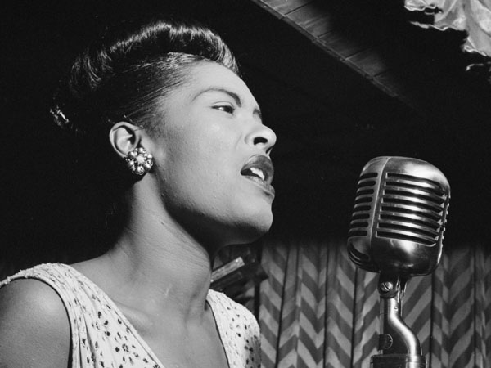
Southern trees bear a strange fruit,
Blood on the leaves and blood at the root,
Black bodies swinging in the southern breeze,
Strange fruit hanging from the poplar trees.

-- from ‘Strange Fruit’ made famous by Billie Holiday in 1939
Art must come out of catastrophe […] One thing about catastrophe, for me, is that it always seems to lead to a kind of magical realism. That moment of utter disaster, the very moment when it seems almost hopeless, too difficult to proceed, you begin to glimpse a kind of radiance on the other end of the maelstrom.
--- Interview with Kamau Brathwaite (2005)
‘Caliban experiments like his Shakespearean original with the language Prospero taught him […] colonial texts are bounded by the colonizer’s culture, inevitably included within “Shakespeare’s unmatched universality.”
--- Goldberg, Johnathan. Tempest in the Caribbean. Minneapolis: University of Minnesota Press, 2004. Print.
‘Hybridity is an association of ideas, concepts and themes that at once reinforce and contradict each other […] Hybridity should be understood historically in a triplicate context: (a) the development of vocabularies of a racial and cultural mixture from the nineteenth-century onwards (b)the historical basis of contemporary hybrid identities; (c) the juncture at which the language of hybridity entered the study of international communication.’
--- Kraidy, Marwan. Hybridity or the Cultural Logic of Globalisation. Philadelphia: Temple University Press, 2005. Print.

Bahktin’s Hybridity
Organic (unconscious) hybridity: natural process by which one language or culture absorbs elements from another ‘coexisting within the boundaries of a single dialect, a single national language…’
Aesthetic (intentional) hybridity: [in Pnina Werbner’s words] ‘shock, change, challenge, revitalize or disrupt through deliberate, intended fusions’ to create a ‘an ironic double consciousness’ [or in Bahktin’s] ‘the perception of one language by another language, its illumination by another linguistic consciousness […] that come together and fight it out on the territory of the utterance.’

O'Hara's poetry, even as early as the first years of the 1950s, operated with split awareness, and split intentions. Clearly resembling Whitman in his democratizing impulses, his attempt to devalue "poetic" language and replace it with a demotic, spontaneous language…
-- Molesworth, Charles. The Fierce Embrace: A Study of Contemporary American Poetry. Web. 1979.

O'Hara dispenses with all the traditional props of elegy--the statement of lament, the consolation motif, the procession of mourners, the pathetic fallacy, and so on--and still manages to pay an intensely moving tribute to the great jazz singer.
--- Perloff, Marjorie. Frank O’Hara: A Poet Among Painters. Web. 1977.
Points to Consider
- In what ways do post-colonial poets appropriate and modify language to assert or subvert cultural identity?
- Is it problematic that expression is mediated by language? Whose language is it? Does it matter?
- How does colonialism fit into the idea of ‘modernity’? Is there a paradox between the expansion of empire and globalization characteristic of modernity and the understanding of modernity as synonymous with progress?
- How does this type of poetry act as a force of decolonisation?
- How do the poems function to estrange and then reinvent?

Further Reading

Clifford, James. “A Political of Neologism: Aimé Césaire” The Predicament of Culture: Twentieth-century Ethnography, Literature and Art available here: http://books.google.co.uk/books?id=8D1BBHMI7UMC&pg=PA175&lpg=PA175&dq=aime+cesaire+notebook+return+native+land&source=bl&ots=Ue-NvAJ_bp&sig=-jywi5ym_KStpWqJigZpXyDtEuE&hl=en&sa=X&ei=e2IUU6baFuaL7AbknYDoBw&ved=0CE0Q6AEwBDgo#v=onepage&q=aime%20cesaire%20notebook%20return%20native%20land&f=false
Goldberg, Johnathan. Tempest in the Caribbean. Minneapolis: University of Minnesota Press, 2004. Print.
Kraidy, Marwan. Hybridity or the Cultural Logic of Globalisation. Philadelphia: Temple University Press, 2005. Print.
Kuortti, Joel., and Jopi Nyman, eds. Reconstructing Hybridity: Post-Colonial Studies in Transition. Amsterdam: Rodopi, 2007. Print.
Werbner, Pnina. “The Limits of Cultural Hybridity: On Ritual Monsters, Poetic Licence and Contested Postcolonial Purifications”

