Ends and Beginnings:
Late 19th & Early 20th Century Literature & Culture

Week 9: Richard Marsh The Beetle: A Mystery (1897)

“On a sudden I felt something on my boot, and with a sense of shrinking horror, nausea rendering me momentarily more helpless, I realised that the creature was beginning to ascend my legs, to climb my body […] it was as though it were some gigantic spider – a spider of nightmares; a monstrous conception of some dreadful vision […] It crawled up my neck with hideous slowness, a quarter of an inch at a time […] it reached my chin, it touched my lips – […] The horror of it made me mad.” (14-15)

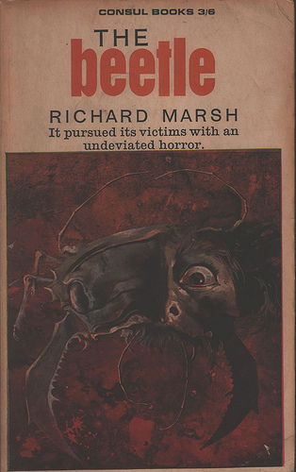
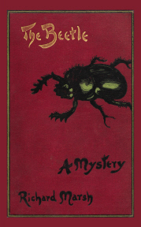
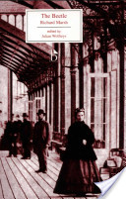
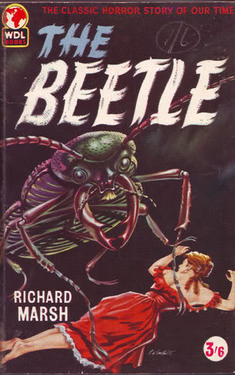
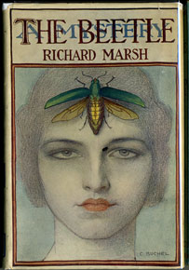
2004
1965
1959
1897
1919

- “Richard Marsh”, penname of Richard Bernard Heldmann (1857-1915)
The Beetle initially serialised in the family periodical Answers as “The Peril of Paul Lessingham: The Story of a Haunted Man”, novelised later the same year.

- Majorie Lindon – New Woman figure
- Paul Lessingham – social reformist politician
- Sydney Atherton – the inventor/scientist
- Robert Holt – tramp; the “victim” of modernity?
- Augustus Champnell – legal detective
Key Themes: Immigration; Degeneration; Poverty; New Women; Technological Advancement; Imperialism; Race/Gender/Sexuality; Taxonomy; Emasculation; Occultism; Hypnotism.
Points to Consider

How does technology feature in the text?
What is the significance of Paul Lessingham’s position as an MP?
What does Sydney Atherton contribute to the text?
Consider the epistolary format. What impact does this have on the narrative?
How might the text interact with narratives of natural history, classification, and collecting?
How might biological, social and national degeneration anxieties be read in the text?
How is gender problematized, questioned and transgressed?
In what ways does the text conform to or question well known archetypes of science fiction/detective fiction/romance?
Consider the legal underpinnings of the narrative.
How does the text integrate discourse concerning the “New Woman”, the Occult, the criminal and the romantic subplot?

As concerns about national, social and psychic decay began to multiply in late Victorian Britain, so Gothic monstrosity re-emerged with a force that had not been matched since the publication of the original Gothic, at the previous fin-de-siècle.

--- Glennis Byron, “Gothic in the 1890s” A New Companion to the Gothic ed. David Punter. Chichester: Wiley-Blackwell, 2012. (187).

Imperial Gothic combines the seemingly scientific, progressive, often Darwinian ideology of imperialism with an antithetical interest in the occult.

--- Patrick Brantlinger, Rule of Darkness. London: Cornell University Press, 1988. (227).

The hegemonic truth about manliness in the nineteenth century was established through metaphors of control, reserve, and discipline, that were placed in opposition to images of chaos, excess, and disorder.

--- Andrew Dowling, Manliness and the Male Novelist in Victorian Literature. Aldershot: Ashgate, 2005.

Disease motifs

“I shook myself like one stricken by the shaking ague.” (15)

“It might have been that he had been afflicted by some terrible disease, and it was that which had made him so supernaturally ugly.” (16)

“I was conscious of a sense of exultation at having escaped from the miasmatic atmosphere of that room of unholy memories.” (32)

“The Apostle, his divagations, his example of the coleoptera, his Arabian friend – these things were as microbes which, acting on a system already predisposed for their reception, produced high fever.” (76)

Criminality

“But it is well that you came through the window – well, that you are a thief – well for me! For me! It is you that I am wanting—…for you are my slave – at my beck and call – my familiar spirit, to do with as I will.”

Degeneration, Physiognomy and Atavism

“The cranium, and indeed the whole skill, was so small as to be disagreeably suggestive of something animal. The nose, on the other hand, was abnormally large; so extravagant were its dimensions, and so peculiar its shape, it resembled the beak of some bird of prey.’ P16 loc 201 ‘this deformity – for the absence of chin amounted to that – it was which gave to the face the appearance of something not human.” (16)

“I resented it with secret rage. But in that room, in that presence, I was invertebrate.” (15)

Gender and Sexuality

“I could not at once decide if it was a man or a woman. Indeed at first I doubted if it was anything human. But afterwards I knew it to be a man—for this reason, If no other, that it was impossible such a creature could be feminine” (15-16)

“The most astounding novelty was that about the face there was something which was essentially feminine; so feminine, indeed, that I wondered if I could have by any possibility have blundered, and mistake a woman for a man; some ghoulish example of her sex who have so yielded to her depraved instincts as to have become nothing but a ghastly reminiscence of womanhood.” (24)

Modernity and Technology

“it seemed to me that he was nothing but eyes.... They were long, and they looked out of narrow windows, and they seemed to be lighted by some internal radiance, for they shone out like lamps in a lighthouse tower...” (18-19)

“As I spoke the visitor was treated to a little exhibition of electricity. The change in his bearing was amusing. He shook with terror. He salaamed down to the ground.” (104)

“The driver leaned over his engine, rubbing his hands with the usual oily rag. He was a short, wiry man with grey hair and a grizzled moustache, with about him that bearing of semi-humorous, frank-faced resolution which one notes about engine-drivers as a class.” (268)

“On and on we went dashing, clashing, smashing, roaring, rumbling, Atherton, who had been endeavouring to peer through the window, strained his lungs again in an effort to make himself audible.” (269)

“I realised and, so to speak, mentally photographed all the little details of the house in front of which I was standing with what almost amounted to a gleam of preternatural perception.” (10)

“…every detail of my involuntary actions was projected upon my brain in a series of pictures, whose clear-cut outlines, so long as memory endures, will never fade.” (38)

“It was a representation, produced by what process I cannot say, which was so wonderfully, so diabolically, like the original, that for a moment I thought the thing itself was on my table.” (218)

Mesmerism, Control and Loss of Autonomy

“What he willed that I should say, I said. Just that, and nothing more. For the time I was no longer a man; my manhood was merged in his. I was, in the extremest sense, an example of passive obedience.” (17)

“I looked him in the face—and immediately became conscious, as I did so, that something was going from me—the capacity, as it were, to be myself. His eyes grew larger and larger, till they seemed to fill all space—till I became lost in their immensity.” (19)

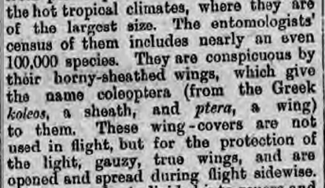
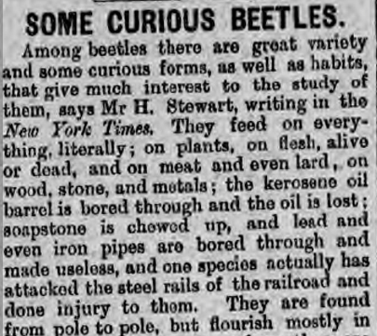
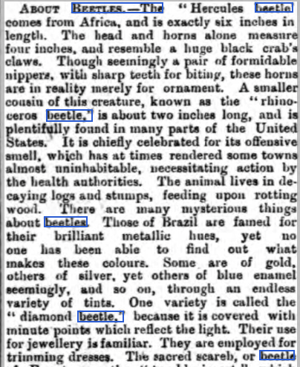
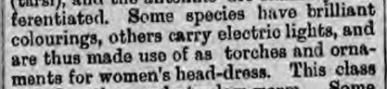
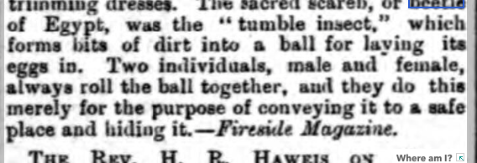
[…]

“About Beetles” Dundee Evening Telegraph,
Friday 26 Aug 1892, 4.
[…]

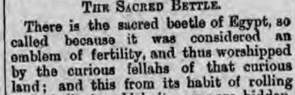

“Some Curious Beetles” Northern Echo,
Saturday 28 Dec 1895, 4.

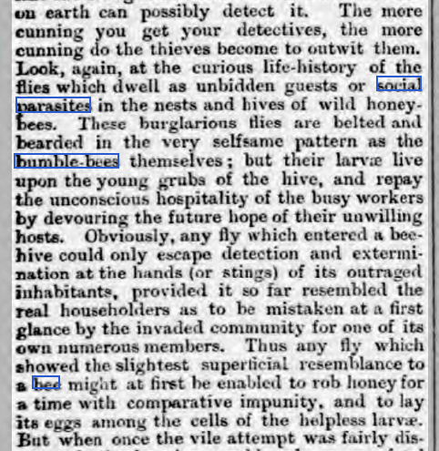
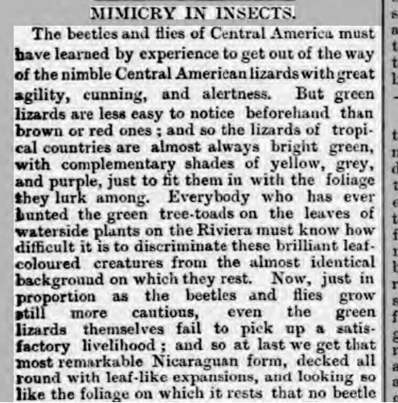
“Mimicry in Insects” Dundee Evening Telegraph, Monday 07 Feb 1887, 4.

