Engaging with Theory
And Structuring Paragraphs

Essays:
The basic shape of an essay is:
- Introduction (with a thesis statement)
- Body (your argument)
- Conclusion (wrap it all up)
This basic structure can be stretched to fit any kind of project: a thesis might have an introductory chapter, 3 or 4 body chapters and a concluding chapter. A 2000-word essay is likely to have an introductory paragraph, 5 to 7 body paragraphs and a concluding paragraph.
No matter the length, the basic shape remains.

Paragraphs:
As you may notice, the paragraph is the building block of this form. Through paragraphs, you construct your argument. However, you can also think of paragraphs like mini-essays. They should have a main idea, an argument to support/contradict and a transition to the next point (a sort of conclusion). It’s within this structure that you’ll use and engage with theory in order to support your argument.

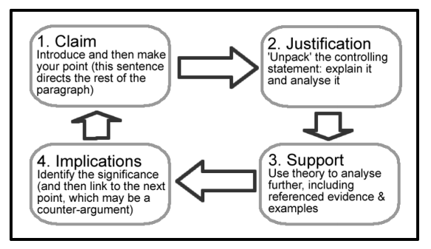

Practice:
Using the above chart, outline a paragraph that would address this claim:

- Claim – In Angela Carter’s, The Magic Toyshop mirrors – and their absence – play a fundamental role in constructing femininity.

- Justification –

- Support –

- Implications –

