Handout for Edward Said

Exhibitionist/Voyeur

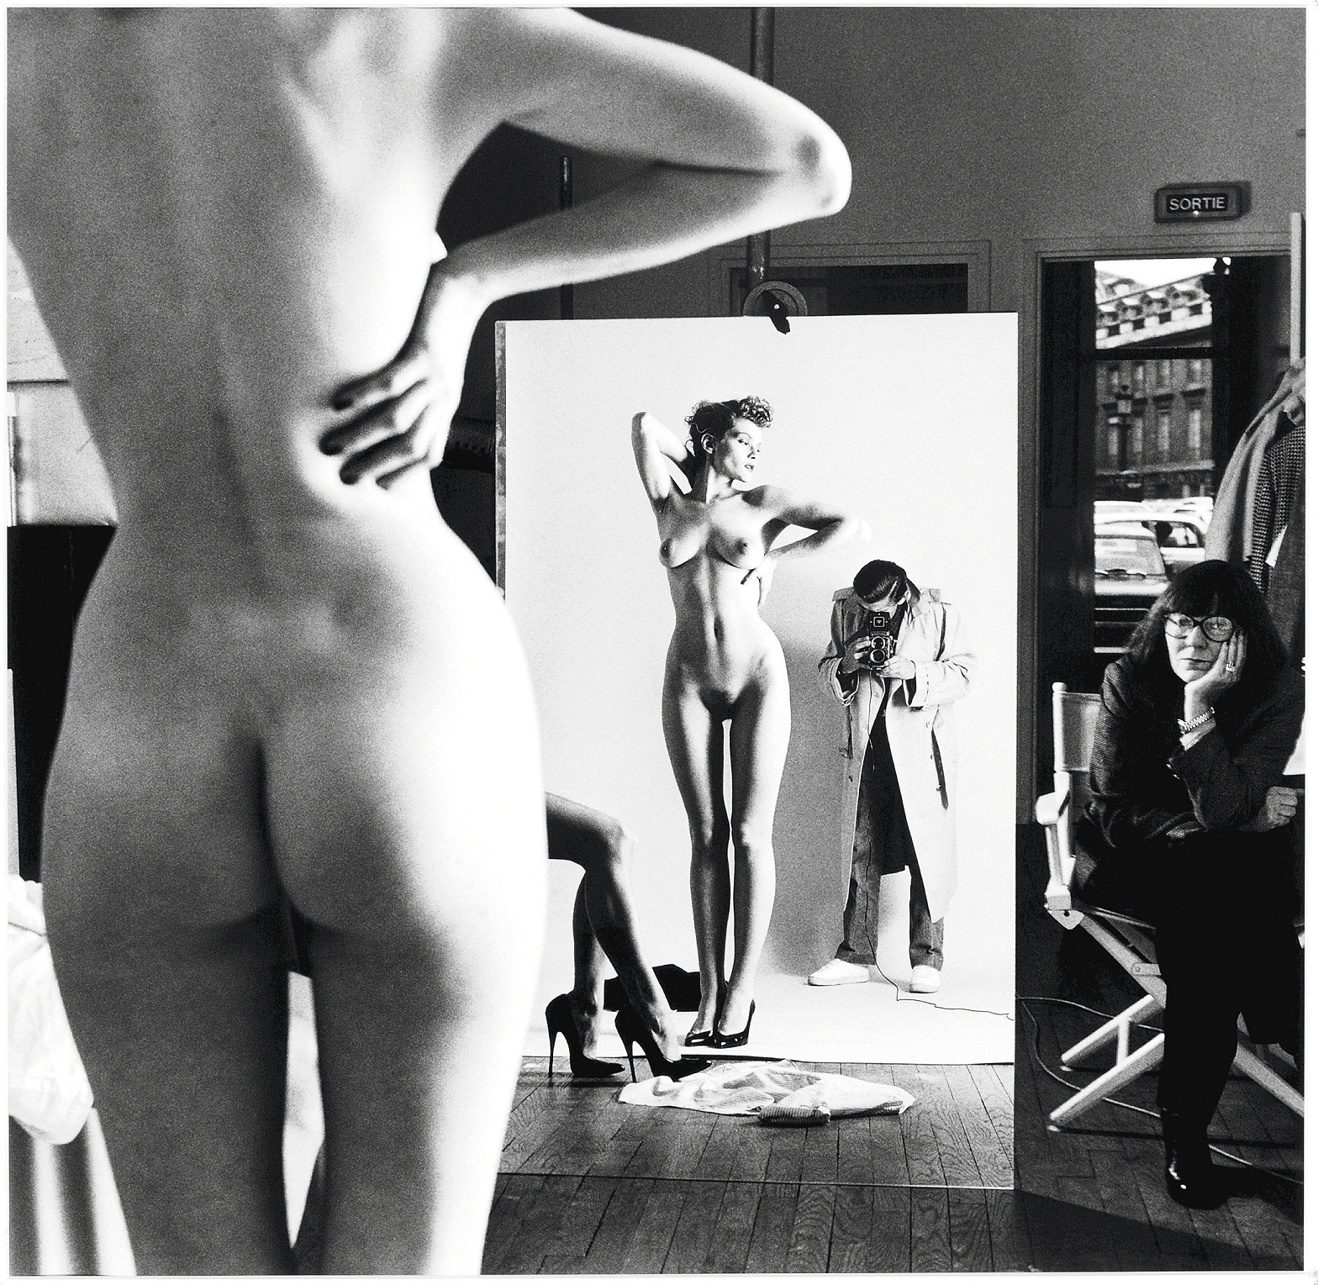
-- Self-Portrait with Wife June and Models, Helmut Newton, Vogue Studio, Paris, 1981.
It is not normal for the photographer to exhibit himself, as Newton does here. The mirror is there so the model can see herself, and thus have some idea of the form in which her appearance will register on the film. Normally, the photographer would have his back to the mirror, remaining outside the space of the image. Here, however, Newton has colonized the desert island of backdrop paper that is usually the model’s sovereign possession in the space of the studio. He has invaded the model’s territory, the domain of the visible. From this position, he now receives the same look he gives. The raincoat is Newton’s joke at his own expense, he exhibits himself to his wife, and to us, as a voyeur. […] The photographer – a flasher, making an exposure – is here explicitly both voyeur and exhibitionist.
-- from Victor Burgin, In/Different Spaces: Place and Memory in Visual Culture (London: Univ. of California Press, 1996), p. 62.

Dehumanisation
I observed that a photograph can be the object of three practices (or of three emotions, or of three intentions): to do, to undergo, to look. The Operator is the Photographer. The Spectator is ourselves, all of us who glance through collections of photographs – in magazines and newspapers, in books, albums, archives … And the person or thing photographed is the target, the referent, a kind of little simulacrum, any eidolon emitted by the object, which I should like to call the Spectrum of the Photograph, because this word retains, through its root, a relation to ‘spectacle’ and adds to it that rather terrible thing which is there in every photograph: the return of the dead.
-- from Roland Barthes, Camera Lucida, trans. by Richard Howard (London: Vintage, 2000), p. 9.
[Photography] allows me to accede to an infra-knowledge; it supplies me with a collection of partial objects and can flatter a certain fetishism of mine: for this ‘me’ which liukes knowledge, which nourishes a kind of amorous preference for it. In the same way, I like certain biographical features which, in a writer’s life, delight me as much as certain photographs; I have called these features ‘biographemes’; Photography has the same relation to History that the biographeme has to biography.
-- from Barthes, Camera Lucida, p. 30.

