Derrida: Structure, sign and play in the discourse of the human sciences
Acentricity
  - ‘The centre is, paradoxically, within the structure and outside it’ – it is within and without – ‘without’ signifying an absent centre, - signifying a centre (characterised by its absence) which is outside of (‘without) the structure.
  - ‘the centre, which is by definition unique, constituted that very thing within a structure which, whilst governing the structure, escapes structurality.’ I have tried to visually represent this below.
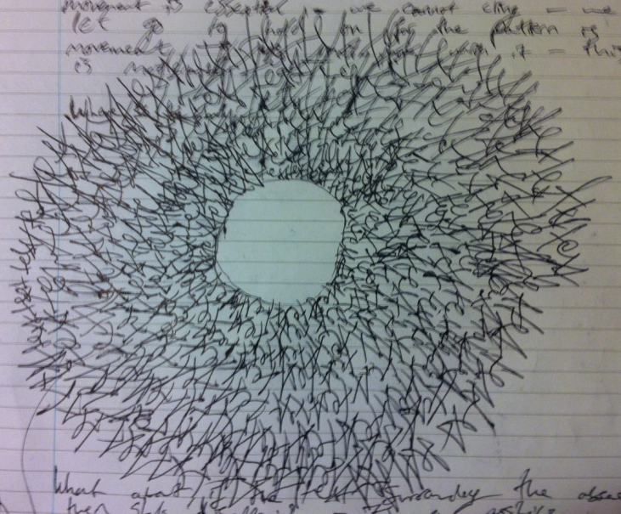
Thus it is like a point of gravity – we only know gravity by its effects – we cannot see a centre point of gravity, or rather, it is not part of the material world but rather a force which governs it. Thus by reading a text or observing a structure we perceive a centre – but it is only by the text that we see this. In the image the ‘text’ spirals round in a spherical structure – the ‘hole’ in the middle is not of the same stuff as the ‘text’ – it does not in-fact exist – (I did not draw it) ... I only wrote the word text over and over again and, by the structure of this, revealed an absent space at the centre which defines and is defined by the text.

- Myth
‘There is no unity or absolute source of the myth’
The myth is its own source
  - the ‘text’, the structure, may be understood as myth:
    - myth = the absence of truth = truth
that is, a mythological tale is of one which, by definition, is not based in truth, but this absence of truth is the truth (or nature) of the myth
Thus the myth points to a centre-point which is not there: the myth creates and is created by its mythological centre
Thus a rejection of epistemic discourse:
‘Therefore it is necessary to forego scientific or philosophical discourse, to renounce the episteme which absolutely requires, which is the absolute requirement that we go back to the source, to the centre’ -
... and thus: ‘mythological discourse’ – a discourse which does not seek to locate a fixed source.

Instead, it identifies the structure as living, as organic – ‘being as presence’ rather than subject to history:
‘the concept of episteme has always called forth that if historia, if history is always the unity of a becoming’ thus if one puts ‘history between brackets’ and identifies the ‘structuralist moment’, one understands the structure as in a perpetual condition of flux – of stillness and motion: ‘the origin of a new structure [is conceived] on ... an overturning of nature in nature, a natural interruption of the natural sequence’ – so the structure is constantly redefining itself and thus redefining its centre: it is at once self-creative and self-destructive.

