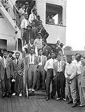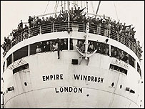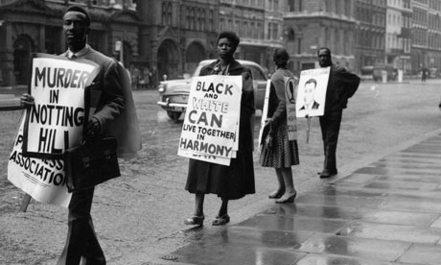

Sam Selvon's The Lonely Londoners

Language and Structure
- Why might Selvon have decided to use third person rather than first person narrative?
- What is Moses' function in the novel?
- Selvon has been celebrated for forging a literary idiom which captures the nuances, rhythms, sensibilities and ethos of West Indian speech, how might the use of this language be interpreted?

Characterisation
- How do Selvon's characters deal with prejudice in the novel?
- How do the episodic anecdotes of the characters' exploits portray West Indian/Nigerian men to what would have been a largely British readership?
- Do the characters of the novel embody repetitive colonial stereotypes associated with black men?

Representations of Women
- How are white women perceived by the characters in the novel?
- Is the presentation of West Indian women any different to the image of white women in the novel?
- Are the gender roles ever reversed or effectively deconstructed in the novel?

Themes
- The novel drifts between the tragic and comic, how do you think Selvon would have liked us to read his novel?
- How does the memory of "imaginary homelands" explored in the novel elucidate the immigrant experience in Britain?
- What is your impression of the characters' experience of London?

