Week 10
Chandra Talpade Mohanty: Feminism Without Borders

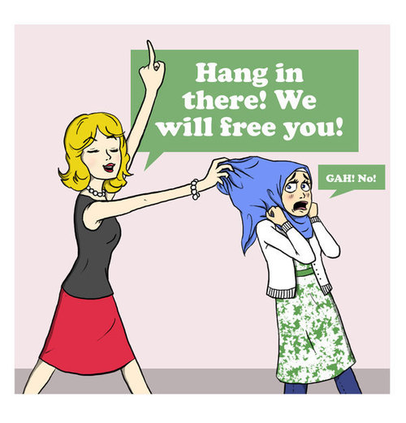
‘It is only by understanding the contradictions inherent in women's location within various structures that effective political action and challenges can be devised.’
In her essay Mohanty argues that western feminist theory has a tendency to describe Third World women as a homogenous group of victims living under a dominant patriarchy. This, she claims, is the continuation of the colonising mindset, or a kind of wolf in sheep’s clothing, where the wolf is colonial ideology and the clothing western feminisms. What is problematical about the collective term "women" as a group, as a stable category of analysis, is that it assumes an ahistorical, universal unity between women based on Western generalisations about their subordination and represents a kind of critical cul-de-sac where all discussions head down the same road.

Instead of analytically demonstrating the production of women as socioeconomic political groups within particular local contexts, this view limits the definition of the female subject to gender identity, bypassing social class and ethnic identities. What characterises women as a group is their gender (sociologically, not necessarily biologically, defined) over and above everything else, indicating a monolithic notion of sexual difference. Because women are thus constituted as a coherent group, sexual difference becomes synonymous with female subordination and power is automatically defined in binary terms: men have power and women don’t. Men exploit, women are exploited. Such simplistic formulations are historically reductive; they are also ineffectual in designing strategies to combat oppressions. All they do is reinforce binary divisions between men and women.

Mohanty presses the need to deconstruct the notion of Third World women as a single victimised entity. She attempts to unpick the relationship between the term ‘woman’ as a ‘cultural and ideological composite other constructed through diverse representational discourses--scientific, literary, juridical, linguistic, cinematic, etc’ and ‘women’ which she defines as ‘real, material subjects of their collective histories’. She goes on to explain that
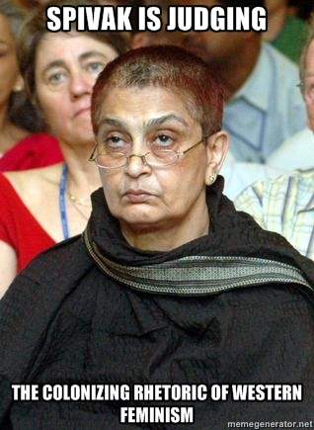
This connection between women as historical subjects and the representation of Woman produced by hegemonic discourses is not a relation of direct identity or a relation of correspondence or simple implication. Rather it is an arbitrary relation set up by particular cultures.

In simple terms, Mohanty accuses Western feminism of over simplifying Third World feminism and viewing the debate through a lens of victimry, oppression, hegemonic patriarchy and violence. This view suffocates a more differentiated debate. Critics need to examine these issues by situating them within the proper local and historical context rather than trying to use a one-size-fits-all approach which tends to resemble a colonial and Orientalist view of the Third World and appropriates and colonises the ‘constitutive complexities that characterize the lives of women in these countries’.

Mohanty uses a quote from Ahdel-Maleic to outline the ideological foundation supporting Western feminisms:

Contemporary imperialism is, in a real sense, a hegemonic exercising to a maximum degree a rationalized violence taken to a higher level than ever before—through fire and sword, but also through the attempt to control hearts and minds. For its content is defined by the combined action of the military-industrial complex and the hegemonic cultural centres of the West, all of them founded on the advanced levels of development attained by monopoly and finance capital, and supported by the benefits of both the scientific and technological revolution and the second industrial revolution itself. (145-46).

Using this model, Mohanty argues that Western feminist scholarship cannot avoid the ‘challenge of situating itself and examining its role in such a global economic and political framework’ and that ‘Western feminist writing on women in the Third World must be considered in the context of the global hegemony of Western scholarship —that is, the production, publication, distribution, and consumption of information and ideas.’ In response to this Mohanty raises several key criticisms of Western feminism regarding Third World women:

- Western feminism operates on the assumption of women as an already constituted, coherent group with identical interests and desires, regardless of class, ethnic, or racial location, or contradictions. This view suggests that all men are bound together via a sociological notion of the "sameness" of their oppression. This is presented as a universal condition. Evidence for this universal view lacks critical analysis and makes unfounded assumptions.

- Western feminism assumes a homogeneous notion of the oppression of women as a group which produces the image of an "average Third World woman." This average Third World woman leads an essentially truncated life based on her feminine gender (read: sexually constrained) and her being "Third World" (read: ignorant, poor, uneducated, tradition-bound, domestic, family-oriented, victimized, etc.). Mohanty suggests that this assumption stands in stark contrast to the (implicit) self-representation of Western women as educated, as modern, as having control over their own bodies and sexualities and the freedom to make their own decisions.

- Defining women as archetypal victims freezes them into "objects-who-defend-themselves," men into "subjects-who-perpetrate violence," and (every) society into powerless (read: women) and powerful (read: men) groups of people. Male violence must be theorized and interpreted within specific societies in order for both to understand it better and to organize effectively to change, its Sisterhood cannot be assumed on the basis of gender; it must be forged in concrete historical and political practice and analysis.

Mohanty writes that ‘the problem with this analytic strategy is that it assumes men and women are already constituted as sexual-political subjects prior to their entry into the arena of social relations.’ She uses examples of women from African and Arabic cultures where the Western view is that of a homogenous oppressed group. This view fails to consider ‘specific practices within the family that constitute women as mothers, wives, sisters, and so on.’ Such a view automatically assumes that ‘Arabs and Muslims, it appears, don't change at all. Their patriarchal family is carried over from the times of the prophet Muhammad. They exist, as it were, outside history.’

What would am alternative reading look like?

Mohanty envisions a theoretical approach that would consider how the ‘category of women is constructed in a variety of political contexts that often exist simultaneously and overlaid on top of one another.’ Such a theory would do away with ‘easy generalization’ that regards women in the Third World as victims bound together through a shared oppression. Rather than generalising, this approach would consider local, political analysis, which generates theoretical categories from within the situation and context being analysed, suggesting strategies for organising against exploitation. She concludes by stating that ‘it is only by understanding the contradictions inherent in women's location within various structures that effective political action and challenges can be devised.’

Theory Questions:

- When you think about Third World women, what images and ideas come to mind?

- How and why is it problematic to view women as a single homogenous group? Why might this also be a particularly useful approach?

- Is Mohanty undermining the notion of universal women’s suffrage?

- What problems arise when a local cultural practice is seen as oppressive by one culture and part of a system of core beliefs by another?

Text Questions:

- Think about how the Third World and Third World women are portrayed and represented in popular media. Is there a hegemonic view of the Third World and Third World women as a homogenous group of helpless, passive victims?

- To what extent do female characters in The Buddha of Suburbia challenge, resist or conform to a hegemonic view of the Third World and Third World women?

- Does Kureishi’s focus on the localised, everyday lives and events experienced by characters who work against generalised views and assumptions about race, class and gender?

- Can we read the novel as a Marxist critique of gender and race through the lens of class and hegemony?

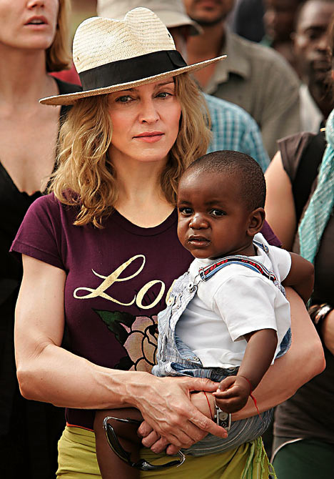
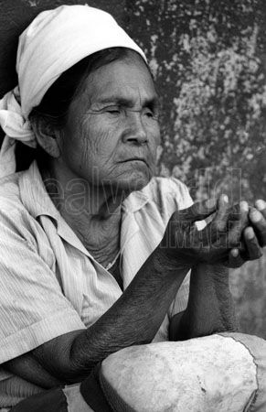
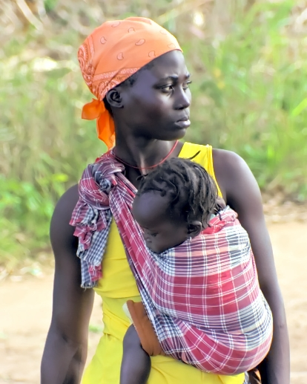

Notes:

