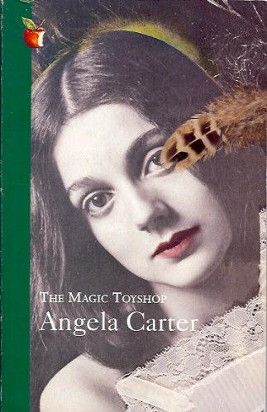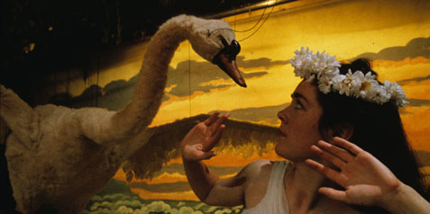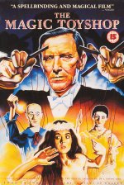
Week 2 - Angela Carter, The Magic Toyshop (1967)
Opening Questions:
- What cultural problem is being set up?
  - What are the paradoxes? What are the clashes?
- Why might readers at a particular time and place find this work compelling?
  - How does it speak to you as a reader?
  - How did it speak to the readers at the time it was written?
- Are there differences between my values and the values implicit in the text?
  - If yes, then what do I do with that?
  - Does it make me revise my own values?
  - Does it enrich my values?
  - Do I need to critique the values in the text?
- What kind of cultural intervention is this text making?
  - What comment is it making?
  - How does the text comment on the context in which it is enmeshed?
- How does this text position me as a reader?
  - What assumptions must you have to be an insider to that text?
  - Does it tell you what to do?
  - Does it raise questions that you are left to answer?
  - Does it invite you to take action?
  - What are you being asked to do in your position as a reader?
- What is the text setting up as “normative”? What is being set up against the normative as “different”?
  - What is normal in the world of the text?
  - Is what is normative linked to for example class, ideology, race, gender, sexual behaviour? If so, in what way?
  - Is the text privileging a particular belief system or culture as normative?
  - What is conventional (follows the rules) and unconventional (doesn’t follow the rules)?
  - What is anti-conventional? Are there characters that deconstruct the status quo of the text?

Gender and The Magic Toyshop:
- How does the text construct woman or female? Is it in opposition to man and male?
- Are there women in the text who are set up as not normative?
- How does the text construct man or male?

Intertextuality
- Literary texts depend on texts written before them to create a range of references and imagery.
- Intertextuality is when an author borrows, absorbs, and transforms a prior text to create new meaning.
- Intertextuality is different to illusion, which gestures other texts without taking on the meaning of the text.
Discuss the following questions in relation to the images:
- How is this image used in the novel?
- Consider how this might expand the existing range of imagery?
- How does the narrative appropriate the images and contextualise them for the characters?
- What questions and themes do they create?
- Is the image absorbed and transformed within the novel?

