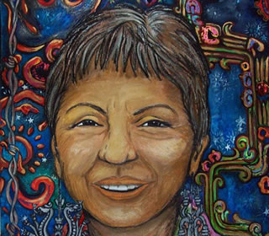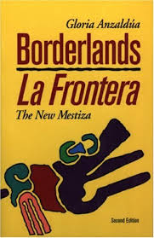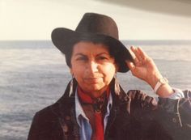

Week 10: Gloria Anzaldua, Borderlands

- What would you say is Anzaldua’s message?

- Did you identify with any of her insights?

- Anzaldua mixes cultures, language, and writing genres, what effect does this have on the reader?

- Examine the theme of being an “outsider within” and marginality within Borderlands.

- How is Anzaldua’s feminism different from the “feminism defined by women and men of the dominant class?

- Why does she merge a range of different genres in Borderlands?

- What genre of writing within Borderlands is most effective in conveying Anzaldua’s message?

- What is “Chicana feminism”? How is it different to Anglo-American feminism?

- Who are the “new mestiza” in Borderlands?

- What is “Bridge feminism” or “border feminism”?

- What is the purpose of incorporating autobiography within a historical document?

- Examine the cultural tyranny that Anzaldua believes the Chicana feminist must battle against.

- What does Anzaldua believe the “new mestiza” must do to achieve liberation?

- Explore the different strategies used to disempower Chicano/a, which are described by Anzaldua. In particular analyse the poem “We Call Them Greasers” (134).

- In the poem “To live in the Borderlands means you” (194) what is Anzaldua’s definition of the new mestiza, the feminist on the border?

