Modern World Literatures – Seminar Handout
Fridays 15:00-17:00 – Room H501
Session 3 (24/10/14) – Blake, Shelley, and Pushkin
Course information
- Chris Maughan
- Email: c.j.maughan@warwick.ac.uk
- Online profile: www.warwick.ac.uk/fac/arts/english/people/postgraduate/enrlag
- Office hour: Fridays 17:00-18:00 (T1-3 H501)
- Assessment reminder - a short response (500 words maximum) to one of the 'Discourses of Modernity' at the Modernity Clinic is due in class in Week 5 of Term 1.

The Individual, the State, and ‘Nature’
Labour is, first of all, a process between man and nature, a process by which man, through his own actions, mediates, regulates and controls the metabolism between himself and nature. He confronts the materials of nature as a force of nature. He sets in motion the natural forces which belong to his own body, his arms, legs, head and hands, in order to appropriate the materials of nature in a form adapted to his own needs. Through this movement he acts upon external nature and changes it, and in this way he simultaneously changes his own nature. He develops the potentialities slumbering within nature, and subjects the play of its forces to his own sovereign power. (Marx, Capital, Vol. 1, 283)
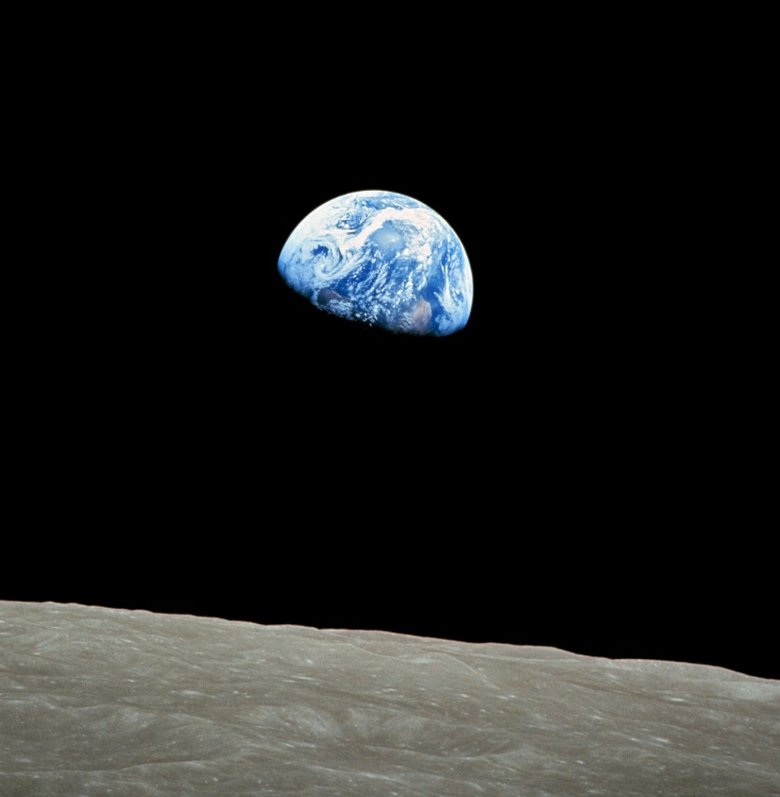
‘[In] “The Bronze Horseman” … Petersburg’s whole life story is here, brilliantly crystalized and compressed: a vision of the city’s grandeur and magnificence, and a vision of the madness on which it is based – the mad idea that a volatile nature can be permanently tamed and dominated by imperial will; nature’s revenge, erupting cataclysmically, smashing grandeur into rubble, shattering lives and hopes; the vulnerability and terror of Petersburg’s common people caught in the midst of a battle of giants … Pushkin’s poem speaks for the martyred Decembrists, whose brief moment in Senate Square would come just a year after Yevgeny’s. But “The Bronze Horseman” also goes beyond them, for it reaches far deeper into the city, into the lives of the impoverished masses whom the Decembrists ignored. … For the time being [] they would slink away or stay out of sight – underground, in Dostoevsky’s image of the 1860s – and Petersburg would continue to incarnate the paradox of public space without public life.’ (Berman, All that is Solid, 188-189)

Like Rousseau, Romanticism negates the negation. Typically, it defines civilization as alienation from nature, and accordingly idealizes both childhood and imagined lost ways of dwelling in oneness with the earth. And, like Rousseau, the Romantics explored three possible ways of returning to nature. The first of these three paths was the dream of a transformation for all humankind, through the overthrow of that very institutionalized despotism which defines society as the opposite of nature. This was the way from Rousseau's Social Contract to the storming of the Bastille to the Romantics' initial enthusiastic welcoming of the French Revolution. It is the model for that brand of green thinking known as 'social ecology': the social ecologist argues that capitalism and militarism are the sources of environmental degradation and that it will therefore be impossible to harmonize humankind with nature until we remake society in a more compassionate and less competitive mould. (Bate, J. Song of the Earth, 38)
Discussion questions

- What issues/questions does Pushkin [or Shelley, or Blake] raise about the relationship between the state and its subjects? [Consider in light of our discussion of how ‘Nature’ effects and is effected by concepts of the state and the individual]

- How is Shelly's approach to the relationship between the people and the state comparable to Pushkin's? Are the similar/different?

- Are the ideas explored in these poems still relevant to us today? [How are our own conceptions of nature similarly shaped by the shifting political tensions of our time? What distinguishes our own views of nature from those of the Romantics?]

- Does the use of the supernatural/magical hinder the message of the poems?

- Do these poems effectively register the experience of being a citizen/capture the world in which they are written? Are they true/accurate/sympathetic?

- How should/can we interpret the discourse with the metaphors? (Augeries)
- The poem's conclusion; optimistic or pessimistic? (Augeries)
- What does the persona want from the West Wind in part 5?
- Who is Anarchy; violent protest or violent repression, both?
- Who does Hope truly address?
- Who is the horseman? (symbolically)
- What causes Yevgeny's ultimate breakdown?
- The Neva; any other meanings, except an instigator of change?

