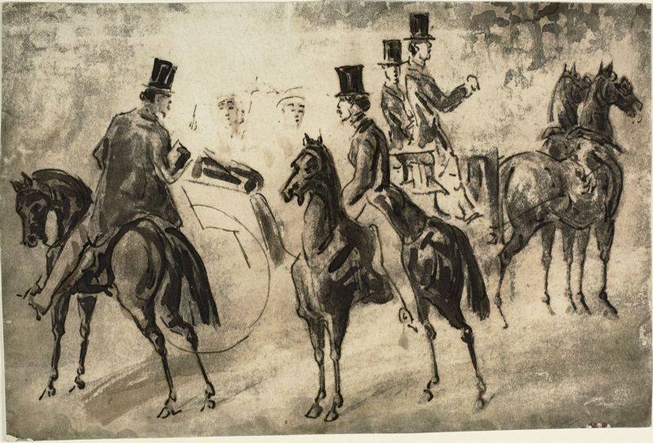
Constantin Guys
Riders and Equipage

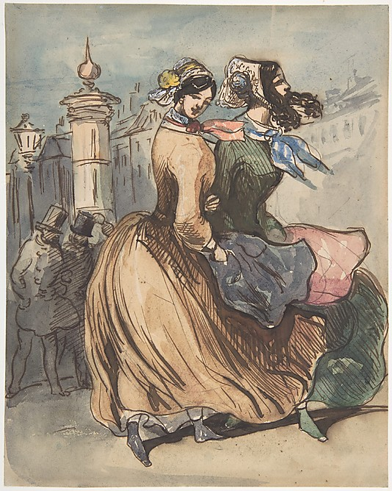
Constantin Guys
Two Grisettes

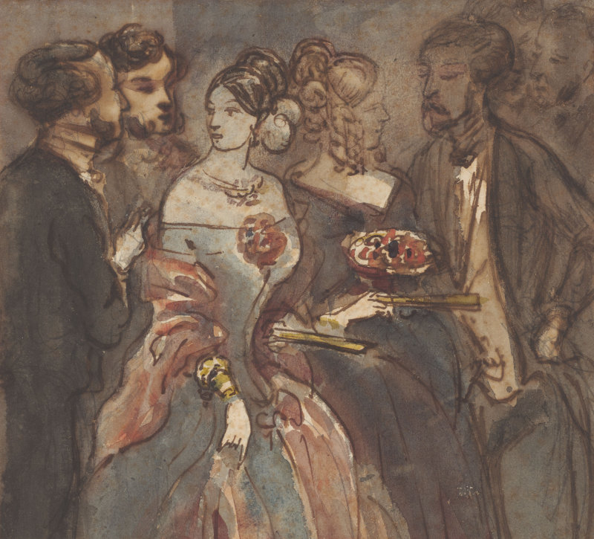

Constantin Guys
Reception

Unit II (1848-1914): Modernity, Capital, Empire – Baudelaire and Rimbaud
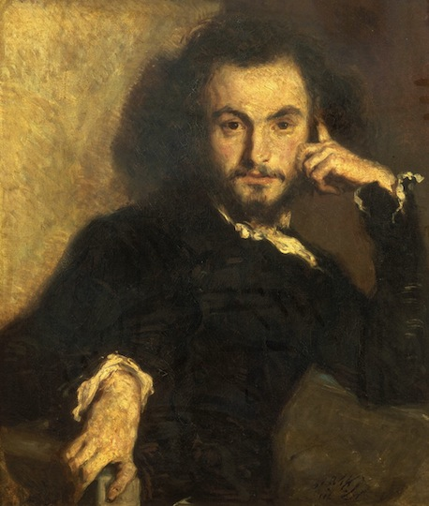

Charles Pierre Baudelaire (1821-1867)

1845: Salon de 1845
1846: Salon de 1846
1847: Le Fanfarlo [a novella]
1857: Les Fleurs du Mal (The Flowers of Evil)
1860: Les paradis artificiels
1861: Réflexions sur Quelques-uns de mes Contemporains
1863: Le Peintre de la Vie Moderne (The Painter of Modern Life)
1869: Le Spleen de Paris
Portrait by Emile Deroy (1820–1846)

'Beauty is made up, on the one hand, of an element that is eternal and invariable [...] and, on the other, of a relative circumstantial element, which we may like to call...contemporaneity, fashion, morality, passion.' (p392)

'Modernity is the transient, the fleeting, the contingent; it is one half of art, the other being the eternal and immoveable.' (p403)

-- Charles Baudelaire, ‘The Painter of Modern Life’

‘[Of M.G./The Painter of Modern Life] He enjoys handsome equipages, proud horses, the spit and polish of the grooms, the skilful handling by the page boys, the smooth rhythmical gait of the women, the beauty of the children, full of the joy of life and proud as peacocks of their pretty clothes [...] the cut of a dress…clusters of ribbons and curls...bonnets …chignons...waistlines...skirts.’

--- Charles Baudelaire, The Painter of Modern Life p401.

'To be modern is to find ourselves in an environment that promises us adventure, power, joy, growth, transformation of ourselves and the world - and at the same time, that threatens to destroy everything we have, everything we know, everything we are. Modern environments and experiences cut across all boundaries [...] in this sense modernity can be said to unite all mankind. But it is a paradoxical unity, a unity of disunity: it pours us all into a maelstrom of perpetual disintegration and renewal, of struggle and contradiction, of ambiguity and anguish. To be modern is to be part of a universe in which, as Marx said, "all that is solid melts into air."'

-- Marshall Berman, All That is Solid Melts into Air: The Experience of Modernity, p15.

‘[Baudelaire sees] both worlds simultaneously – the Paris before Haussmann, and the Paris during and after its redevelopment; France before the revolution of 1848, and France in the increasingly triumphant capitalist culture that followed; the death throes of the ancien regime with its unravelling social fabric, and the preening bourgeoisie with its nouveau riche self satisfaction that touted social utilitarianism and “good works” to repress political guilt and crass mercantilism. Baudelaire’s aesthetic strabismus is born of an inability to integrate the dying world with the burgeoning one – he sees, to repeat, both at once.’

-- Francoise Meltzer, Seeing Double: Baudelaire’s Modernity, p1.

* Tension between beauty and reality; modern life as beautiful but inseparable from misery and anxiety created as by-product of ‘progress’:

‘[I ask the question whether] by continually redefining humanity in proportion to the new enjoyments it offers, indefinite progress might not be its most cruel and ingenious torture; whether, proceeding as it does by a negation of itself, it would not turn out to be a perpetually renewed form of suicide…like the scorpion that stings itself with its own tail –progress, that eternal desideratum that is its own eternal despair.’

-- Charles Baudelaire, ‘Progress’ (1855)

‘[Haussmann’s urban redevelopment of Paris] wrecked hundreds of buildings, displaced uncounted thousands of people, destroyed whole neighbourhoods that had lived for centuries. But it opened up the whole of the city, for the first time in history, to all its inhabitants […] Paris was becoming a unified physical and human space.’

-- Marshall Berman, All That is Solid p153.

Points to Consider:
- Is Baudelaire’s ideology concerning Modernity consistent?
- How does ‘the crowd’ figure in Baudelaire’s concept of the ‘modern’ life?
- What role does Art play in modern experience? (and vice versa)
- Can we read Baudelaire in dialogue with Marx? How does Baudelaire present the class divide?
- What relevance and what roles do: barricades, boulevards, crowds, commodities, city architecture, industrialisation, revolution, technological advancement and urban redevelopment have and play in Baudelaire’s poetry?
- How does Baudelaire’s critique of modernity compare with Rimbaud’s? And with other texts on the module?

Suggested Reading

Berman, M. ‘Baudelaire: Modernism in the Streets’ in All That is Solid Melts into Air: The Experience of Modernity (London: Verso, 2010)
Meltzer, F. Seeing Double: Baudelaire’s Modernity (Chicago: University of Chicago Press, 2011) particularly ‘Introduction’ and “Words Pay No Debts” and ‘In Memory of the Present’
Terdiman, R. ‘Baudelaire’s “Le Cygne”: Memory, History, and the Sign’ in Present Past: Modernity and the Memory Crisis (Ithica: Cornell University Press, 1993)

