Unit I (1789-1848): Enlightenment, Revolution, Romanticism
Week 2: Faust Part I (1808) Johann Wolfgang von Goethe

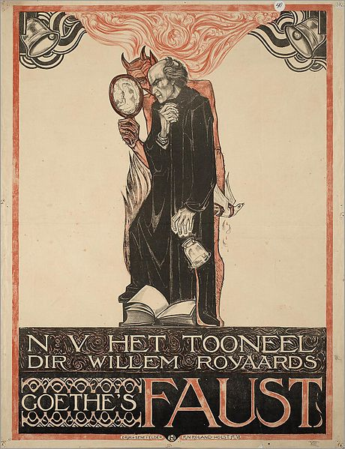
Timeline
1772-1775: mysterious fragmentary version called Urfaust written (MS destroyed by Goethe but copy thought to be authentic found in 1887)
1790: Faust, a fragment
1806: Preliminary version of Part I
1808: Faust, part I
1828-9: Revised edition of Faust, Part I
1831: Goethe finished part II
1832: Faust, part II published posthumously

Faust |foust| (also Faustus | foustəs;ˈfô-|) (died c. 1540), German astronomer and necromancer. Reputed to have sold his soul to the Devil, he became the subject of dramas by Marlowe and Goethe, an opera by Gounod, and a novel by Thomas Mann.

Goethe’s Faust by Richard Roland Holst

‘In Goethe’s drama, Faust ultimately develops into the type of the unsatisfied yearning of the human intellect for “more than earthly meat and drink,” this was because the great German humanist deliberately infused into the old story a spirit absolutely opposed to that by which it had originally been inspired. The Faust of the early Faust-books, of the ballads, the dramas and the puppet-plays innumerable which grew out of them, is irrevocably damned because he deliberately prefers human to “divine” knowledge; “he laid the Holy Scriptures behind the door and under the bench, refused to be called doctor of Theology, but preferred to be styled doctor of Medicine.”’

--- Walter A. Phillips, Encyclopaedia Britannica (1911) 11th Edition.

THE LORD. Do you know Faust?
MEPHISTOPHELES. The Doctor? Do you mean –
THE LORD. My servant.
MEPHISTOPHELES. Ah he serves you well, indeed!
He scorns earth’s fare and drinks celestial mead.

--- Prologue in Heaven, Faust, part I. (p11 in Oxford World Classics)
‘To the Tropical European, though perhaps not to the tropical native, the most important study is probably that of malarial fever, the investigation of which has already furnished us with some of the finest examples of human intelligence, perseverance, and observation, and unveiled to us some of the most wonderful workings of Nature. To myself this chain of marvels, full of poetry and religion, nowhere better seen than in the splendid illustrations of Drs. Ross and Fielding-Ould, always recall the words of the second-greatest Teuton of the century:
Wie alles sich zum Ganzen webt,
Eins indem andern wirkt und lebt !
Wie Himmels Kraefte auf und nieder steigen,
Und sich die goldenen eimer reichen !
Mit segen duftenden Schwingen,
Vom Himmel durch die Erde dringen.
Harmonisch all das All durchklingen !

--- William MacGregor, ‘An Address on Some Problems of Tropical Medicine Delivered at the London School of Tropical Medicine’ The British Medical Journal (1900)
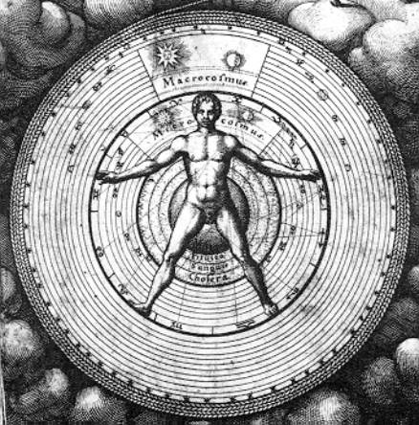
Translation:
How it all lives and moves and weaves,
Into a whole! Each part gives and receives, Angelic powers ascend and redescend
And each to each their golden vessels lend;
Fragrant with blessings, as on wings,
From Heaven through the earth and through all things,
Their movement thrusts, and all in harmony it sings!

Points to Consider:
- What is the significance of the one prose scene (26) in the play?
- What is the relationship between natural philosophy (science) and theology?
- What significance do the multiple prefaces (dedication, prelude on the stage and prologue in heaven) have on the play?

MEPHISTOPHELES. If I may be his guide you’ll lose him
Yet; I’ll subtly lead him my way, if you’ll let
Me do so; shall we have a bet?
THE LORD. He lives on earth, and while he is alive
You have my leave for the attempt;
Man errs, till he has ceased to strive.
[…]
THE LORD. Well go and try what you can do!
Entice that spirit from its primal source,
And lead him, if he’s not too hard for you
To grasp on your downward course –
And then, when you have failed, with shame confess:
A good man, in his dark, bewildered stress,
Well knows the path from which he should not stray.

Suggested Secondary Reading:

Marshall Berman, ‘Goethe’s Faust: The Tragedy of Development’ All that is Solid Melts into Air: The Experience of Modernity (London: Verso, 2010) pp37-87.

Rolf-Peter Janz, ‘Mephisto and the Modernization of Evil’, Goethe’s Faust: Theatre of Modernity eds Hans Schulte, John Noyes & Pia Kleber (Cambridge: Cambridge University Press, 2011) pp32-39. [available as electronic resource]

David Hawkes, ‘Faust and Enlightenment’, The Faust Myth: Religion and the Rise of Representation (New York: Palgrave Macmillan, 2007) pp139-165. [available as electronic resource]

James M. Van Der Laan, Seeking Meaning for Goethe’s Faust (New York: Continuum, 2007)

