Ends and Beginnings:
Late 19th & Early 20th Century Literature & Culture

Selected Stories from Daughters of Decadence ed. Elain Showalter

Vernon Lee: 'Lady Tal’
Kate Chopin: ‘An Egyptian Cigarette’
Charlotte Mew: 'A White Night'
George Egerton: ‘A Cross Line’
Ada Leverson: ‘A Suggestion’
Olive Schreiner: ‘The Buddhist Priest’s Wife’

Keywords: sexuality; gender; aestheticism; decadence; literature; psychology; new woman; marriage; reproduction.

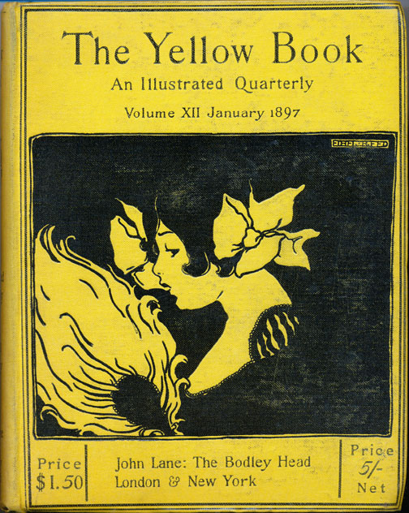
1857: Divorce and Matrimonial Causes Act – women permitted limited divorce.
1870 and 1882: Married Women’s Property Acts – allowed married women to retain their earnt income; gained the right to own and control their own property.
1886: Contagious Diseases Acts repealed.
1891: men denied conjugal rights to their wives’ bodies without consent.

The ‘New’ Woman (associated with):
- consolidating women’s rights (marriage, reproduction, labour, education, suffrage, sex)
- redefining gender roles and denying restrictive concepts of gender ‘spheres’
- overturning patriarchal ideologies

Heterogeneous fictional archetype – “mannish” Girton girl; bad mother; disillusioned spinster; promiscuous or androgynous;

The New Woman was by turns: a mannish amazon and a Womanly woman; she was oversexed, undersexed, or same sex identified; she was anti-maternal, or a racial supermother; she was male-identified, or manhating and/or man-eating or self-appointed saviour of benighted masculinity; she was anti-domestic or she sought to make domestic values prevail; she was radical, socialist or revolutionary, or she was reactionary and conservative; she was the agent of social and/or racial regeneration, or symptom and agent of decline.

--- Richardson, Angélique, Chris Willis, eds. The New Woman in Fiction and in Fact: Fin-de-siecle Feminisms. London: Palgrave Macmillan, 2001. Print.

The ideal marriage, despite all dangers and difficulties, should be free […] The economical dependence of woman is the first condition of free marriage. She ought not to be tempted to marry, or to remain married, for the sake of bread and butter. But the condition is a very hard one to secure.

--- From: Mona Caird ‘Marriage’ (1888).

With mild young men she is apt to be crushing. She directs her conversation and her glance above their heads. She has a way of throwing scraps of talk to them in return for mild platitudes—crumbs from a well-stored intellectual table.

--- From: ‘Character Note: The New Woman’ (1894)

Aestheticism: ‘L’art pour l’art’ – Art as existing for the sake of beauty and experience, divorced from any political, moral or didactic purpose.
-- symbolism
-- synaesthesia
-- sensual experience

The Yellow Book – (1894-1897) quarterly literary periodical published by Elkin Matthews and John Lane. Associated with aestheticism and decadence and containing a range of literary and artistic genres.

[Decadent literature includes] an intense self-consciousness, a restless curiosity in research, an over-subtilizing refinement upon refinement, a spiritual and moral perversity […] interesting, beautiful, novel as it is [it] is really a new and beautiful and interesting disease.

--- from Arthur Symons, ‘The Decadent Movement in Literature’ (1893)

[New Woman stories] search for new thrills and sensations, and they possess a maddening faculty for dissecting and probing their ‘primary impulses’—especially the sexual ones […] they are oppressed with a dismal sense that everything is an enigma, that they themselves are ‘playthings of the inexplicable’; or else they try to ‘compass the whole physiological gamut of their being’—whatever that may be. I am quoting from Miss George Egerton’s Discords a fair type of English neurotic fiction, which some critics are trying to make us believe is a very high class literature.

--- from Hugh E. M. Stutford, ‘Tommyrotics’ (1895)

Autonomous female subjectivity [was increasingly] linked with sexuality claimed by New Women writers from Olive Schreiner to George Egerton to Sarah Grand, whose fiction was typically banished from “high” art for being too sexual […] for contemporary male critics, the female writers’ concern with sexuality was often seen as evidence of their tendency to focus on particularities rather than on abstract or universal issues.

--- Zom, Christa. Vernon Lee: Aesthetics, History and the Victorian Female Intellectual. Ohio: Ohio University Press, 78. Print.

[Vernon Lee] repeatedly sketches images of womanhood as constructions of male minds, thus altering the trope of the dangerous woman into that of the “unknown” woman, who has so far been defined only through her relationship to man. (Zom, 79)

Points to Consider:
- How do New Women writers portray motherhood and its relationship to female identity?
- In what ways are natural imagery and sensual experiences used in New woman fiction?
- What is the relation between form and content?
- How do Naturalism, Decadence and New Women politics interact in fin de siècle short stories?
- Consider the power and intrigue that female characters hold over men in the stories.

