
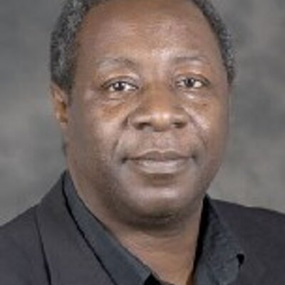





DETAILS:
Date: Friday 15th January 2016
Time: 2pm - 5pm (Tea and cake provided)
Venue: IAS seminar room, Milburn House,
University of Warwick
Places for the event are limited, so please register.
http://prevent-agenda.eventbrite.co.uk

Feminist Dissent is supported by The Warwick Impact Fund, CSWG, the Department of English.
Decoding the Prevent Agenda and its Impact on Education in the UK

Friday, January 15th, 2016
2-5 pm
Institute of Advanced Study, Milburn House, University of Warwick

This Workshop will examine the government’s Prevent Agenda, a counter-terrorism strategy introduced by the UK government, and its impact on educational institutions. Will it succeed in curbing the rise of extremism among the youth or will it further stigmatize young Muslims? Is it discriminatory? Is it furthering “community cohesion” or weakening it? What impact will it have on gender issues within communities of students? Join us for the discussion!

Speakers:
Rashad Ali, Institute for Strategic Dialogue
Tehmina Kazi, Director, British Muslims for Secular Democracy
Goldie Osuri, Department of Sociology, University of Warwick
Wilf Sullivan, Race Equality Officer, Trade Union Congress
Hicham Yezza, Ceasefire Magazine

