In Robeson’s Footsteps

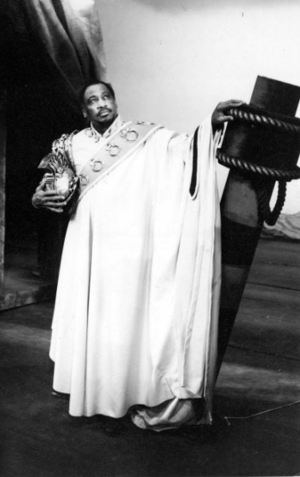
With
Rakie Ayola
Nicholas Bailey
Simon Manyonda
----
Director: Tom Cornford
Script: Tony Howard

Performance and discussion: Friday 15 January 2016

The Cinema, Tricycle Theatre

In 1930 the singer, actor, and activist Paul Robeson made history by playing Othello at the Savoy Theatre, London. Weeks earlier, the Savoy Grill had refused to serve him. Then, and for the rest of his career, this great African-American artist used Shakespeare to launch a challenge against prejudice.
As we launch the BBA Shakespeare Performance Database, today’s events remember Robeson’s foundational achievements. His inspirational Othello opened up possibilities for generations of actors, and it continues to do so. After dozens of interviews with BAME actors and directors, the Multicultural Shakespeare project presents a dramatized documentary reading, based on historical sources and first-hand accounts. We consider Paul Robeson’s Shakespearean legacy – from the Savoy to Windrush to today.
With thanks to Rakie Ayola, Karen Bryson, Lolita Chakrabarti, Joseph Charles, Noma Dumezweni, Mona Hammond, Oscar James, Alby James, Paterson Joseph, Adrian Lester, Jonathan Man, Simon Manyonda, Patrick Miller, Hugh Quarshie, Madhav Sharma, Lucy Sheen, Jatinder Verma, Lola Young, Daniel York and many others, and with special acknowledgement to Stephen Bourne and the late Cy Grant.
Supported by funding from the Arts and Humanities Research Council, The Multicultural Shakespeare in Britain project is dedicated to expanding knowledge of the contribution made by British black and Asian performers to the appreciation and understanding of Shakespeare. Our exhibition, To Tell My Story, has toured theatres, schools and libraries around the country.
The British Black and Asian Shakespeare Performance Database is now available at https://bbashakespeare.warwick.ac.uk/
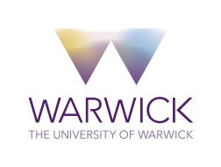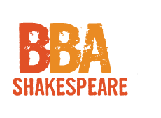

Rakie Ayola
Rakie Ayola trained at (and is a Fellow of) The Royal Welsh College of Music and Drama. As well as her extensive work in TV, film and radio she has performed with companies such as Birmingham Rep, Bristol Old Vic, Edinburgh Royal Lyceum, the National Theatre, the Royal Court, Shakespeare's Globe, the RSC, Shared Experience, Sheffield Crucible and Sherman Theatre Cymru. The classical roles Rakie has played include Milament (The Way of the World -Ian Charleson Award Commendation) Ophelia, Viola, Dido Queen of Carthage, Olivia and Paulina (The Winter's Tale, RSC, 2013). In 2016 Rakie will play Goneril in King Lear at Manchester Royal Exchange.

Nicholas Bailey
Nicholas Bailey was born and educated in Birmingham. He trained at LAMDA and the National Youth Theatre. He is best known for his role as Anthony Trueman in East Enders. He made his professional theatrical debut in Julius Caesar in 1994 at the Manchester Royal Exchange. Other Shakespeare credits are A Winter’s Tale (Royal Exchange); Hamlet (Library Theatre Manchester); King Lear (BBC and National Theatre); Macbeth (Mercury Theatre Colchester). An MBA in International Business, Nicholas recently founded Legacy360, a leadership and communication company. He is a BBA Shakespeare Honorary Fellow.

Tom Cornford
Tom Cornford is a Lecturer in Theatre and Performance at the Royal Central School of Speech and Drama, University of London, and a director and dramaturg. He was previously Lecturer in Theatre at the University of York and has taught acting and directing in the UK, the USA and Germany. He is currently completing his first book, Theatre Studios: Practices, Philosophies and Politics of Ensemble Theatre Making.

Tony Howard
Tony Howard, Professor at the University of Warwick, has led the Multicultural Shakespeare in Britain project since 2012. He is author of Women as Hamlet: Performance and Interpretation in Theatre, Film and Fiction. He curated seasons of international Shakespeare films for the Cultural Olympiad and the Harlem Shakespeare Festival. He has had plays and (working with Barbara Bogoczek) translations performed at the Barbican, Stratford East, the Royal Court, Riverside Studios and Battersea Arts Centre.

Simon Manyonda
Simon Manyonda trained at LAMDA. In 2013, he received an Ian Charleson Award Commendation for his work as Lucius in the RSC’s Julius Caesar. His other Shakespeare credits include Antony and Cleopatra (Liverpool Playhouse), A Midsummer Night’s Dream (Filter); King Lear (National Theatre), A Midsummer Night’s Dreaming (RSC).

For more information about Multicultural Shakespeare in Britain visit www.warwick.ac.uk/MulticulturalShakespeare

