History Department Research Seminar Series 2014-2015

Stella Tillyard
Independent scholar and writer, author of Aristocrats (1994 biography, won the History Today Award),
Citizen Lord (1998 biography), A Royal Affair (2006 history), Tides of War (2011 novel)
with discussant
Lizzie Collingham
Associate Fellow at the University of Warwick, independent scholar and writer,
author of Imperial Bodies: The Physical Experience of the Raj,
Curry: A Tale of Cooks and Conquerors, and The Taste of War: World War II and the Battle for Food

History and the
Historical Novel
What is the historical novel for and what can it do when we now have such good accessible history?
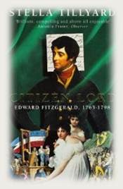 | 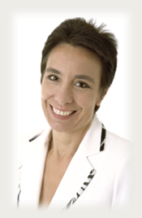 | 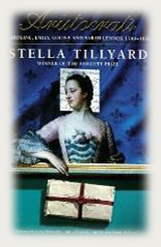

Wednesday 14th January 2015, 4.30-6.30pm, Room R0.03/4
with refreshments and informal discussion. All are welcome.
Series convened by Professor Maxine Berg
enquiries to: Sheilagh.Holmes@warwick.ac.uk 024 7657 2601

