CENTRE FOR THE HISTORY OF MEDICINE
SEMINAR SERIES 2013-2014
Tuesday 22 October 2013 (Week 4)
5.00pm – Ramphal Building Room R0.14
Professor Linda Bryder

(University of Auckland)

Fathers and Childbirth
From the 1950s Parents Centre, a new consumer group in New Zealand, included amongst its goals the right for men to accompany their wives into maternity hospitals at childbirth. This campaign was eventually successful, fathers’ presence at childbirth became the norm, and hospital spaces changed significantly to accommodate these new demands. While pressure for men’s attendance came primarily from women, I will suggest that it was not just because women found hospitals an alien environment and wanted the emotional support of their partners. With almost 80 per cent of all births occurring in hospital by the late 1930s, many women had previously given birth without the presence of their husbands. Rather, I will argue that the demand for the presence of fathers at childbirth was related to a new popular psychology movement in the post-war period which stressed the value of stable family units for society as a whole and the role of childbirth in helping to achieve this. As the presence of fathers increasingly became commonplace, I will investigate the responses of health professionals as well as the men and women themselves, to see whether it played out as this prescriptive literature had led them to believe.

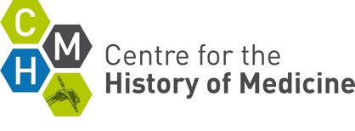 | Centre for the History of Medicine  The University of Warwick  Coventry CV4 7AL United Kingdom  Tel: 024 76 572601  Email: hist.med@warwick.ac.uk

