CENTRE FOR THE HISTORY OF MEDICINE
SEMINAR SERIES 2013-2014
Tuesday 19 November 2013 (Week 8)
5.00pm in Ramphal Building Room R0.14
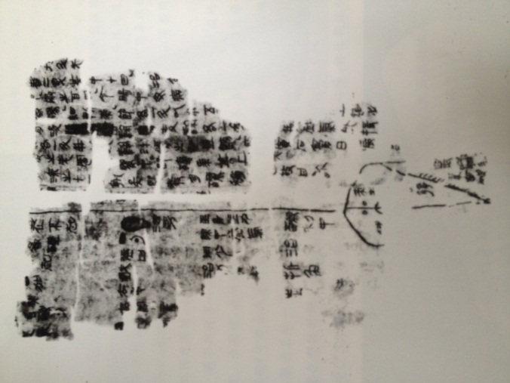 | Dr Vivienne Lo (UCL)  with Eleanor Re’em  Recipes for Love in the  Ancient Worlds
This presentation compares love, sex and the technologies of passion in early China and Greece and reflects on how these cultures figured in innovative scientific theories and empirically based knowledge. Observation about the impact of sexual activity, and particularly the effect of orgasm on the body was a core feature of medical innovation in both cultures. The notion of empiricism interrogated here, or of the empirical, is understood in a number of common ways: a) the process through which remedies and strategies were simply observed to ‘work’, regardless of whether they were ritual or substance based (or both), b) the work of those practitioners who did not deploy scholarly theories as part of the authority cited for the efficacy of their practice and, in passing, c) those treatments that have stood the test of time to be legitimated by modern clinical work. These categories are not mutually exclusive in the strategies which we discuss, but making them explicit serves to emphasise key aspects of the nature and practice of efficacy. Recipes for love, sex, and passion, we argue, and their contribution to scientific thought in the ancient worlds, have been unreasonably overlooked.

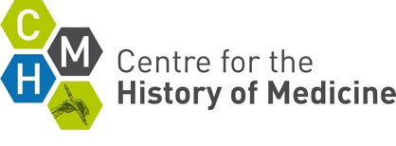 | Centre for the History of Medicine  The University of Warwick  Coventry CV4 7AL  United Kingdom  Tel: 024 7657 2601  Email: hist.med@warwick.ac.uk

