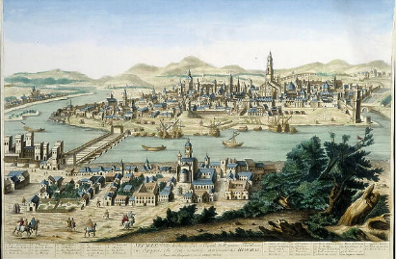
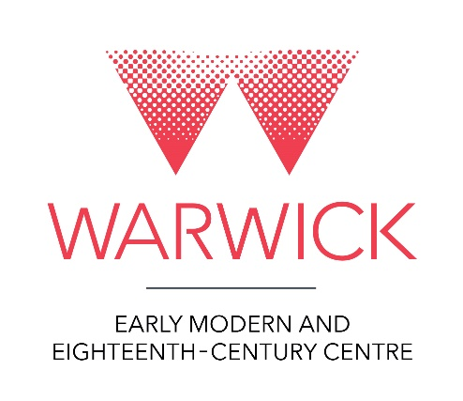
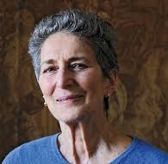
Early Modern and Eighteenth-Century Centre Events
Autumn Programme 2024

Joint EMECC and STVDIO Welcome Event: Investigating Empowerment and Song Via the Prizewinning 100 Ballads Website (100ballads.org)
Angela McShane (Warwick)
Week 2. Thu 10 Oct, 13.00–14.00 (lunch served 12.30) in OC0.05 Oculus Building

History on Film: The Return of Martin Guerre and the Legacy of Natalie Zemon Davis
Discussion with Charles Walton, Penny Roberts, Anne Gerritsen and Anna Pravdica followed by a film screening of The Return of Martin Guerre (1982).
Week 4. Wed 23 Oct. Panel discussion and pizza 16.30–18.00 in OC1.08 Oculus Building.
Film screening 18.00–20.00 in FAB Cinema room (ground floor).

Re-Imagining Politics and Society, 1750-Present: A Symposium Celebrating Mark Philp’s Academic Career
A celebratory workshop supported by the History and Politics departments.
Week 6. Fri 8 Nov, 10.00–18.00, Scarman Conference Centre
Please contact Naomi Pullin to attend either the workshop or wine reception.

Work-in-Progress Seminar: Ministers, Maps and Mistresses: Extra-Illustrating the Restoration
Hannah Straw (Warwick), chaired by John West (Warwick).
Week 7. Thu 14 Nov, 13.00–14.00 (lunch served 12.30), in OC0.04 Oculus Building

EMECC-My-Parish-EHRC Joint Seminar: Parishes and Towns: New Approaches in Polish Historiography
Dr. hab. Marek Słoń (John Paul II Catholic University Lublin / Poland), chaired by Beat Kümin
Week 9. Thu 28 Nov, 13.00–14.00 (lunch served 12.30, 3rd floor social space, FAB3.57), FAB2.43 Faculty of Arts Building
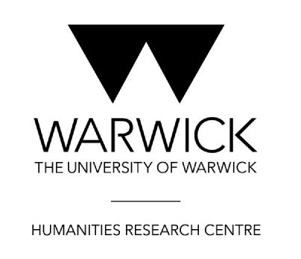
EMECC-EHRC-GHCC Joint Seminar: No Country for Travellers? British Visitors to Spain and Portugal, 1760–1820
Roey Sweet (Leicester), chaired by Natalie Hanley-Smith (Warwick)
Week 10. Thu 5 Dec, 12.00–13.00 (tea and coffee served 12.00), in OC0.04 Faculty of Arts Building and on MS Teams

