Magical Source: Mary Toft’s first ‘confession’

Mary Toft alleged to have given birth to rabbits in 1726. The case caused a media sensation, a flurry of pamphlets and a court case. In the end, the case was proven to be a hoax. And this has shaped many studies of the case which took a cursory glance (if that) at the experiences of the woman at the centre of events and instead focussed on either medical historical perspectives or broader concepts relating to the imagination and the self. My research into the case was transformed by a close re-examination of the three ‘confessions’ taken down by James Douglas, a doctor present at three interviews of Toft by a Justice of the Peace in London. They allowed me to put Toft at the centre of my research, and to consider the case as not just a hoax.

The confessions are each quite long so here you have just the first page of Confession 1. Links to full transcriptions and photographs are below.

To consider:
- What do the transcriptions not record from the manuscript itself? Why might this matter?
- How do my transcriptions differ from those of Dennis Todd and what difference might this make?
- How did my reading of this document – and the methods I applied in that reading – affect my research?
- What else – besides this document itself – might have fed into that new research?

Transcription of this first page:
Decb 7 1726

I will not goe on any longer thus i
shall sooner hang my selfe.

I was delivered of a furie[live/true?] monstrous
birth. Some thing came away with a flooding
After I had seen some rabbits whc
The liver and gutz came away first.
I longed for.

The same day the waters came as in
your other labours. Then a substance ^ ^{as big as my arm}
came away the uppermost of it was like a gutt and the other end round as her fist.
My mother opend it and the [inside?] like a an
an afterbirth.
The flooding continued afterwards above
a week three weeks after the 1. flooding I was
took again with a floodg in the hops garden

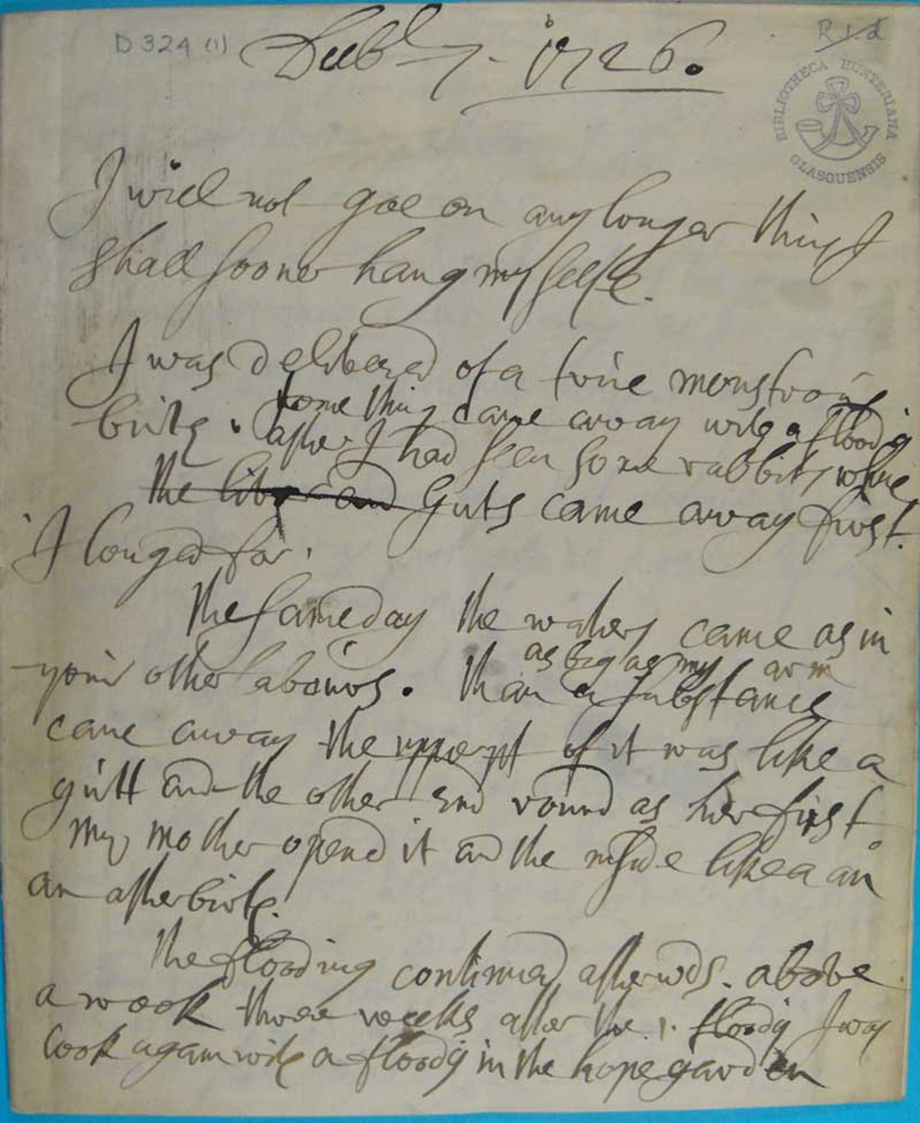

Mary Toft’s confession on 7 Dec. 1726, MS Hunter D324, f1.

The three ‘confessions’ of Mary Toft were used in my open-access article:
Karen Harvey, ‘What Mary Toft Felt: Women’s Voices, Pain, Power and the Body’, History Workshop Journal, Volume 80, Issue 1, Autumn 2015, pp. 33-51.

and also in my book, The Imposteress Rabbit Breeder: Mary Toft and Eighteenth-Century England (OUP, 2020).

You can find photographs of all the confessions in Glasgow University Special Collections here: https://www.flickr.com/photos/uofglibrary/sets/72157631751522610/

You can find full transcriptions by Dennis Todd here: https://tofts3confessions.wordpress.com/ (Todd’s book, Imagining Monsters: Miscreations of the Self in Eighteenth-Century England (University of Chicago Press, 1995), examines the case but doesn’t draw on the confessions in any detail).

