Goods from the East: Trading Eurasia 1600-1830

Conference at the Palazzo Pesaro-Papafava, Venice
Friday 11 to Sunday 13 January 2013

organised by the ‘Europe’s Asian Centuries – Trading Eurasia 1600-1830’ project, Global History and Culture Centre, Department of History, University of Warwick

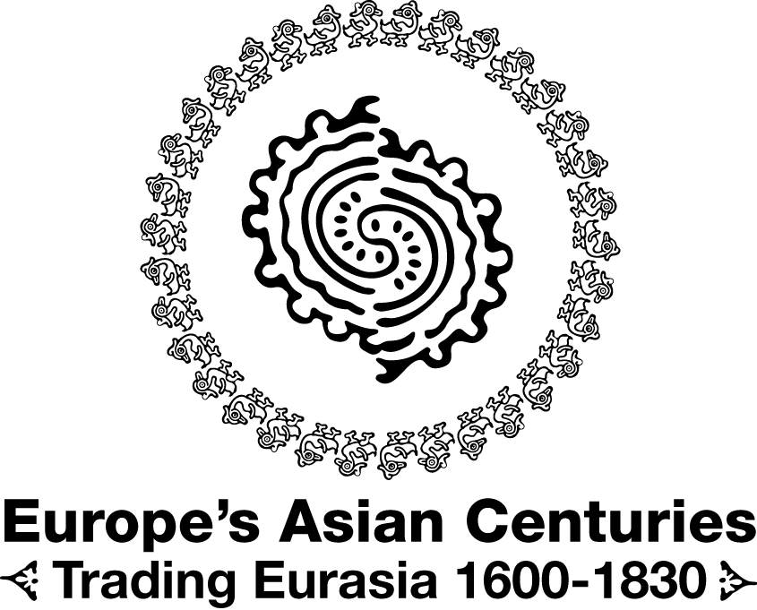

“Exotic” Goods?
Far-Eastern Commodities for the French Market in India in the 18th Century

In this presentation, I will tackle the issue of Asian product consumption by the French nationals residing in India, and more specifically in Pondicherry, in the eighteenth century. The Pondicherry trading post, located on the Coromandel Coast, south of Madras, was the main base for French trading in the Indian Ocean, and in Asia at large. It relied on several secondary trading posts that helped in collecting and storing goods to be exported to Europe.
The point here is to focus on products from the Far East, that is to say from the eastern part of India to Japan. Why focus on these products specifically? The main reason is that these goods from the Far East were subject to a very specific form of consumption. As we will see, their role varied. Some of them were widespread and had completely blended into the daily habits of the French, while others were seen as exceptional goods, and thus reflected a fondness for Asia in a certain category of the population.
I suggest dealing with the issue in three stages. First, we shall try to understand how a French trading post located in India was supplied, and which were the Far East areas at stake. Second, we shall focus on how private trade operated, since private trade was the largest supplier of Far East products: who was involved in trading, and what were the commercial networks through which the products were distributed. Finally, we shall try to understand how the goods were used, what place they had in French people's everyday environment, and what was their cultural value through the notion of exoticism.

World-wide supplying

Let us begin with the issue of supplying. Studies of material culture in Europe in the eighteenth century often run up against the difficulty of identifying where the acquired goods were coming from. This is particularly the case for products coming from other regions, other countries or even other continents. We are confronted to a similar questioning when it comes to research on the possession of European goods in India. In this case, the object coming from outside originated in Europe or the Far East, while the households under study are French. It is through the various products that were available to residents of the Pondicherry trading post that consumption could be outlined. A difference should be made between, on the one hand, chosen consumption when the offer was sufficiently wide-ranging and varied, or, on the other hand, forced consumption when there was a shortage, or at least when the goods that were available to the buyer ran scarce.

Pondicherry or the French "island" of the Coromandel Coast

So, which were these goods that made up the Pondicherry market? Several factors gave the trading post a sense of insularity. The first factor lies in its location on the Coromandel Coast, in the South of India. Everything that came in and out of Pondicherry did so by the sea, whether the products were coming from Europe, the Mascarene Islands, the Far East, or other trading posts in India. The sea made it possible for Pondicherry to be connected to Europe and the wider Asian area. Other factors allow us to consider it as an island, but this time from a more social and cultural point of view on which we cannot elaborate here, unfortunately.
The cargo of the ships that left Europe for India was made up of two categories of product: metals to be transformed for currency use, and consumer goods. Ranking first among those goods were foodstuffs, most of which were spirits. Eau de vie was much consumed in India by all demographic categories. Wine was reserved for the well-off, especially when it came to French PDO wines such as Bordeaux, Champagne, Burgundy, etc., but also other European productions such as Madeira wine or Italian wine from Calabria. Foodstuffs were mostly limited to those spirits for transport and storage reasons. Only Dutch cheese was inventoried a few times. There was a variety of other products imported from Europe: textiles (including fine materials such as lace), tin or silver plates, and more rarely Sèvres or Saxony porcelain. The cargo was supplemented with small furniture items, art objects, weapons, herbal remedies, books, jewelry, and so on.
But what about products that were available in India? India provided mainly common consumer goods, ranking first among which were foodstuffs. Pondicherry was surrounded with rice plantations which served as the staple that helped meet the needs of the Indian and European populations of the city. On top of this, one can add poultry, game, and cattle, which were another part of daily meals. Fruits also held an important role because the climate made it easy to cultivate them, and their variety kept people from getting fed up with them. What is more, most of them could be grown directly in the gardens Pondicherry homes, which added real savings on top of the food diversity element. But India also provided a large amount of cloth and painted fabric for clothing and interior furnishing purposes. Indian and French tailors did the rest in order to allow Westeners to dress like Europeans, while being able to use the lightness of Indian textiles which were much more suited to the climate of South India.

Supply areas of the Far East

However, this was not enough. Pondicherry appealed to the Far East market to fill in the gaps of both Indian production and European imports. In order to do this, the trading post could rely on a country trade network –Asia's internal trade– to find supply in consumer goods and building materials. Pondicherry was supplied by three main areas.
The closest one consisted of the Indonesian archipelago –with Manila, Aceh, and Batavia– to which could be added Pegu in Burma (now Bago in Myanmar) and Mergui in Siam (now Myeik in Myanmar).
The second area was China. It was in itself a first class source of supply, not only as to the quantities of imported goods, but also as to their quality.
The third and final area was Japan, which was characterized by the very high quality of the products that were supplied.
Although the existing facilities and the trading networks made it possible to trade with the Far East, the political dimension must also be taken into consideration. The presence of various European nations trading in Asia was, indeed, not tolerated and permitted in the same way in all parts of the Indian Ocean and East Asia. The example of Japan, in itself, is characteristic of this. In 1639, the Portuguese, who were allowed to engage in trade there, were expelled, thereby leaving the privilege of trading with the Land of the Rising Sun solely to the Dutch. Such trading monopolies did not mean, however, that it was impossible for a nation to obtain certain products. They just went different routes by resorting to intermediaries.

Private trade: a widespread practice throughout society

Before looking at the use that was made of the goods coming from the Far East, it is essential to understand how they came to Pondicherry, and how Europeans had access to them.

Private traders and individual trading

Trading was central to the lives of Pondicherrians, whether French, English, Armenian, or of course Indian. And on this issue, the notarial archives leave no room for doubt. While it is logical to find inventoried goods from merchants, traders, and ship owners, it is much more surprising to note that many individuals were also engaged in such practice. It is indeed essential to make the difference between these two types of trade: "private trade" when it was done by professionals (ship owners, traders, etc.), and the "individual trade" when it was done by individuals whose occupation is not related to trading.
These notarial acts therefore provide very precise data on the composition of wealth, and thus allow for the easy identification of commercial-purpose goods, that is to say, goods that were up for resale, and were kept in private homes. It appears that people from all the occupational categories represented in this trading post city were involved in trading, whether they were military personnel, administrative staff of the East India Company, crew members, servants, craftsmen, and so on. But there are, of course, variations across ranks or occupational levels. Remarkable examples are abundant. If only one example should be cited, let it be that of a clergyman –an abbot by the name of Father de Walle– in whose case 90% of the property that was inventoried after his death was made up of commercial-purpose goods. This consisted of five bales containing seven hundred and twenty pieces of cloth of various kinds which could have been used, ultimately, to make more than seven thousand handkerchiefs. We are very far from the sort of activity that might be expected of a clergyman in eighteenth century India.

Distribution channels for Far East products

The issue of trade networks within the trading post itself can be raised. Where did those "merchants" whose occupation was not trading get their supplies? Their unofficial activities replicated well developed and effective commercial networks. It was the case that the East India Company delegated country trading to private individuals. The very substantial benefits that those individuals drew from such business were indeed well known, and sparked many a trading vocation. Although professional country traders are well known, much less so is the role played by individuals. Yet, these individuals actively participated in the fitting out of ships to the Far East. They could do so in two ways: either by directly investing money to buy goods that were loaded onto ships to be exchanged when they reached destination, or by lending money (including by means of bottomry loans) to merchants in order to draw a benefit at a later stage.
The products were then circulated in Pondicherry. Unfortunately, we have little evidence that could provide reliable information about this resale issue. Records show, however, that some French people owned shops in the trading post that were kept by Indians. Such is the case for Charles de Flacourt, in Pondicherry, an individual merchant who owned sixty-five shops in the St. Lawrence bazaar. Thus, the products were made available to the greatest number of people.

Products from the Far East: from raw material to work of art

After looking at where the merchandise and consumer goods were coming from, through which networks they made their way to the trading posts of India, and by whom they were traded, we can finally think about the places such Far East goods held in the lives of the French, and about the cultural value that was attached to them. The notion of exoticism is a key element here, and it is essential to reconsider its perception in the context of the Pondicherry trading post in the eighteenth century. Although exoticism has been widely studied in the European context for the same time period, especially through the study of consumption, the perspective must be adjusted when studying a French population in India. Exoticism can be defined as the search for new horizons, for a distant world which changes the scenery and –because it is not easily accessible– is fascinating and compelling. When they arrived in India in the second half of the seventeenth century, the French were likely to be impressed and bewildered by this new daily environment. But what was the case after they had spent several months there or, better yet, when they were descendants of several generations of families who had settled in the Indian Ocean? We will see that, depending on the products, the exotic dimension fluctuated.

Raw materials and common consumer goods

There was not a wide range of raw materials coming from the Far East. Their first and foremost purpose was to make up for a shortage –or, at least, for the bad quality– of such materials in India. This is particularly the case for copper –which came from China or Japan– or for the renowned Mergui wood (from Siam) and Pegu teak (from Burma). Some of the wood was highly prized by cabinetmakers and joiners, who utilized it to make furniture. It was also used for shipbuilding, but were mainly used in housebuilding. Teak doors and windows were not uncommon in Pondicherry since teak wood combines a beautiful appearance and a high resistance to the hot and humid climate of monsoon periods. Precious materials were also imported: ivory, gold, and tombak (from the Philippines); sapphires and crystals (from Ceylon). For packaging and shipping time reasons, the only foodstuffs that were brought in from the Far East were limited to Arrak (which is a sort of eau de vie) from Batavia, wine from Japan, and rice from Burma. China mainly supplied tea, sugar and the odd jars of jam. More unexpectedly, Aceh –which is located in the north of the island of Sumatra– was one of the main places supplying horses. Several boats were indeed set out to import these animals to Pondicherry. They were highly valued for their endurance at work.

Resorting to China and Japan to get furniture and clothing

But it is inside the homes of French people in the trading post that the Far East was most represented. Whole sets of manufactured objects coming mainly from China and Japan were making their way to all the rooms in the house. These were objects commonly used in everyday life such as bowls, ewers, spittoons, or boxes of all sorts –for soap, wigs, tea, tobacco, and so on. On top of this, one could find porcelain tableware naturally made of china: plates, bowls, kettles, teapots, coffee pots, dishes, cups, saucers and mugs. Their quality varied from common china, often with blue decorations, to armorial porcelain that was reserved for armigerous families. Then came a series of small utilitarian objects: fans, writing cases, canes, cabarets (or spirit cellar) with their flasks. Medium-size furniture supplemented the whole lot: folding screens made of wood or canvas, tables, chairs, armchairs, which were often made of lacquered wood.
Textiles from China also played an important part in interior furnishing, mainly to stuff seats and armchairs, but also to cover the floors with Chinese rugs. But it was in clothing that most of the fabric was used. The French were very keen to preserve the European dressing styles. Clothes therefore followed Western standards but were made with silk, satin, velvet, Nankin, Pekin cloth, and so on.

A choice place among collectors

China and Japan also embodied the quest for beauty and rarity. The French indeed made use of objects from the Far East to show their taste for art but also for unusual objects, which were referred to as oddities in Europe. It was a real luxury trade that started developing in the 1740s/1750s, with the emergence –among the well-off– of actual collections of art objects.
This is how vases and decorative urns made of Japanese Imari porcelain got into the sitting rooms of French homes. Chinese statuettes, most often made of varnished clay, were exhibited, which could represent female figures or animals. Some stone or bronze statuettes could take the form of a Chinese lion. The odd Chinese magots could also be found –more rarely– as Europeans were keen on them at the time. Walls were decorated with paintings and engravings –framed in wood that was gilded or painted red– which depicted Chinese scenes. Finally, some rare items reflected the interest that the French took in Asian know-how. Inventories also show two allusions to "moving figures". These were in fact automata from China, which were very rare items in India at that time, and which were also much sought after in Europe. These articulated dummies equipped with complex mechanisms were made from precious materials, like this automaton kept at the Lorient Museum of the East India Company, which represents a Chinese mandarin whose face and hands were crafted using carved and painted ivory.
These Asian items truly stand out in sharp contrast to the way the French would constantly try to surround themselves with references to Europe throughout the eighteenth century either through architecture styles, through Western-like shapes for furniture, or through the contents of their wardrobes.

Conclusion

To conclude, Far East merchandise was ubiquitous in the everyday life of French people in Pondicherry in the eighteenth century, but various types of merchandise played different roles. On the one hand, some merchandise was making up for the lack of building material or consumer goods. On the other hand, some types of merchandise were favoured among the well-off who included the Chinese and Japanese productions in their art object collections.

Kévin Le Doudic
University of South-Brittany /
European University of Brittany
Research Laboratory CERHIO CNRS – UMR 6258
Lorient (France)
kevinledoudic@gmail.com

Abstract

Through the setting up of a trading post in Pondicherry (Southern India) in the second half of the 17th century, the East India Company was to acquire the logistic means to carry out its business activities in the Indian Ocean and Asia. A small society organized around the Company and its commercial and administrative staff: military personnel, crew members, servants, clergymen, etc. To meet the needs of this population, the Company was had supply the trading post so as to make up for shortages in local consumer goods. This, however, did not suffice. It was therefore necessary to find alternative sources of supply, and Far East products were naturally used to fill the gap. The French, through country trade, had indeed already built networks that enabled them to assemble the necessary cargo for their ships returning to Europe.
The analysis of both the supply and the practice of private trade makes it possible to understand how goods were circulated not only throughout Asia, but also within the Pondicherry trading post itself. Who were the Frenchmen who practised the sort of trade that helped supply households with Far East products? Depending on their nature, the roles played by such products could vary. From simple raw materials to the most sought after collector's items, a compelling taste for the exotic, and a growing interest for the Chinese and Japanese civilizations in the eighteenth century have enriched the interiors of Pondicherry Frenchmen's homes, as evidenced in notarial archives.

