GLOBAL HISTORY & CULTURE CENTRE
GLOBAL HISTORY & CULTURE CENTRE AND
EIGHTEENTH-CENTURY CENTRE JOINT SEMINAR

WITH GREAT POMP AND MAGNIFICENCE:
Royal Gifts and the Embassies between
Siam and France in the 1680s

Professor Giorgio Riello
(University of Warwick)
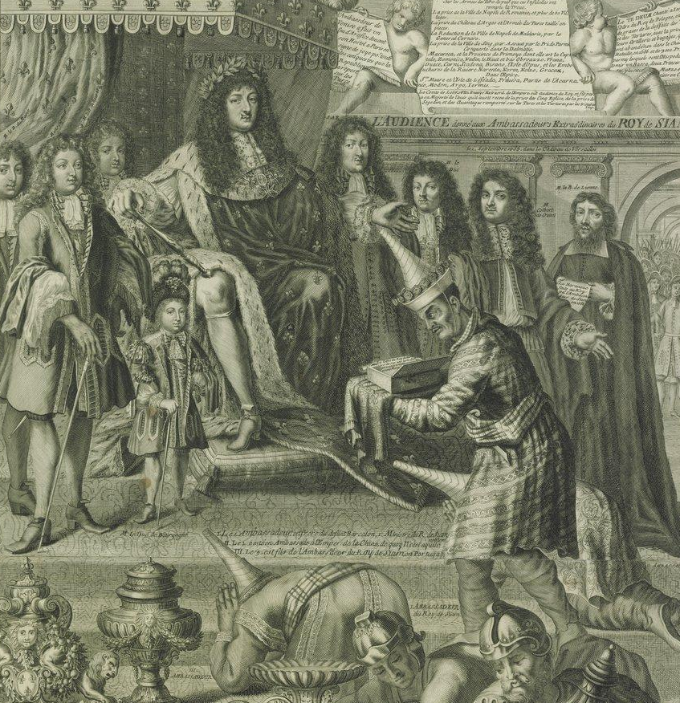

Thursday 15 January 2015
5-7pm
R0.12 Ramphal Building
Refreshments served. All are welcome.
