Material Culture of the Americas in a Global Age
Peabody Essex Museum

Friday, March 23, 2012

Anne Gerritsen and Giorgio Riello, University of Warwick, Chairs

9:30-11:00am Morning session – Welcome, introductions in Idea Studio B

Overview of MET Interwoven Globe exhibition, Amelia Peck
Overview of MFA, Boston Asia and the New World, Dennis Carr

11:00-11:30am Coffee in Atrium

11:30am-1pm Object discussion in Idea Studio A:

- Suzanne Hood, Ceramic shards at Williamsburg
images of shards on monitor and related ceramics from PEM
- Marybeth De Filippis, Melakan high chest, AE85331
- Susan Bean, Indian muslin dress, 123571.W
- Dana Leibsohn, Peruvian crown, E14655

1:00-2:00pm Lunch in Idea Studio B

2:00-3:00pm Object discussion in galleries:
Karen Kramer Russell,
Shapeshifting: Transformations in Native American Art
Christina Hellmich, Oceanic Gallery
Dan Finamore, East India Marine Hall

3:00-3:30pm Coffee in Atrium

3:30-5:00pm Concluding discussion in Idea Studio B

5:00-7:00pm Dinner at the home of William R. Sargent, 20-4 Federal Street, Salem

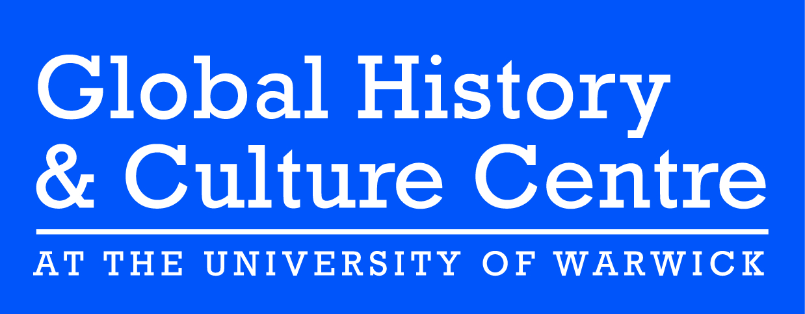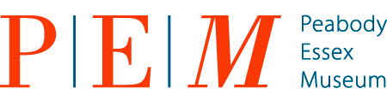
Participants

Susan Bean, Peabody Essex Museum
Maxine Berg, University of Warwick
Amy Bogansky, Metropolitan Museum
Dennis Carr, Museum of Fine Arts, Boston
Karina Corrigan, Peabody Essex Museum
Sarah Fee, Royal Ontario Museum
Marybeth De Filippis, Independent scholar
Dan Finamore, Peabody Essex Museum
Caroline Frank, Brown University
Nonie Gadsden, Museum of Fine Arts, Boston
Anne Gerritsen, University of Warwick
Christina Hellmich, Fine Arts Museums of San Francisco
Suzanne Hood, Colonial Williamsburg
Dana Leibsohn, Smith College
Jean Michel Massing, University of Cambridge
Amelia Peck, Metropolitan Museum
Ruth Phillips, Carleton University
Elena Phipps, Metropolitan Museum
Donna Pierce, Denver Art Museum
Meha Priyadarshini, Columbia University
Giorgio Riello, University of Warwick
William Sargent, Independent curator
Kate Smith, University of Warwick
Paula Richter, Peabody Essex Museum
Karen Kramer Russell, Peabody Essex Museum
Melinda Watt, Metropolitan Museum

This event is sponsored by a grant from the Arts and Humanities Research Council (UK). This grant supports a two-year international academic partnership exploring global commodities and the material culture of early modern connections, 1400-1800.

