 |  | 

Courts and Luxury in the Early Modern World
20-21 June 2011
Held at European University Institute, Department of History and Civilization, Villa Schifanoia, Florence

organized by
The Warwick Global History and Culture Centre, Monash University
and the European University Institute,

Monday 20 June 2011

10.00-10.15 Introduction

10.15-12.15 Session 1. Production for the Courts.
Chair: Giorgio Riello (University of Warwick)
10.15-11.00 Anne Gerritsen (Warwick University), ‘The Material Culture of the Yuan Court’
11.00-11.30 Coffee Break
11.30-12.15 Guido Guerzoni (Bocconi University, Milan), ‘Make or Buy? The economic Impact of Este Manufactures in the Sixteenth Century’

12.15-13.45 Lunch

13.45-18.00 Session 2. Gifts and Embassies
Chair: Luca Molà (European University Institute)
13.45-14.30 Adam Clulow (Monash University), ‘Gifts for the Shogun: The Dutch East India Company, Global Networks and Tokugawa Japan’
14.30-15.15 Sarah Bercusson (York St John University) ‘Gift-giving and the Female Consort: The Creation of Courtly Networks’
15.15-16.00 Susie Protschky (Monash University), ‘Maintaining the Lustre of the Golden Age: Tales for Tourists in Dutch and Danish Museum Collections of Courtly and Colonial Gifts’
16.00-16.30 Coffee Break
16.30-17.15 Stephen McDowall (Warwick University), ‘Commodore Anson’s (1697-1762) Cantonese Porcelain and Two Competing Histories of a Diplomatic Exchange of 1743’
17.15-18.00 Margot Finn (Warwick University), ‘Rejecting the Princely Gift: Public and Private in East India Company Exchange’

Tuesday 21 June 2011

9.30-13.00. Session 3. The Material Culture of the Court
Chair: Giulia Calvi (European University Institute)
9.30-10.15 Isabelle Paresys (Université de Lille), ‘Luxury Dress at Court in Early Modern France’
10.15-11.00 Susan Strong (Victoria and Albert Museum), ‘New Year at the Mughal Court’

11.00-11.30 Coffee Break

11.30-12.15 Hannah Greig (University of York), ‘Faction and Fashion: The Sartorial Politics of Court Dress in Eighteenth-Century England’

12.15-13.45 Lunch

13.45-16.45. Session 4. Collecting and Exotica
Chair: Maria Giuseppina Muzzarelli (University of Bologna)
13.45-14.30 Leah R. Clark (Alfred University), ‘Pawning and Exchange in the Italian Courts: The Circulation and Replication of Gems and Jewels in the Quattrocento’
14.30-15.15 Raffaella Morselli (University of Teramo), ‘Ferdinando Gonzaga and his Museum: Trade and Collections of Exotic Objects in Mantua in the Seventeenth Century’
15.15-15.45 Coffee Break

15.45-17.00 Final Roundtable followed by drinks and dinner

Participants

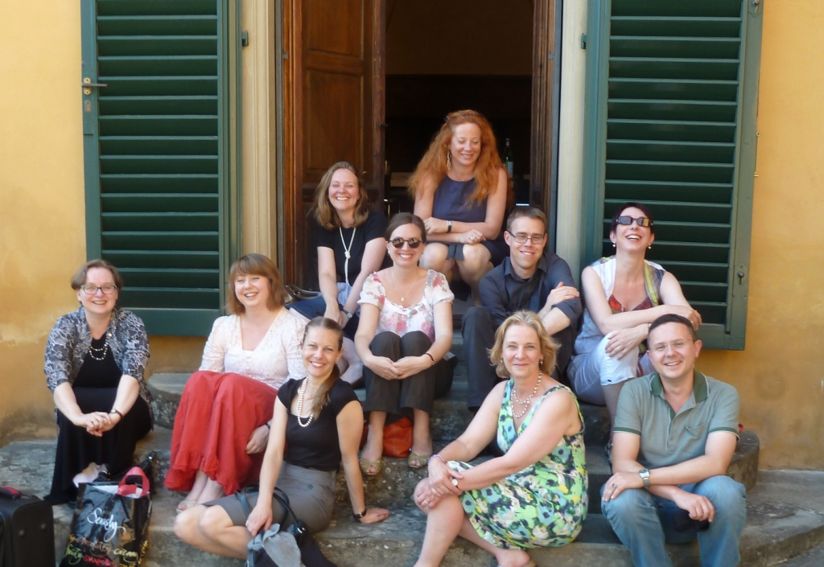

Sarah Bercusson sarahbercusson@hotmail.com
Giulia Calvi giulia.calvi@eui.eu
Leah R. Clark leah.clark@mail.mcgill.ca
Adam Clulow adam.clulow@monash.edu
Margot Finn m.c.finn@warwick.ac.uk
Anne Gerritsen a.t.gerritsen@warwick.ac.uk
Hannah Greig hannah.greig@york.ac.uk
Guido Guerzoni guido.guerzoni@unibocconi.it
Stephen McDowall s.j.mcdowall@warwick.ac.uk
Giuseppina Muzzarelli maria.muzzarelli@unibo.it
Luca Molà luca.mola@eui.eu
Raffaella Morselli rmorselli@unite.it
Isabelle Paresys isabelle.paresys@univ-lille3.fr
Susie Protschky susanne.protschky@monash.edu
Giorgio Riello g.riello@warwick.ac.uk
Susan Stronge s.stronge@vam.ac.uk

