=======================================================================
Reactions from the twittersphere (with thanks to Neil Evans for collecting them and adding translations where necessary)

Uni of Wales Press

@UniWalesPress 21 Nov
Out now! We are proud to announce the publication of ‘Towards Modern Nationhood: Wales and Slovenia in Comparison, c. 1750-1918’ by Robin Okey. This book compares how two underdog peoples shaped their modern national identities.
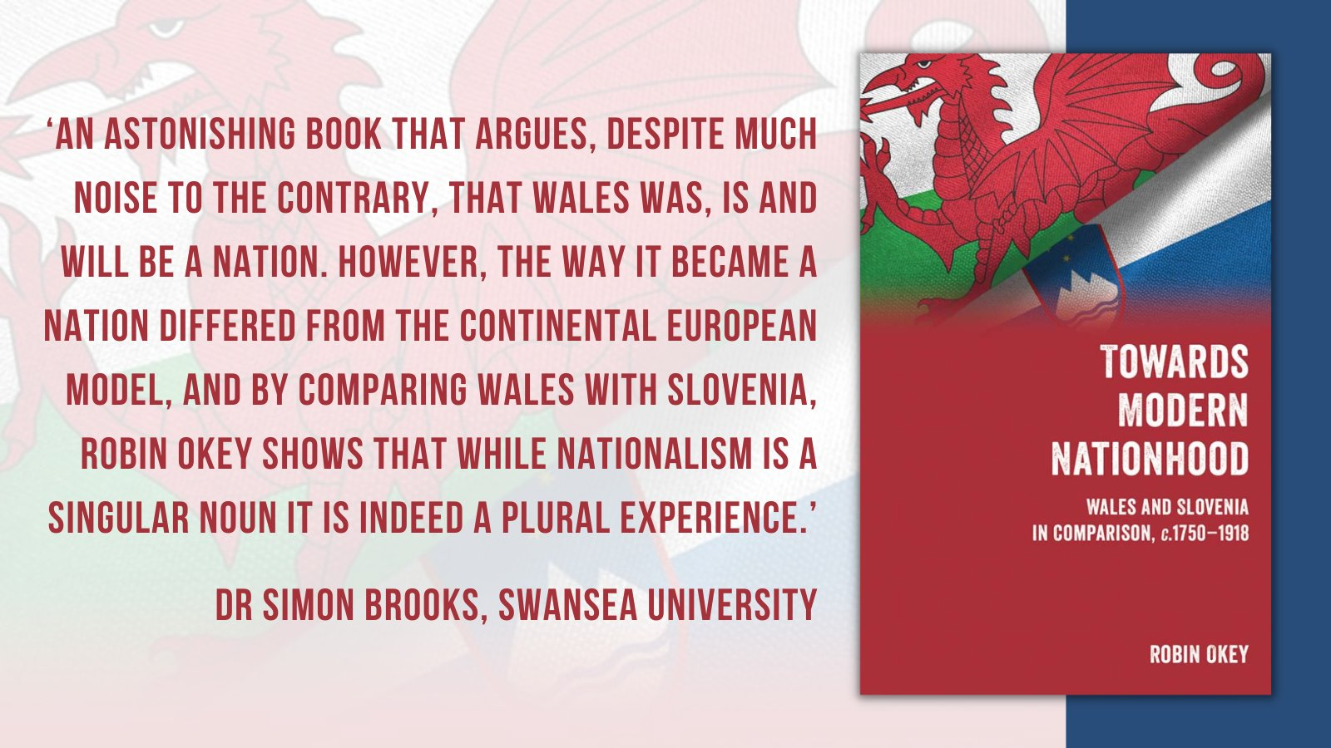
----------------------------
Neil Evans
@NeilevansEvans
·
15 Dec
Very sad to announce the death of Robin Okey, a fine historian of Eastern Europe and of Wales. His superb book 'Towards Modern Nationhood' which compares Wales and Slovenia 1780-1914 has just been published. It will cement his high reputation.

Nest
@Nest33445439

I am sorry to hear that. I have one of his books on a to read pile somewhere . . . 'Eastern Europe: from feudalism to communism'. It looks good.
8:44 pm · 15 Dec 2023
·
168
View

Neil Evans
@NeilevansEvans·
15 Dec
All his work was excellent. He was a diffident man who didn't really believe that.

Paul O'Leary
@olearypaulb
·
15 Dec
Very sad news, indeed. [Paul is Sir John Williams Professor of Welsh History at Aberystwyth, Emeritus]

Richard Owen

@Mechell_RO
·
16 Dec
Trist iawn. I first met him at the Eisteddfod in Rhydaman in 1970, and at various Eisteddfodau since then, and always had very interesting conversations. I look forward to reading his book on Wales and Slovenia. [Very sad. Ammanford.]

Y Brython Newydd
@CymryLloegr
·
15 Dec
Very, very sad to hear this, Neil. I last spoke to him about 2-3 weeks ago to congratulate him on his superb book. He showed immense fortitude in very difficult circumstances to bring it out. I have sent you a private message via DM.

Neil Evans
@NeilevansEvans

I had some email conversations about it and my friend Chris Read did a great deal to help him see it through the press. Chris sent me the news.
9:16 pm · 15 Dec 2023
·
164
Views

Richard Wyn Jones
@RWynJones

That's very sad news, Neil. 5:43 pm · 16 Dec 2023
·
145
Views

---------------------------------------------------

Uni of Wales Press

@UniWalesPress

UWP are very sad to hear of the passing of Professor Robin Okey https://uwp.co.uk/professor-robi

GwasgPrifysgolCymru
@GwasgPrifCymru

4h
Mae GPC yn drist iawn i glywed am farwolaeth Yr Athro Robin Okey https://gwasgprifysgolcymru.org/yr-athro-robin

Y Brython Newydd (Dr Simon Brooks)
@CymryLloegr
·15 Dec
Shocked to hear of the death of Robin Okey who was a towering figure as a Welsh and east European historian. He showed both fortitude and bravery in bringing his book - on the national movements of Wales and Slovenia - to publication (only last month) in difficult circumstances.

Y Brython Newydd
@CymryLloegr
·
15 Dec At a personal level, I am hugely grateful to Robin Okey for his immense personal kindness towards me. When going home to London, I tried to break the journey to see him in Kenilworth, and it was a joy to be in the company of a man of wisdom and humanity who contributed so much.

@WiniDavies@toot.wales

@WiniDavies

Dwi ddim yn arbenigwraig yn y maes ond roeddwn i'n nabod gwaith Robin Okey. Biti mawr

[I am not a specialist in the field I know the work of Robin Okey. Great pity. Winfred is Professor Emerita of German at Aberystwyth]

Y Brython Newydd
@CymryLloegr
·
17 Dec
Ydy, mae'n golled enfawr. Mae ei lyfr diweddaraf - am Gymru a Slofenia - yn dda iawn hefyd. [Yes it’s massive loss. His last book – about Wales and Slovenia is very good as well]

Y Brython Newydd
@CymryLloegr
·
15 Dec
Cyfraniad mawr Robin Okey fel hanesydd oedd ei allu i weld cenedlaetholdeb mewn cyd-destun cymharol, gan awgrymu'n gynnil ffyrdd posib ymlaen i genedl y Cymry. Yn frodor o Gaerdydd, roedd yn byw yn Kenilworth, nid nepell o gampws Prifysgol Warwick lle bu'n Athro mewn Hanes.
[The great contribution as a historian was to enable the seeing of nationalism in a full comparative context, subtly suggesting possible ways forward for the Welsh nation
A native of Cardiff who was living in Kenilworth. Not far from the Warwick University campus where he was a professor of history.]

