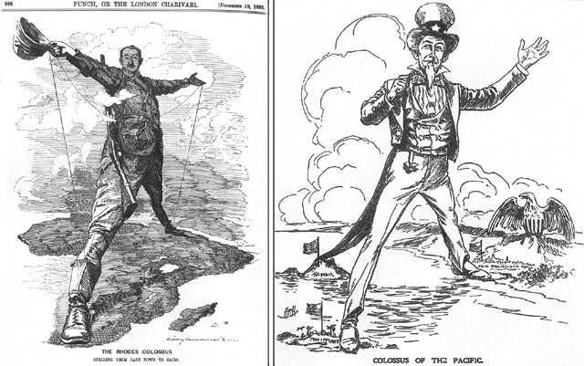 | Political Cartoon: ‘The Rhodes Colossus’, Punch, 1892 (commemorating the establishment of a telegraph services between South Africa and Egypt).
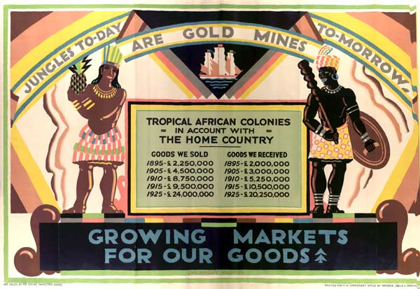 |  | Poster: ‘Jungles to-day are gold mines to-morrow’ London 1927
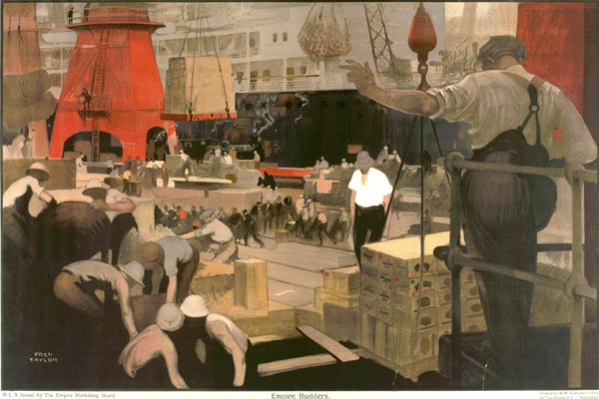 |  | Poster: ‘The Empire Builders’, London 1927

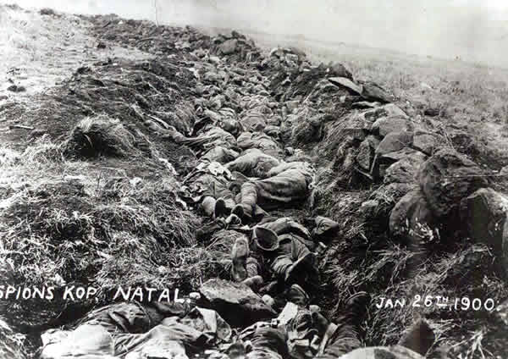 | British Casualties, Natal, Boer War 1900.
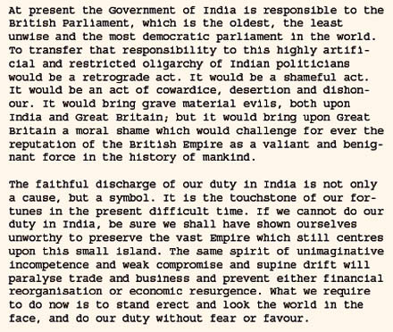 | Churchill, Speech on India , 1931
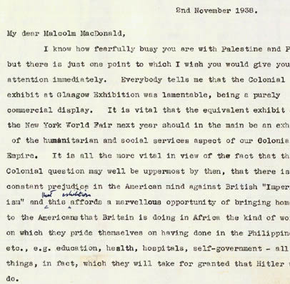 | Letter written in 1938 commenting on the work of the British empire
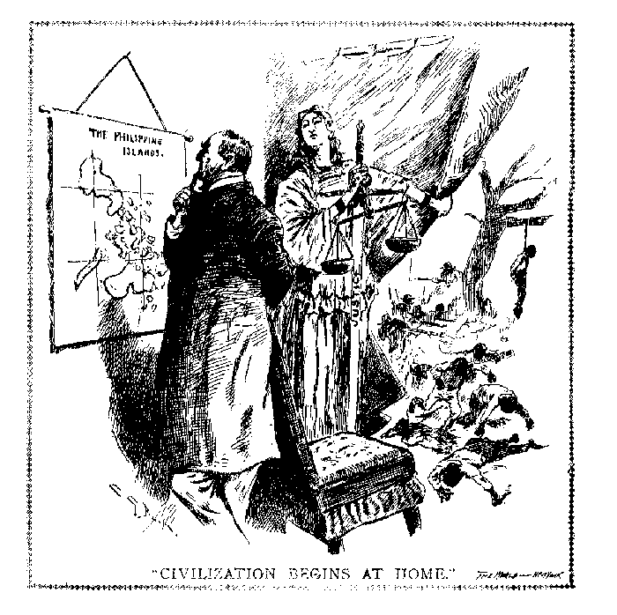 | "Civilization Begins at Home," New York World, reprinted Literary Digest, November 26, 1898.

