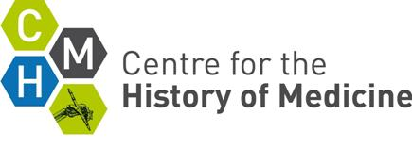
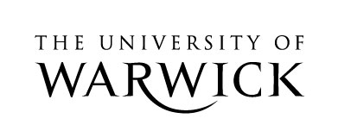
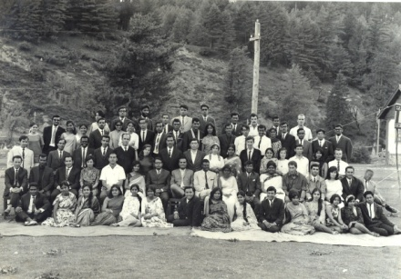

The Problem of Power

University of Warwick
6 October 2011

The Cross, Kenilworth

Evening Meal

The Evening Meal for the ‘Problem of Power’ will be held at 8PM, The Cross in Kenilworth, 6 October 2011.

The 3-course meal will be £30 per head (including 2 glasses of wine).

Please choose from the options below and email your choices to t.horton@warwick.ac.uk

Starters
Potted prawns, whole meal bread
Chicken liver & wild mushroom pate, date chutney, Melba toast
Goats cheese panna cotta, Chevre, Pequillo peppers, crostini - V

--
Main Courses
Fillet of salmon, crushed new potatoes, prawn salsa
Chicken breast, bacon wrap, thyme mash, wild mushrooms, garlic cream
Wild mushroom crumble, rocket & parmesan salad V

Desserts
Treacle tart, Cardamom cream, lemon curd kulfi
Ice cream & sorbets, white and dark chocolate cookies
--
Payment of £30 will be required to secure a place.
By 22 July 2011, send a cheque payable to:
Sarah Hodges, Department of History, University of Warwick, Coventry, CV4 7AL

Name: ………………………………………………………………………………………………….

Starter Choice: ……………………………………………………………………………………………………

Main Course Choice: …………………………………………………………………………………………..

Dessert Choice: …………………………………………………………………………………………………..

--

Any dietary requirements:

………………………………………………………………………………………………….

The Cross at Kenilworth’s website: http://www.thecrossatkenilworth.co.uk/

