London Travel information and Hotel Location

The Bedford Hotel, 83-95 Southampton Row, London WC1B 4HD, +44 (0)20 7636 7822

Travel to the Hotel via the Underground from Heathrow, Russell Square station on the Piccadilly Line is close to all the hotels and stops at Heathrow Airport, Covent Garden, Leicester Square, and Knightsbridge (Harrods).
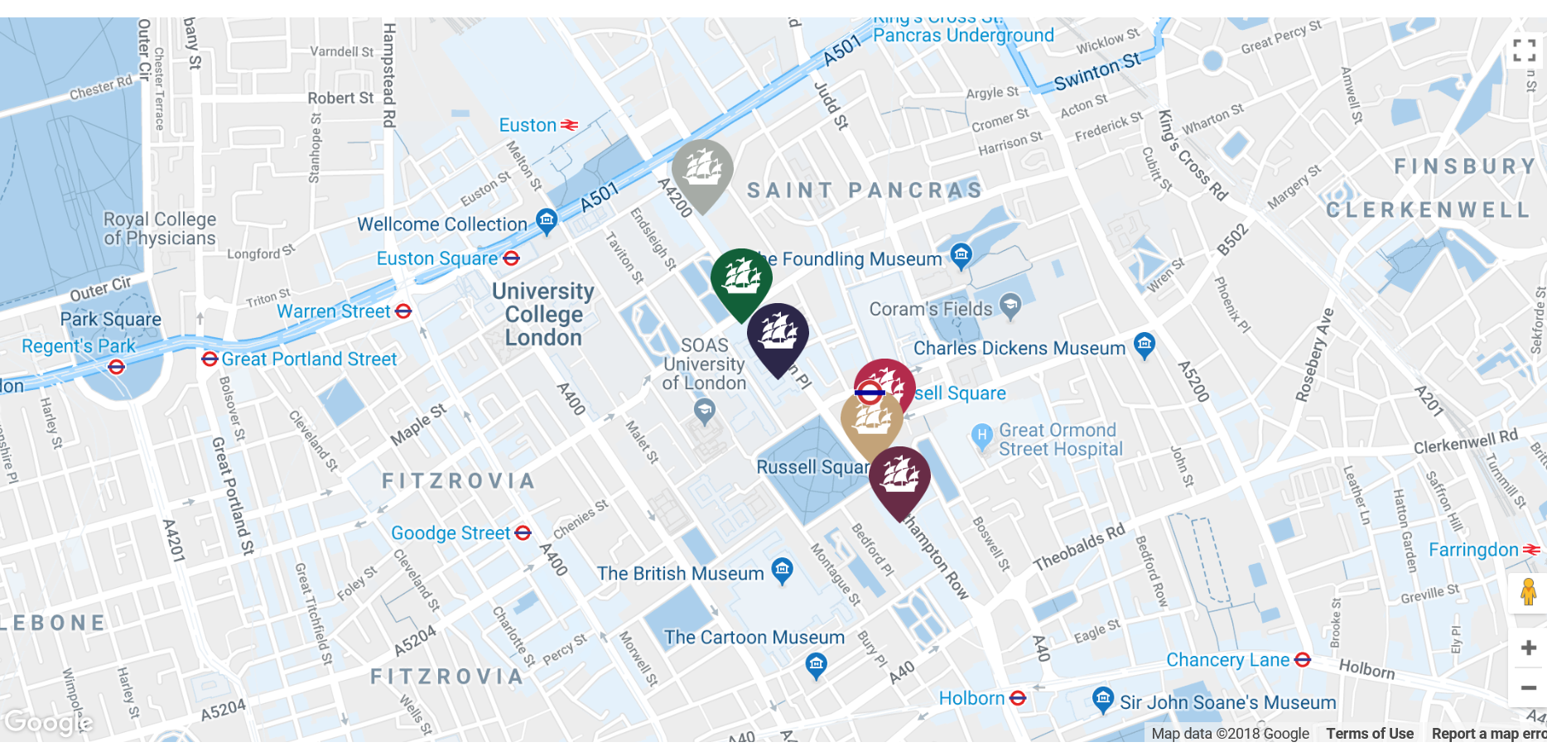
The Bedford Hotel

Station to get off at Russell Square
LONDON TUBE

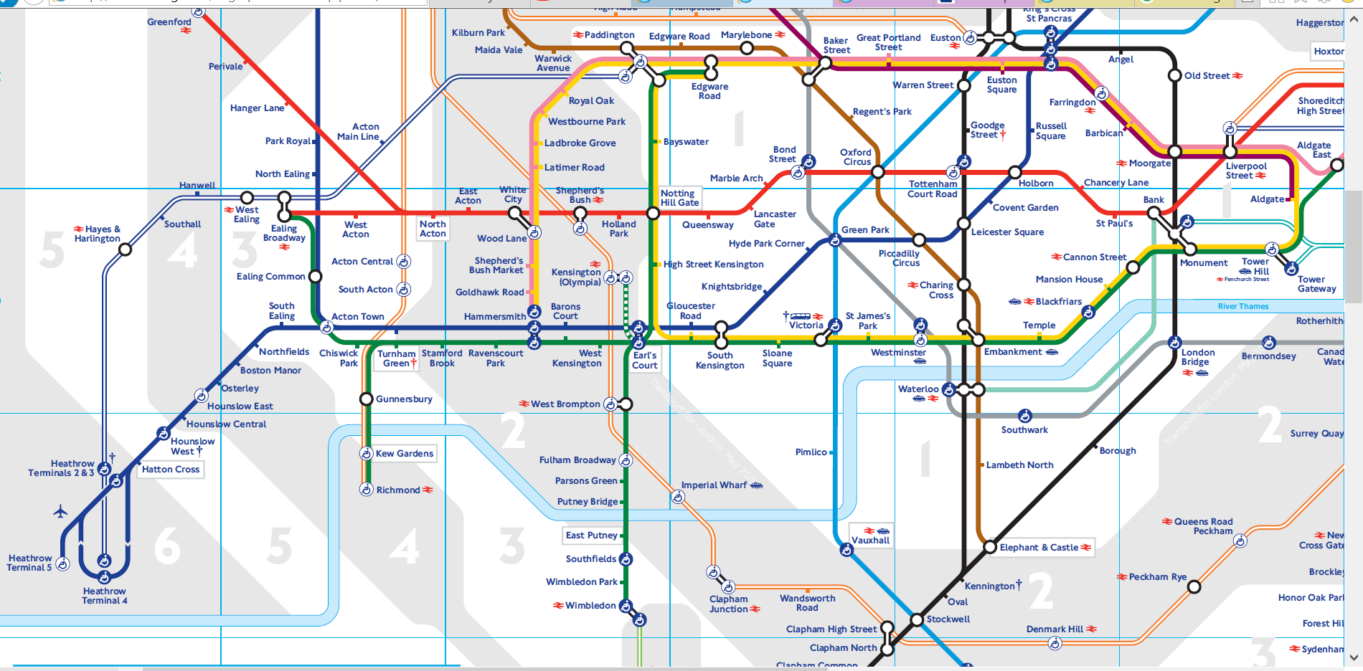
Piccaddilly Line at Heathrow Airport

Travelcards
Travelcards allow you to make as many journeys as you like on bus, Tube, tram, DLR, London Overground, TfL Rail and National Rail services in London.
Day Travelcards, Group Day Travelcards and 7 Day Travelcards are available:
- Online from the TfL Visitor Shop or from VisitBritain shops before you arrive in London
- From Tube station ticket machines
- At London Overground and TfL Rail station ticket offices
- Most National Rail stations
- TfL Visitor Centres

Day Travelcard
Day Travelcards are issued as paper tickets and allow unlimited travel in a single day within the zones they are valid for.
Depending on the time of day you travel, different types of Day Travelcard are available:
- Anytime Day Travelcards - can be used for the whole day (using the date printed on the ticket), and for journeys starting before 04:30 the following day
- Off-peak Day Travelcards - valid from 09:30 (Mondays to Fridays) or any time on weekends and public holidays on the day of travel (using the date printed on the ticket), and for journeys starting before 04:30 the following day
Day Travelcard or pay as you go?
Pay as you go with daily capping is cheaper than buying a Day Travelcard when you travel in Zones 1-9.

Contactless payment cards

Most credit, debit and charge cards displaying the contactless symbol can be used for adult rate pay as you go travel on London's public transport. Android Pay and Apple Pay are also accepted.
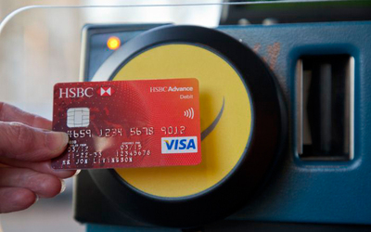
Benefits of contactless
- It's quick and easy - there's no need to queue to buy a ticket
- It offers great value - pay as you go with contactless is cheaper than buying single tickets and you can benefit from both daily and weekly (Monday to Sunday) capping
Overseas transaction fees or charges may apply for non-UK cards. This will be one charge per day, not each time you travel. Please check with your card issuer.

Oyster card
If you don't have a contactless payment card or a Visitor Oyster card, you can get a standard Oyster card in London. You pay a £5 deposit (refundable) then add pay as you go credit or a Travelcard to pay for your journeys.
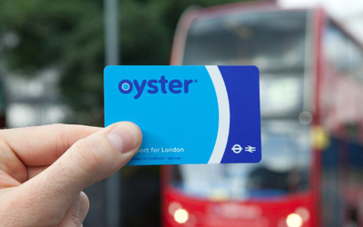
You can get an Oyster card from:
- Tube, London Overground, TfL Rail and some National Rail stations
- Around 3,900 local shops in London, known as Oyster Ticket Stops. Find your nearest one
- TfL Visitor Centres
- Online (UK visitors only)
Benefits of Oyster
- It offers great value - pay as you go is cheaper than buying single tickets and you can benefit from daily capping
- It's convenient - if you are staying for a week or longer and using public transport every day, you can add a Travelcard to your Oyster card, which can save you time and money
Find out more about Oyster cards.

