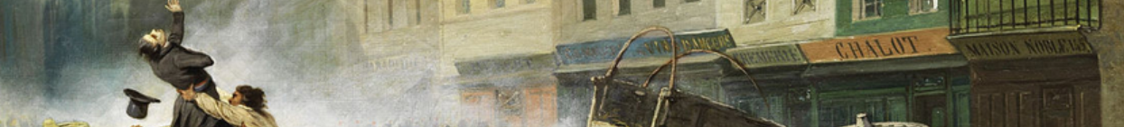
Barricades
Methods, Styles and Dynamics of Contention
A workshop on changing forms of protest in Restoration Europe 1815-1850
May 17th 2019 Wolfson Exchange 10.00-5.15
10.00 Coffee - 10.20-10.45 Introduction: Mark Philp
10.45-11.45 Spain: Florencia Peyrou, tbc /Rosie Doyle: Spanish Pronunciamientos 1820-1831: Riego and Torrijos
11.45-12.45 Netherlands and Britain: Maarte Janse: Scaling up? Mass petitions, mass organizations, mass meetings in Britain and the Netherlands, 1815-1850/Katrina Navickas ‘1819 - a turning point or a hiatus in developing dynamics of contention in Britain?’
12.45-1.30 Lunch
1.30-3.00 France, Rome, the Ionian Islands: Francesco Buscemi: "Prying on the Exiles. Mazzini's opened mail and the British Freedoms"/Alessandro Capone: " Barricades of a nation: narratives and counter-narratives of resistance during the French siege of Rome in 1849"/Aggelis Zarokostas: Following the ‘mongrel minister’: Ioannis Capodistrias and the collection of information by British authorities in the Ionian Islands, 1815-1822
3.00–3.15 Tea
3.15-4.15 Revolutionaries, Women, and Theatre: Philippe Le Goff: ‘Blanqui’s theory of mass mobilisation’/Amal Malik: 'Women in Cartoon and Caricature: Contesting power between 1815-1850’/Kate Astbury: ‘Politics of Theatre’
4.15-5.15 Concluding discussion
For refreshments and lunch – please contact (with dietary prefs) T.Smith.2@warwick.ac.uk

