‘Reformation, Politics & Rebellion’

Dissemination of Reformation Ideas
Lecture Autumn Week 10

Introduction: The Reformation as a media event

1. Oral dissemination
- Preaching the Word of God: most effective in largely illiterate society (Scribner); sermon message appears quite coherent and focused on Lutheran doctrine (Moeller)
- Other forms of oral communication: reading aloud; tavern debates like that involving ‘peasant-priest’ Nikolaus Schweigker at Memmingen 1524; plays & songs
Prominent preachers include Martin Luther (Wittenberg), Huldrych Zwingli (Zurich), Martin Bucer and Matthäus Zell
(Strasbourg), Andreas Osiander (Nuremberg), Christoph Schappeler (Memmingen); examples of lay preachers: Johannes Zymler
, Diepold Beringer (Nuremberg, aka ‘Peasant of Woerd’
)

2. Direct action
- Iconoclasm: startling removal of images (Wittenberg, Ghent) prompts controversy
- Education: but was the Reformation impact really as significant as long thought?
Idolatry; Andreas Karlstadt, On the Removal of Images (Wittenberg 1522); Luther’s Invocavit sermons and To the Councilmen of All Cities in Germany (1524); schools in Hesse, Württemberg, Strasbourg

3. Visual messages
- Medieval tradition and popular appeal via use / inversion of established symbols
- Challenges and dangers: simplification, negative emphasis, misunderstandings
- Protestant iconography and propaganda was polarizing, polemical & powerful
Pope Gregory the Great; Hans Baldung Grien; multi-talented Luther friends Lucas Cranach the Elder 1472-1553 & the Younger 1515-86; Barthel Beham, Erhard Schön and other woodcut artists

4. Written communication
- Germany as a centre of printing offered synergies between reformers & printers
- Many different types of printed materials from Bibles via pamphlets and catechisms to flysheets; 300,000 copies of Luther’s works in circulation in early 1520s
English martyrologist John Foxe; pamphlet writers include lay people like shoemaker Hans Sachs

Conclusions
- Cultural significance of the Reformation as an unprecedented multimedia campaign
- Combination of oral/musical, ‘tangible’, visual and written forms of dissemination
- Challenge of heterogeneous and conflicting messages
- The early sixteenth century as a watershed in the history of mass communication

Blickle, Peter et al. (eds.), Macht und Ohnmacht der Bilder [Power and Impotence of Images] (2002)
Brown, C. B., Singing the Gospel: Lutheran Hymns and the Success of the Reformation (2005)
Edwards, M. U., Printing, Propaganda and Martin Luther (1994)
Ehrstine, G., Theater, Culture and Community in Reformation Bern 1523-55 (Leiden, 2003)
Michalski, S., The Reformation and the Visual Arts (1993)
Scribner, B., ‘Popular Piety & Modes of Visual Perception’, in: Journal of Religious History 15 (1989)

BK 12/24
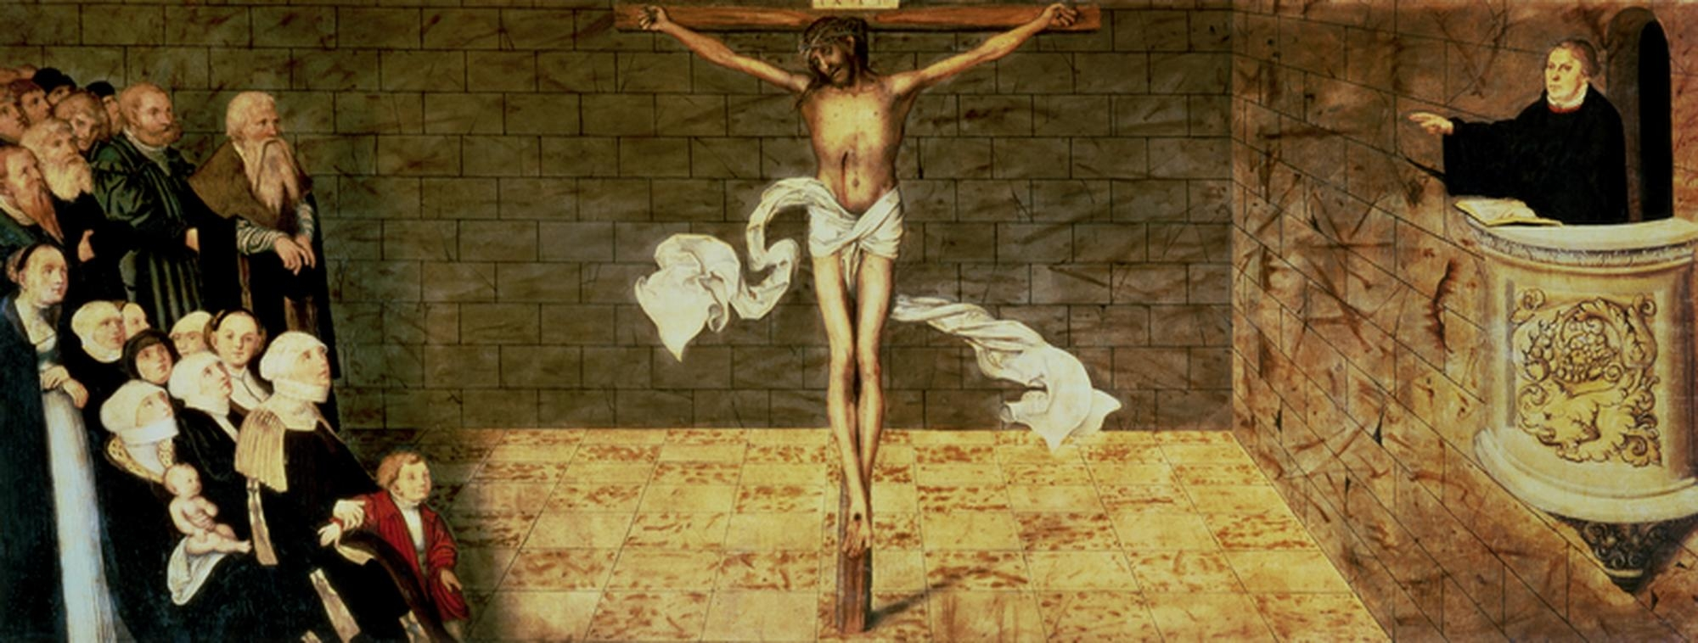

Lukas Cranach the Elder, ‘Luther Preaching’ (before 1539)

‘The age of the Reformation constitutes a landmark in the history of the image. For the first time pictures were used as weapons, above all by the Protestants, who developed illustrated broadsheets and pamphlets as a medium of mass communication. Combining texts and pictures made it possible to convey messages of high complexity ... In most cases the pictures of the pamphlets and broadsheets are no mere illustrations but communicate the intended content.’
C.-P. Warncke, ‘Bildpropaganda der Reformationszeit [Visual Propaganda in the Reformation], in: B. Stollberg-Rilinger & T. Weißbrich (eds), Die Bildlichkeit symbolischer Akte (2010), pp. 185-97, 197
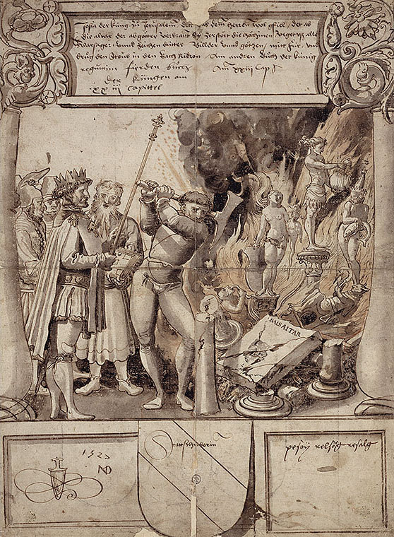
Niklaus Manuel, ‘King Josias destroying the idols’ (Ink draft for glass window, 1527)

