‘Reformation, Politics & Rebellion in 16thC Germany’

The Political Landscape of the Holy Roman Empire

‘Lecture’ Handout for Autumn Week 2

1. Introduction to the Module

- Significance of Reformation; Luther’s impact; module structure and themes; website: http://go.warwick.ac.uk/germanyreformation

2. The Holy Roman Empire of the German Nation

- Definition: Origin 800, Golden Bull 1356; end 1806; bonds of religion, feudal ties, Diet
- Political geography: borders, c. 400 units; Character: ‘failed nation state’, ‘Europe of Regions’, ‘federation’, ‘complementary Empire-state’ (Georg Schmidt)? Very fragmented
- Membership: composed of ‘estates’ (Reichsstände); 3 levels of political activity: Empire, territory, region/locality; 2 ways of belonging: immediate vs intermediate links to centre
- Political life: elected Emperor; limited feudal/personal powers; great variety of secular and ecclesiastical rulers; monarchies and republics; no modern/individual political rights, but popular influence esp. in towns, villages and (Swiss/Hanseatic) leagues

Terms, names and dates: Charlemagne; feudal ties (Lehensverband); Imperial Diets (Nuremberg, Regensburg, Augsburg); immediate (reichsunmittelbar) vs intermediate (reichsmittelbar) members; Habsburg dynasty; electors of Mainz, Trier, Cologne (=ecclesiastical princes) and Bohemia, Saxony, Brandenburg, Palatinate (secular); Hansa, Swabian League; Imperial Free Cities; Hartmann Schedel.

3. Political Developments

- Foreign policy: two flashpoints (Habsburg vs Valois rivalry, Ottoman threat)
- Domestic policy: pressure for reform; major decisions on public peace, imperial cameral court & common penny (Worms Diet 1495); processes of juridification/territorialization
- Historiography: from ‘nationalist’ critique to recognition / appreciation of achievements

Terms, names and dates: Peace of Cateau Cambrésis 1559; Reformatio Sigismundi 1438; Berthold von Henneberg; Matricular System; Imperial Regency; Imperial Criminal Code (Carolina, 1532); Imperial Circles; Imperial Aulic Council; ‘juridification’ of Empire (Volker Press); territorial sovereignty (Landeshoheit); Voltaire; Karl Otmar Freiherr von Aretin; Michael Hughes/Peter Wilson

4. Conclusions
- Highly complex and fragmented structure of the Holy Roman Empire
- Imperial, territorial and regional / local layers of political activity
- Mix of secular and ecclesiastical rulers as well as monarchical / republican regimes
- Popular influence (local communes / petitions / rebellions)
- Constant foreign policy preoccupations relating to Valois / Ottoman conflicts
- Strong pressure for reform and balance of power shifting from Emperor to princes
- More positive assessment of Empire in recent historiography

Quotes
‘[your image is] not rendered according to the content of our command and according to the exemplar that you have in your hand … so that we are greatly displeased’: cited in L. Silver, Marketing Maximilian, 2008, p. 84.

‘The growing unwillingness to jeopardize a case by premature use of force encouraged acceptance of norms specified in imperial law, thus helping to preserve the existing constitutional structure.’ P. Wilson, Empire, 47.

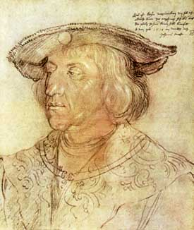
Albrecht Dürer, ‘Emperor Maximilian’ (1518)

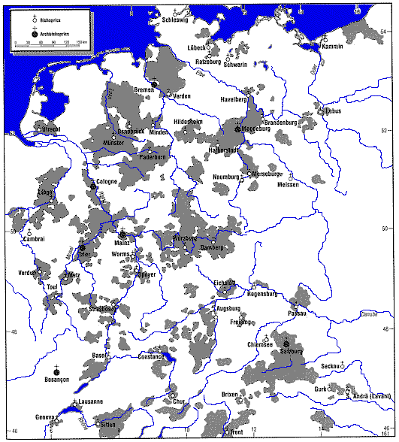
Hans. J. Hillerbrand (ed.), Oxford Encyclopaedia of the Reformation (1996), iv. 333
BK 10/2024

