‘Reformation, Politics & Rebellion’

Lutheran Liturgy and Rituals

Lecture Autumn Week 9

1. A new religious culture
- From theory to practice: signalling theological change in worship and rites of passage
Preaching, religious books (A Short Form of ….. 1520), church ordinances, visitations
- Enhanced lay role: priesthood of all believers; household religion; vernacular Bible
- Revised calendar: reduction of feast days; abolition of ‘religious’ fasting periods
- Church architecture: stronger focus on pulpit but no radical iconoclasm as in Zurich
- Protestant art: Karlstadt vs Luther; link between art/Eucharistic theology; general decline
- Popular culture: more restrictions & closer supervision but much negotiation in practice
Catechumens; Hauskirche (‘house church’; Patrice Veit); Corpus Christi; Castle Hartenfels at Torgau (architect Nickel Gromann); preaching/‘hall’ churches; Andreas Karlstadt; Peter Burke, ‘Triumph of Lent’; Jean Delumeau

2. Liturgy and rituals as communication media
- Emphasis on Scripture/pulpit (rather than sacrifice/altar) to spread the word of God
- Endorsement of church music: Luther acknowledges its positive emotional power; supports singing of Psalms and hymns (in contrast to ‘Reformed’/Zwinglian attitudes)
- Sacraments: Baptism (entrance into community), Lord’s Supper (in German / 2 kinds)
- Rituals as life-cycle ‘rites of passage’: marriage rather than celibacy as the new ideal; disciplinarian emphasis in burial customs but resilience of custom/tradition/social display; place all hope in God’s grace and your faith; emergence of Luther ‘cult’ at Wittenberg
Congregational singing; Johann Sebastian Bach; Reutlingen 1524; Elector Joachim II of Brandenburg; Johannes Bugenhagen; Philipp Melanchthon; Gerlacus Bonnus of Lübeck 1548; rise of funeral sermon

Conclusions
- Introduction of vernacular services and acceptance of fewer sacraments
- Moderate changes in liturgy & church interiors (in contrast to ‘Reformed’ confession)
- Rituals can serve as ‘signals’ of new doctrines & as instruments of ‘social control’
- At best partial ‘purification’ of popular culture (which retains different priorities)

References
Luther, German Mass (1526): http://www.iclnet.org/pub/resources/text/wittenberg/luther/germnmass-order.txt

Bergmann, R., ‘Luther’s attitude to the question of images’, Renaissance and Reformation, 17 (1981)
Christensen, Carl, Art and the Reformation (1979)
Karant-Nunn, S., The Reformation of Ritual: An Interpretation of Early Modern Germany (London, 1997)
Koslofsky, C., The Reformation of the Dead: Death and Ritual in Early Modern Germany 1450-1700 (Basingstoke, 2000)
Michalski, Sergiusz, The Reformation and the Visual Arts (1993)
Palmer Wandel, L., The Eucharist in the Reformation: Incarnation and Liturgy (Cambridge, 2006)
Roper, L., ‘“Going to church and street”: Weddings in Reformation Augsburg’, in: Past and Present 106 (1985), 62-101
Safley, T. M., ‘Let no man put asunder’: The Control of Marriage in the German Southwest: A Comparative Study 1550-1600 (Kirksville, 1984)
BK 11/24
‘A Mighty Fortress is Our God’
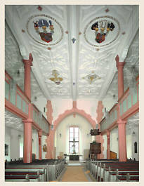
By Martin Luther (trans. F. H. Hedge)

A MIGHTY fortress is our God,
A bulwark never failing;
Our helper he, amid the flood
Of mortal ills prevailing.
For still our ancient foe
Doth seek to work us woe;
His craft and power are great;
And, armed with cruel hate,
On earth is not his equal.

Did we in our own strength confide,
Our striving would be losing —
Were not the right man on our side,
The man of God’s own choosing.
Dost ask who that may be?
Christ Jesus, it is he,
Lord Sabaoth his name,
From age to age the same,
And he must win the battle.

From: Hymns of the Christian Church
(Harvard Classics, 1909-14) Holy Ghost Church at Nidda in Hesse (1618)

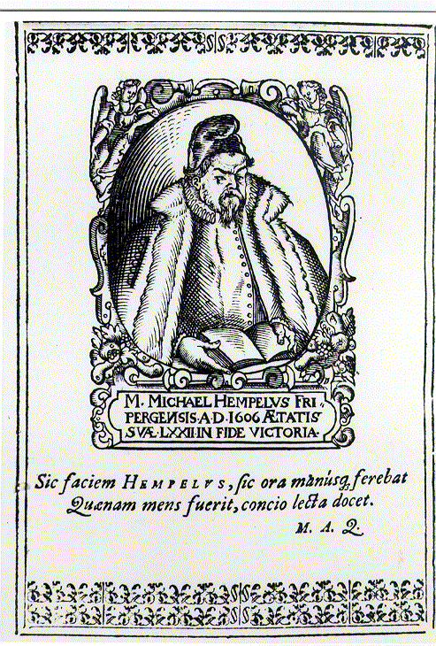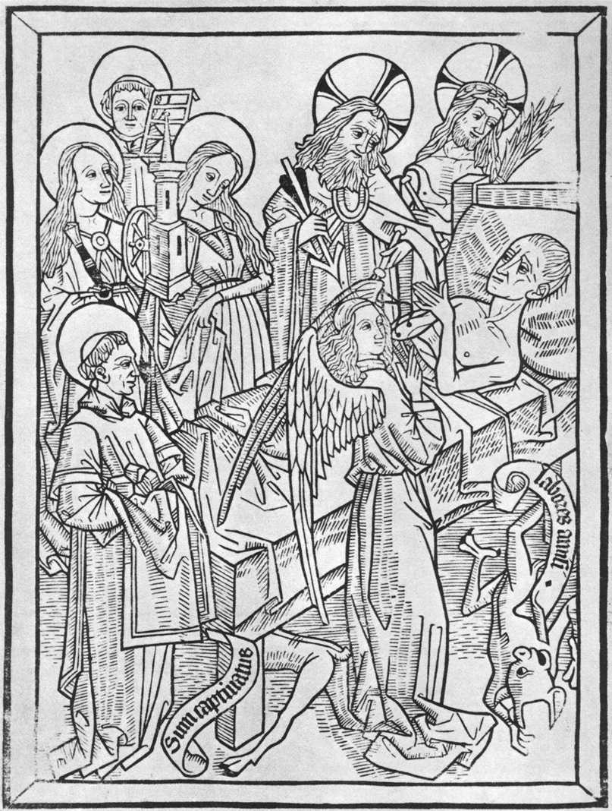

‘Art of Dying’ Woodcut c. 1470 (Washington) Cover page of the funeral sermon
preached for Michael Hempel (d. 1611)

