‘Reformation, Politics & Rebellion’ BK 05/25

Imperial Politics
Lecture Summer Week 23

PART I: Introduction
- ‘[I]t is not possible to understand the development of the Reformation without taking the political dynamic into account’ [Dixon, Reformation in Germany, 128]
- Note the heterogeneous nature of the Holy Roman Empire and the Habsburgs’ potential conflict of interests between their territorial/dynastic & imperial goals

1. Imperial knights and the Reformation
- Challenged by socio-economic (‘agrarian crisis’) and political (state) pressures
- Luther’s appeal to the German nobility (1520) struck a chord / gained support
- The Knights’ War of 1522-23: defeat eroded Lutheran fervour among nobles
Fraternal associations; Franz von Sickingen (d. 1523); Ulrich von Hutten (d. 1523)

2. Emperor Charles V
- Background, political framework and personal character (chivalry, religious zeal)
- Imperial election 1519: Charles sought to contain heresy as well as French rival
- Foreign policy challenges: Ottoman threat, Valois dynasty, Protestant England
- Sense of failure / power abuse triggered abdication: from Charles V to Ferdinand I
‘Capitulation’ 1519; Titian; Francis I (Treaty of Madrid 1526); Peace of Cateau Cambrésis 1559

PART II: Imperial politics c. 1520 - 1555
- Period can be divided into (i) a conciliatory followed by (ii) an aggressive phase
(i): Edict of Worms 1521 followed by religious/diplomatic negotiations
(ii): Threat to Lutheran religion and imperial pressure prompted princes into Schmalkaldic League (1531) & Wars (1546-47, 1552); turning-point for Empire
- Outcome: The Peace of Augsburg 1555 effectively states: cuius regio, eius religio
Diets of Speyer 1526/29 (Protestation of 19 July 1529); Diet / Confession of Augsburg 1530; Colloquy of Regensburg 1541; Philipp of Hesse; Johann Friedrich of (Electoral) Saxony; Bremen, Magdeburg; Duke Heinrich of Braunschweig-Wolfenbüttel; Battle of Mühlberg; Moritz of (Ducal) Saxony

Conclusions
- Imperial knights responded to the Lutheran appeal in a time of crisis
- Charles V’s policies were affected by personal failings and structural problems (‘Of all his crowns, it was that of the Holy Roman Empire – the only one that he had not inherited but had fought to acquire – which brought him the highest prestige but the least power and the most problems’: Blockmans, Charles V, 181).
- The Peace of Augsburg established Lutheranism as an official religion in the Empire

Blockmans, Wim, Emperor Charles V 1500-1558, trans. Isola van den Hoven-Vardon (London, 2002)
Brady, Th. / Cameron, E. / Cohn, H., ‘The Politics of Religion: The Peace of Augsburg 1555. A Roundtable Discussion, in: German History 24 (2006)
Cohn, Henry, ‘Did bribes induce the German electors to choose Charles V as emperor in 1519’, German History 19 (2001), 1-27
McEntegart, Rory, Henry VIII, the League of Schmalkalden and the English Reformation (2002)
Till, Eric (director), ‘Luther’ (Film/DVD, 2003)
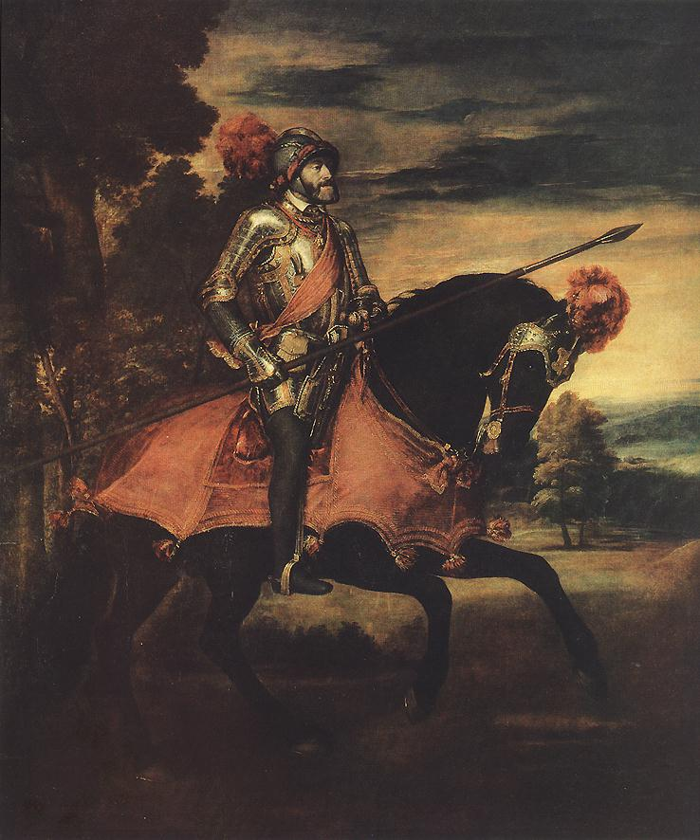
Titian, ‘Charles V at Mühlberg’ (oil, 1548) & Peace of Augsburg with seals (1555)

