‘Reformation, Politics & Rebellion’ BK 05/25

Long-Term Effects
Lecture Summer Week 24

Introduction: Scholarly verdicts on the importance of the Reformation

1. The Reformation in chronological perspective
- End of the Middle Ages? 1517 watershed vs socio-political continuities
- End of the Reformation? Peace of Augsburg 1555 vs longer-term processes
- ‘Runway of modernization’ (Schilling) vs ‘harvest of the Middle Ages’ (Tom Brady) vs ‘westwardly migrant revolution’ (Oberman); Berndt Hamm: ‘innovative event’ situated in other developments; Hillerbrand: evident contemporary impact

2. Religious effects
- Spiritual changes: shift away from sacrificial mass, the ‘dead’ & intermediaries
- Doctrinal fragmentation: the growth of pluralism in European society
Augsburg Confession 1530; Tridentine Decrees 1564; Second Helvetic Confession 1566
- Christianisation (unprecedented religious indoctrination) vs secularisation (loss of claims to absolute truth); in the end a concurrent ‘secularization of the sacral [and] sacralization of the earthly realm’ (Dixon & Schorn-Schütte)

3. Socio-cultural consequences
- Shift in attitudes towards life (social discipline, marriage) & work (divine service)
‘Elective affinity’ between the Protestant ethic and the spirit of Capitalism (Max Weber)
- Disenchantment and rationalization (Weber) vs providence / divine signs
- Growth of critique, (multi-media) mass communication and education
- Reminder of usefulness of scholarly concepts: usually contested but helping us to see underlying issues, distil ‘essence’ of complex processes & advance debates

4. Political impact
- Local: enhanced role for lay individuals and esp. authorities in religious life; dashed hopes for the worldly application of ‘divine law’ and secular freedom
- Territorial: acceleration of state building process in the Empire (enhancement of princely control), but also development of theories of resistance against tyrants
- (Inter-)national: political, constitutional and military conflicts over religious issues; global repercussions through missionary activities and religious refugees
- Some shared issues, but no straight line from Luther to Bismarck and Hitler

Conclusions
- The Reformation was a process of fundamental importance for European history: challenge to religious authority, seeds of pluralism, boost for state formation
- Religious change formed part of a wider set of transformations / modernizations: urbanization, military / scientific developments, technological innovations etc.
- The Reformation proved a success in terms of institutional and long-term impact (something most medieval heretical movements lacked), but it could not transform popular spirituality/mentality overnight (patchy visitation evidence; protracted processes of negotiation; variations depending on contexts)

Ronnie Po-chia Hsia, James Kittelson, Geoffrey Parker, Lyndal Roper, Luise Schorn-Schütte, Gerald Strauss

References
P. Blickle, Die Reformation im Reich [The Reformation in the Empire] (3rd edn, Stuttgart, 2000)
P. Collinson, The Reformation (London, 2003)
B. Hamm, ‘Wie innovativ war die Reformation?’ [How innovative was the Reformation?], in: Zeitschrift für Historische Forschung 27 (2000), 481-97
H. Hillerbrand, ‘Was there a Reformation in the Sixteenth Century’, Church History 72 (2003), 525-52
D. MacCulloch, Reformation: Europe’s House Divided 1490-1700 (London, 2003)
T. Nipperdey, ‘The Reformation and the modern world’, in: E. Kouri; T. Scott (eds), Politics and Society in Reformation Europe (1987), 535-52
H. Oberman, Two Reformations: The Journey from the Last Days to the New World (N. Haven, 2003)
U. Rublack (ed.), The Oxford Handbook of the Protestant Reformations (Oxford, 2017)
R. van Dülmen, ‘The Reformation and the Modern Age’, in: Scott Dixon (ed.), The German Reformation (Oxford, 1999), 193-219

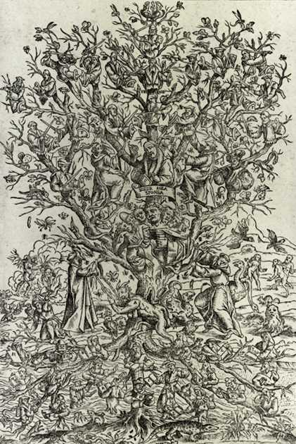

‘Ketzerbaum [Tree of Heretics]’, anonymous woodcut (1589)
https://www.kulturrat.de/wp-content/uploads/2016/04/Dossier_Reformation_1.pdf, p.11 (accessed 13/5/25)

