European World Beat Kümin 10/17

The Social Order

Key Messages: Hierarchy & Inequality, Heterogeneous Groups, Rise of State & Middling Sort

- Social Structure
- Ordering as a historical construct, imposing structure on a dynamic phenomenon
- Early modern society consisted of ‘estates’ or ‘orders’ based on birthright, legal privileges, collective honour and corporate organization rather than of ‘classes’ (determined by economic resources) or ‘individuals’ (equipped with human rights)
- Medieval division into those who pray (clergy), fight (nobles) and work (commoners) further differentiated through occupational diversification, overseas expansion and socio-economic developments (robe nobility, middling sort, marginal groups, slaves …); population growth, price rises and land shortage provoke social polarization in town and country
2. Social Status
- Status conveyed by e.g. lineage, wealth/occupation, office-holding or marriage partners & displayed through e.g. consumption (dress/diet/house), ‘leisure’ activities (hunting, coffee houses), imagery (heraldry, tomb monuments) and positioning (in church, political assemblies and on ceremonial occasions like processions)
3. Social Relations
- Supported by bonds like (personal) feudal ties and patronage systems (facilitated by brokers); transcending social groups, we find many overlapping ‘communities’ of people linked by a common point of reference and/or shared interests such as familial / kinship ties, living in the same locality/neighbourhood, religious beliefs, political affinity, intellectual orientation, common occupations, situational alliances; much evidence for solidarity (poor relief) & sociability (esp. for rites of passage and in churches, guilds, taverns), but mind scholarly critique of seeing them in too harmonious a light;
- Strained by tensions over e.g. precedence, attacks on honour, rights, distribution of resources; discontent over violations of custom, taxation etc triggers various forms of resistance, from ‘weapons of the weak’ like foot-dragging and rumours to open, violent mass rebellion like the English Peasants Revolt (1381) & the Peasants War in the Holy Roman Empire (1524-25)

4. Social Dynamics
- Early modernity witnesses state formation & the rise of ‘middling’ groups / ‘professionals’

Conclusions
- Early modern society consisted of (increasingly differentiated) ‘estates’ defined by variables like function, legal rights and reputation
- Status was displayed, acknowledged and negotiated in various forms of social exchange
- Strong bonds and mutual dependencies coexisted with (periodically erupting) tensions
- Gradual advances made by the ‘middling sort’ created discrepancies between socio-economic and political power (corrected in the American/French revolutions)

Dewald, Jonathan, The European Nobility 1400-1800 (Cambridge, 1996); Dixon, C. Scott; Schorn-Schütte, Louise (eds), The Protestant Clergy of Early Modern Europe (2003); French, Henry R., The Middle Sort of People in Provincial England 1600-1750 (2007); Kamen, Henry, Early Modern European Society (2000); Kümin, Beat, The Communal Age in Western Europe c. 1100-1800 (2013); Scott, Tom (ed.), The Peasantries of Europe: From the Fourteenth to the Eighteenth Centuries (1998);
Withington, Phil, ‘Company and Sociability in Early Modern England’, Social History 32 (2007)
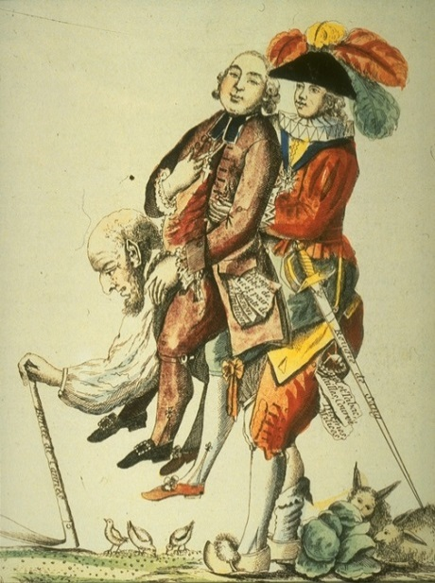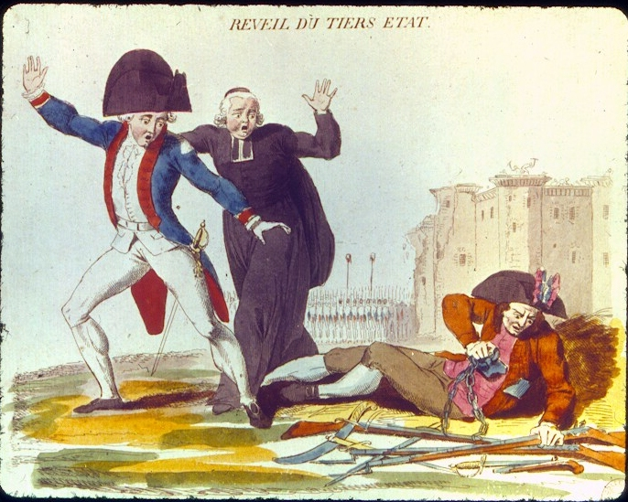
The three estates in the Ancien Régime and the awakening of the common people (French Revolution prints)

‘None shall wear any cloth of gold, tissue, nor fur of sables: except duchesses, marquises, and countesses in their gowns; [none shall wear] silver, tinseled satin or silk …: except all degrees above … baronesses, and other personages of like degrees in their kirtles and sleeves.
[None shall wear] velvet … embroidery or … lace of gold or silver: except all degrees above mentioned, the wives of knights of the Garter and of the Privy Council ...
[None shall wear] satin, damask, or … fur whereof the kind groweth not within the Queen's dominions …: except the degrees and persons above mentioned, or the wives of those that may dispend £100 by the year and so valued in the subsidy book.
No persons under the degrees above specified shall wear any guard or welt of silk upon any petticoat, cloak, or safeguard.’
‘Statute of Apparel’ issued by Elizabeth I in 1574, cited in ‘Elizabethan Era’ (http://www.elizabethan-era.org.uk; accessed 19/10/2010).

In Star Chamber, Giles Dobell of Minhead (Somerset) complained that Robert Heyward and others ‘with force of arms, that is to say with swords and daggers and other weapons … took out Margaret, [my] wife, out of her pew where she was kneeling in the church and brought [her] out into an aisle … against her will and then and there did beat and ill use her.’
Pre-Reformation lawsuit cited in K. French, The Good Women of the Parish (Philadelphia, 2008), 115.

In appearance: Hans Nora, Forester, accused by Uli Schär’s wife of having called her a whore [etc.]. In response, Nora asked for the testimony of witnesses, as he had been full of wine at the time. [3 witnesses are cited, among which the village constable and the landlady Barbara Herren. The constable testified that] upon the woman’s entry to the inn, Nora had exclaimed: out with all whores! … [Then the landlady added that] the plaintiff had also called Nora ugly names. …
Both parties desired a reconciliation … [The court decided that] 1. All slanderous words shall be void … 2. The forester is fined £1 … 3. Mrs Schär is censured for her insolent language’
Extract from the proceedings of the consistory court in the parish of Neuenegg (Swiss Confederation, 1664)
‘Third, until now it has been the custom for us to be regarded as a lord's personal property, which is deplorable since Christ redeemed us all with the shedding of his precious blood.
Eighth, we are aggrieved, especially those that have their own land, because these lands cannot sustain the payments on them, and because these peasants must then forfeit the land and are ruined.’
Extracts from the ‘Twelve Articles’ of the German Peasants (1525): M. Baylor (ed.), Radical Reformation, 231-8.

