‘Reformation, Politics & Rebellion’

Urban Reformation

Lecture Handout Spring Week 18

Introduction
- The Reformation as a social movement affecting both town and countryside
- Elite concerns about consequences of the broad appeal of the ‘Word of God’

1. Historiographical approaches
- The problem of (often indirect) sources: council minutes, wills, court records etc
- Broad scholarly consensus on the importance of the urban reformation
- B. Moeller (imperial cities) / A.G. Dickens (‘urban event’) / C. Close (negotiation)

2. The late medieval town in the Holy Roman Empire
- Definition items: wall, market, economic differentiation, separate/‘republican’ law
- Most influential: c. 65 imperial free cities: government (oligarchization), ideology (common good), culture (print shops, education; Humanism); attend imperial diet
- Growing council control over Church & clergy; self-view as ‘sacral communities’
- Part of broader (also rural) process of communalization in the late Middle Ages
conjurationes; guild struggles; the ‘common good’; swearing of oaths

3. Case studies illustrating the urban reformation
- Early and intensive support for Reformation in towns (50 switch); four examples:
  - Memmingen in Upper Swabia (small imperial free city with links to Zwingli and Peasants’ War / 12 Articles)
  - Nuremberg in Franconia (key imperial free city; council leadership)
  - Schwabach in Brandenburg-Ansbach (territorial city subject to prince)
  - Lübeck, Northern Germany (‘Hanseatic City Reformation’: Schilling)
- BUT: Cologne, Rottweil, Schwäbisch-Gmünd and around a dozen other towns stay Catholic (vested interests, external policy considerations)
Christoph Schappeler (Memmingen preacher); Willibald Pirckheimer
(Nuremberg Humanist); Andreas Osiander (Nuremberg preacher); Lazarus Spengler (Nuremberg city secretary); Margrave Casimir / Georg the Pious of Brandenburg-Ansbach; Jürgen Wullenwever
(mayor of Lübeck); Hofgericht

4. Comparative analysis – 5 insights from the Reformation process in towns:
- Early response: Zurich leans towards Reformation as early as 1523
- Mixed motives: spiritual fervour for Gospel, but also socio-political impulses
- Various theological preferences: Luther (Northern Germany, Franconia) vs Zwingli / Bucer (Swiss Confederation, Southern Germany, Upper Swabia)
- Reformation as a negotiating process: involving councils, communes, clergy /
theologians, neighbours, regional urban networks and imperial authorities
‘Religious negotiation within a regional framework sat at the heart of the urban Reformation throughout southern Germany’: Close, Cities, 261, referring particularly to Donauwörth and Kaufbeuren
- Typical stages: preaching, popular support, collective action, political efforts, disputation, decision (Ulm vote) and enforcement (‘Magisterial Reformation’ within socio-political constraints like local autonomy, Emperor influence)
Outcome: more lay control and council power, with Zwingli/radicals marginalized
Conclusions
- Background: late medieval communalization in town and countryside (Blickle)
- Early and dynamic response to Lutheran doctrines in ‘congenial’ urban settings
- Much local variety in theology and chronology
- Key element: communal LAY decision and control

Select bibliography
Blickle, P., The Communal Reformation: The Quest for Salvation in 16thC Germany (1992)
Brady, T. A. Jr, Ruling Class, Regime and Reformation at Strasbourg 1520-55 (1978)
Chrisman, M. U., Strasbourg and the Reform (1967)
Christ, M., ‘Negotiation and Power: The Failure of the Reformation in Schwäbisch-Gmünd’, in: in: Reinvention 5 (1/2012)
“ , Biographies of a Reformation: Religious Change and Confessional Coexistence (Oxford, 2021)
Close, C. W., The Negotiated Reformation: Imperial Cities and the Politics of Urban Reform 1525-1550 (2009)
Dickens, A. G., The German Nation and Martin Luther (1974)
Grimm, H., Lazarus Spengler: A Lay Leader of the Reformation [Nuremberg] (1978)
Hamm, B., Lazarus Spengler (Tübingen, 2004) [in German]
Moeller, B., Imperial Cities and the Reformation: Three Essays (1972)
Ozment, S., The Reformation in the Cities: The Appeal of Protestantism to Sixteenth-Century Germany and Switzerland (1975)
Scribner, R. W., ‘Why was there no Reformation in Cologne?’, Bulletin of the Institute of Historical Research 49 (1976)
Schilling, H., ‘The Reformation in the Hanseatic Cities’, Sixteenth Century Journal 14 (1983)
BK 02/25

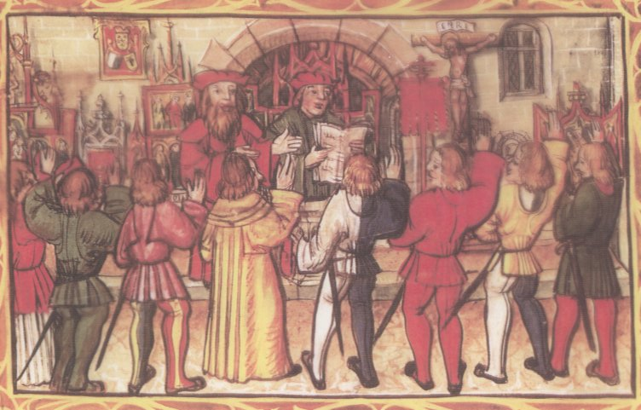

‘Communal assembly & oath’ from Die Luzerner Chronik des Diebold Schilling 1513
[The Lucerne Chronicle of Diebold Schilling] (facsimile edn, Lucerne, 1977), p. 535.

