‘Reformation, Politics & Rebellion’ BK 03/25

Gender Roles
Lecture Spring Week 19

Introduction
- Gender issues have moved to the centre of recent historiography (Merry Wiesner)
- Shows influence of present-day movements (feminism) on interpretations of the past
- Ongoing lively debate on the impact of the Reformation on women

1. Luther’s views
- His writings (as e.g. in The Estate of Marriage, 1522) reject some traditional notions of female sinfulness and spiritual inferiority but confirm need for patriarchal control. Alongside, flippant – if not ‘misogynist’ – statements recorded in the Table Talks
- His marriage to former nun Katharina von Bora causes scandal but also sets new standards for Protestant (clerical) household, revealing elements of real partnership

2. Women responding to the Reformation
Bible emphasis and rejection of mediating role of (male) clergy appeals to many:
- Katharina Zell (née Schütz) of Strasbourg joined the Lutheran cause in the early
1520s, married a former priest and published several tracts (attacking the Catholic clergy), despite council attempts to silence her. Katharina had contacts with prominent reformers, preached at funerals and engaged in poor relief (cf. McKee)
- Argula von Grumbach, a Bavarian noblewoman, clashed with Ingolstadt university theologians in 1520s and published several pro-Lutheran pamphlets
- Ursula Weyda, wife of a tax-collector at Eisenberg, challenged the Catholic clergy in her Against the Unchristian, Slanderous Work of the Abbot of Pegau (1524) by emphasizing the authority of Bible: ‘you stupid, ignorant abbot …You know less about scripture than a cow about dancing … The Word of God alone is important, but monks and priests know nothing of this. They use lies, which the false and devilish papal church tells them.’
- At Schlettstadt (Alsace) in February 1525, women invaded a convent of Dominican nuns to convince them of the error of their ways and ‘to turn them to the Gospel’
- Olympia Fulvia Morata, educated in Ferrara, moved to Germany as the wife of a Protestant doctor (Andreas Gundler, 1550). The couple lived an extraordinary type of reformed marriage, in which the woman was given room for intellectual pursuits. Her works were well promoted and became Protestant ‘bestsellers’
- Elisabeth of Brandenburg (1510-55) was born into the electoral Hohenzollern dynasty, married the Duke of Brunswick-Calenberg, met/corresponded with Luther in the 1530s, became regent after her husband’s death, collaborated with the Hessian reformer Anton Corvinus to establish Protestantism in the territory during the 1540s, but saw her work undermined by her son’s Catholic leanings after he became prince
- Countess Anna of Lodron helped to spread the new faith in Swabia; in Nuremberg, Magdalena Paumgartner was a pious Lutheran who supported her husband’s trade
- A notable number of women became active members of radical religious groups
- ‘Normal’ women exercised less, but still important influence, e.g. through the creation of a ‘godly’ home, fostering the religious education of children etc.
- Yet there is female resistance, too: some nuns refuse to leave their institutions and oppose Luther (Abbess Caritas Pirckheimer/Nuremberg; cf. Leonard, Nuns)
- Overall, however, men direct the course of the Reformation in most respects

3. Debating the impact of the Reformation on women in Germany
- Ozment’s positive view challenged by e.g. Roper, Karant-Nunn and Wiesner
- Greater spiritual equality (priesthood of all believers / sola fide principle) balanced by closure of nunneries and loss of female role models (saints)
- Case studies find enhanced patriarchal control (in households and economy)
- Divorce now a possibility in Protestant churches, but difficult to achieve in practice

Conclusions
- Luther’s views and marriage relations set models for reformed households
- Protestant doctrine implies spiritual equality of sexes but closes some traditional outlets for female spirituality & agency
- Importantly, the Reformation impact needs to be balanced against evidence for continuities, general socio-economic pressures and shared Catholic concerns

Recommended reading
a) Gender history in general
Merry Wiesner, Women and Gender in Early Modern Europe (4th edn & companion site, 2019)

b) Primary sources
S. Karant-Nunn & M. Wiesner (eds), Luther on Women: A Sourcebook (Cambridge, 2003)
P. Matheson (ed.), Argula von Grumbach: A Woman’s Voice in the Reformation (1995)
E. McKee (ed.), Church Mother: Writings of a Protestant Reformer in 16thC Germany (2006)
c) A contribution to the ‘Reformation Impact’ debate
S. Burgartz, ‘Tales of Seduction, Tales of Violence: Argumentative Strategies before the Basel Marriage Court’, in: German History 17 (1999), 41-56

Diarmaid MacCulloch, Reformation: Europe’s House Divided 1490-1700 (London, 2003), esp.:

- Ch. 15: ‘Love and Sex: Staying the Same’ – emphasizes continuities such as nuclear families, patriarchal control and medical views of male/female bodies
- Ch.16: ‘Love and Sex: Moving On’ – exploring areas of change, e.g. Protestantism’s rejection of the ideals of virginity and celibacy, but also identifying other factors like rise of syphilis, and shared Protestant-Catholic concerns with a ‘Reformation of Manners’ and stricter controls on clandestine marriages / extra-marital sexual relations

‘The Reformation era saw a barrage of rhetoric about the importance of the family, and the role of the father as its head. There was very little new in this, but what was new was its assertion among Protestants at the expense of the role of virginity and celibacy.’ [MacCulloch, Reformation, 647]

K. Stjerna, Women and the Reformation (Oxford, 2009), esp. Part II, chs 5-8 (Bora, Grumbach, Elisabeth von Brandenburg, Schütz Zell)
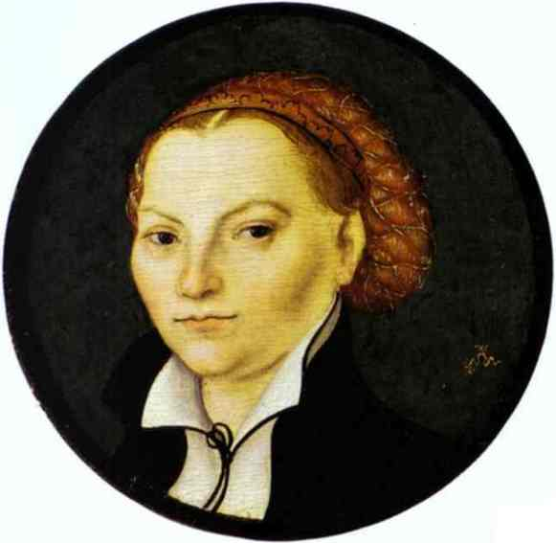 Lucas Cranach t. E., Portrait of Katharina von Bora (1525)

