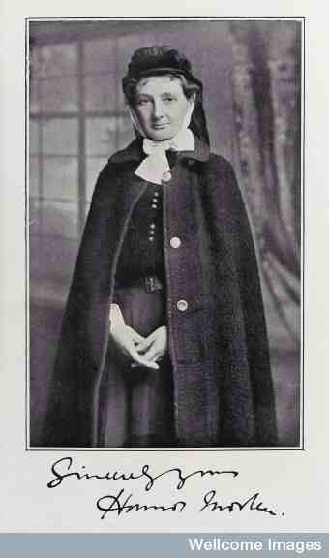
Child Birth and Maternity
Traditional childbirth/maternal mortality
- Child birth was feared – high rates of still birth, infant mortality and maternal mortality. Could also be length, painful and complicated.
- Maternal mortality high: 1900 – 42 per 10,000 births; 1930 – 44; 1940 – 36; 1950 – 8.7. Caused by puerperal sepsis (post-partum fever) (40%), toxaemia (20%), haemorrhage (20%).
- Maternal mortality fell in 1940/50s because of sulphonamides, blood transfusions, obstetric flying squad, better hygiene.
Midwives
- Could be neighbours, semi-professionals or professionals. Often took on other roles in women’s households and the community. Most worked in women’s homes.
- No formal training until the late 19th century – trained through apprenticeship (hands on). Little theoretical or book learning.
- Ideal midwife – kind, honest, gentle and not gossips. Waited on ‘nature’ and not associated with birth control or abortion.
- Midwives played an important role in traditional childbirth – they were in charge. Traditional childbirth was a collective female culture (chiefly understood in social rather than medical terms).
- Home to Hospital – the 18th century rise in lying-in hospitals (run by charities). Provided access to a midwife to working women. Often sites of infection – Ignaz Semmelweis.
- Male obstetric practitioners – ‘man-midwife’ (18th century); GP, gynaecologists and obstetricians (19th century).
- Training (doctors) – midwifery added to education curriculum (1840); diplomas awarded (1850).
- Training (midwives) – King’s College London introduces midwife training (1863); Midwife Registration Act (1902).

Medicalisation of child birth/male monopoly of midwifery
- Caused by: idea of risk; emphasis on formal training/expertise; new technologies (forceps & chloroform); rise of the GP; marketplace competition; shift in location of birth from home to hospital; changes to the culture of childbirth. Became the cultural ‘norm’ after the introduction of the NHS.
- Rise in hospital births – 1900 most births at home but by 1960 only 33% of women gave birth at home. Only 1% by 1992.
- Some counter movements: Pioneer of natural Childbirth Dick-Read, Natural Childbirth (1933) and Childbirth without Fear (1942); Shelia Kitzinger; Wendy Savage; National Childbirth Trust.
3 factors that made the medicalisation of child birth more apparent:
- Men take over childbirth – Female midwives lose autonomy.
- Hospital deliveries increase – shift from home to hospital.
- Increasing use of technologies/intervention in births.
Primary sources:
On experiences of pregnancy and birth: M. Llewelyn Davies (ed), Maternity: Letters from Working Woman (first published 1915); A. Oakley, From Here to Maternity (1986); J. Worth, Call the Midwife (2002); N. Leap & B. Hunter, The Midwife’s Tale: An Oral History of the Handywoman to Professional Midwife (1993); S. Kitzinger, Your Baby, Your Way (1987); G. Dick-Read, Natural Childbirth (1933).

