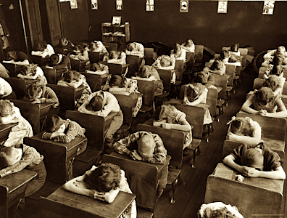
Lecture 4: Medicine at School

Historiographical Perspectives
- Traditional histories have usually focused on legislative change as a sign of ‘progress’.
- Recent scholarship – more complex understanding. Recognition that the process involved increasing adult control over children’s bodies (David Armstrong & Bryan Turner).

19th Century Legislative Reforms (Education)
- Education Act 1870; Elementary Education (Blind and Deaf Children) 1893; Elementary Education (Defective and Epileptic Children) 1899.
Legislative Reforms (Liberal Reforms 1906-1914)
- Shift from laissez-faire system to more collectivist approach - traditionally identified as the birth of the British welfare state.
- Reasons for reforms – 1. Reports into poverty (Rowntreee & Booth) 2. Boer War 3. Growing anxieties about Germany and their commitment to national efficiency (eg. old age pensions) 4. Growth of the Labour Party 5. ‘New Liberalism’ (Asquith, Lloyd George and Churchill).
Legislative Reforms (Children and Reform)
- 1906 Education (Provisions of Meals) Act
- 1907 Notification of Births Act
- 1907 Education (Administrative Provisions) Act – allowed school boards to inspect the health of children in schools.
- 1909 Children’s Act – restrictions on child begging and the sale of tobacco and alcohol to minors. Formation of the juvenile justice system.

Free School Meals/Milk
- From the 1870s school/voluntary provisions established (eg. ‘Penny Dinners’).
- 1906 free school meals act – initially not compulsory and many local councils ignored it. In 1914 was made compulsory. Continued to be national variation in provision.
- Free School Milk introduced in 1934 to give children extra nutrition in addition to school meals.
Medical Inspection in Schools
- Compulsory schooling made children’s health problems more visible – teachers and voluntary workers began to call for the provision of medical inspections in schools.
- 1907 legislation set up school medical inspections – some problems as many parents couldn’t afford treatment for their children. 1912 onwards treatment (full or partial) was paid for by LEA’s.
- 1920s/30s – services expanded and school clinics established.
- Health benefits for both working class and middle class children.
School as a site of health
- Sport – encouraged for boys (especially) and girls from late 19th century onwards. Rugby, tennis, football, cricket, gymnastics, drill, dancing and games.
- Domestic Science – sewing, cooking, budgeting, cleaning and washing. Teaching women to be good future wives and mothers.
- Sex Education – started after the 1940s. Often lacking in the information it provided. Improved over the course of the century.

