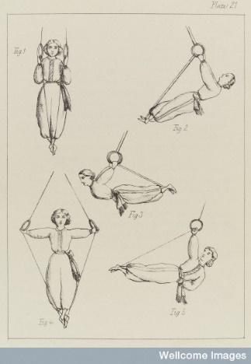
Lecture 9: Healthy Lifestyles: Exercise, Sport and Health
- Rediscovery of the Greco-Roman hygienic ideal of a health mind in a healthy body – mens sano in corpore sano.
- Between 1880 and 1930 body management and exercise was promoted by school teachers, public reformers, campaigners, doctors and policy makers.
- Advocated a healthy regimen, fitness (though exercise), dietary reform, cleanliness, exposure to sunlight and dress reform.
- New ideas about healthy lifestyles emerged against a background of rapid urbanisation, rising living standards, mass consumerism, intense economic and military competition and imperial rivalry.
1. School Sport for Boys 1850-1920
- New focus on physical education began in boys boarding schools in the mid 19th century. Games like cricket, rugby and football were invented and rules were formulated
- Thomas Arnold – Rugby – promoted ‘muscular Christianity’.
- E.L.Cotton – Marlborough – promoted sports as a form of discipline and associated it with ‘gentlemanliness’.
- From 1860’s onwards sports (playing and watching) became increasingly popular with the middle and upper working classes – sign of respectability and manliness.
- Extension of sports across the empire – display of the British masculine ideal on the international stage.
2. Women and Exercise
- Late 19th century – growing sense that exercise for girls should be encouraged but concerns about what was appropriate/’ladylike’.
- Physical education gradually introduced into private girl’s schools – North London Collegiate School and Cheltenham Ladies College.
- Martina Berhman-Osterberg appointed to the London school board in 1881 and introduced Swedish gymnastics.
- Cycling – became a very popular female pastime from the 1880s. Concerns about the dangers to women’s health – physical and mental. Associated with suffragettes.
3. Physical culture
- Physical culture emerged in the late 19th/early 20th century – media led phenomenon associated with key entrepreneurial figures.
- Promoted a variety of bodily ideals, styles of self-presentation and exercise systems – drew upon Swedish gymnastics.
- Eugen Sandow – father of the British physical culture. Originally a showman associated with the music hall – utilised the invention of physique photography. Launched Physical Culture (1898) and sold gym equipment.
- Male beauty associated with the Greek Heroes Apollo (lithe Olympic athletes) and Hercules (Sandow). Female beauty associated with the Venus de Milo (Prunella Stack).
- Beauty and health were now correlated. Idea that beauty could be cultivated through healthy lifestyle.
4. Voluntary organisations
- New ideas about a healthy lifestyle were promoted by organisations like National League for Physical Health Improvement, the Eugenics Education Society, the New Health Society, The Sunlight League, the Men’s Dress Reform Party and the Women’s League for Health and Beauty.
- These groups promoted vegetarianism, hygiene, nudism and sun bathing. Conveyed their message through advice literature, newspapers, films, health education courses, health weeks and public talks.
- New Health Society (1925) – Sir William Arbuthnot Lane – Associated with Social Darwinism and eugenics.
- The Woman’s League of Health and Beauty (1930) – Mary Bagot Stack/Prunella Stack – membership of over 100,000.
Today: ‘If exercise were a pill, it would be one of the most cost-effective drugs ever invented’ (NHS website)

