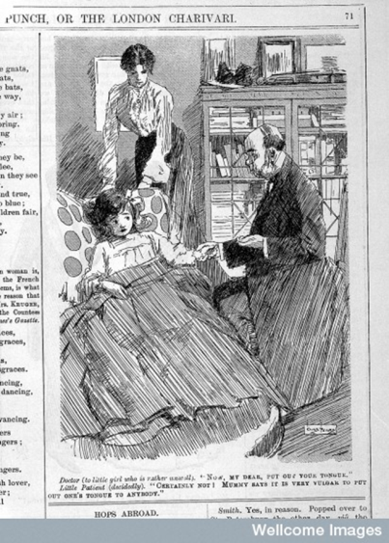
Lecture 10: The Rise of the Family Doctor
Definitions of the medical profession
- Definition of ‘professionalisation’ by S. E. Shortt (1983): ‘A process by which a heterogenous collection of individuals is gradually recognised, by both themselves and other members of society, as constituting a relatively homogenous and distinct occupational group’.
- Defining characteristics/criteria of the medical profession:
1.The possession of a body of highly specialized knowledge: we expect doctors to have a deep knowledge, acquired through long training in medical school. A doctor’s qualifications prove that he or she has completed this training to the standards required of the profession.
2. Professional unity and a strong ethos of public service: we do not expect doctors to compete with one another for patients by advertising their services or by offering cut-price practice. We do expect practitioners to co-operate when caring for patients, and to always work for the patients’ best interests.
3. A monopoly of practice: only members of the medical profession can call themselves doctors. We distinguish between orthodox medical practitioners and those who offer alternative forms of medical treatment by calling them practitioners of ‘complementary’ or ‘alternative’ medicine.
4. Professional autonomy: medical practice is based on highly specialist knowledge, which is not shared with the general public. Therefore, only doctors can judge whether other doctors are trained to a suitable standard and are competent to practice.
5. High social status: doctors earn high salaries and also enjoy a special social respect.

1815 Apothecaries Act
- License of the Society of Apothecaries (LSA) needed to practice as an apothecary: apprenticeship, academic courses, hospital experience and examination.
- Separated apothecary from retail druggist – ‘surgeon-apothecary’
- By 1848 most practitioners held multiple qualifications: LSA, MRCS (Membership of the Royal College of Surgeons), medical degree and midwifery licence. c.15,000 GPs in England and Wales by 1848.
- Became basis of general practice of medicine - already by 1820s division between GPs and consultants began to be laid down.
1848 Medical Act
- Created single medical register
- Equal recognition of all practitioners
- General Medical Council – upheld standards, education, ethics, practice
- 1886 Medical Amendment Act – all medical students required to have qualifications in surgery, midwifery and medicine.

Doctor’s Career Paths - Anne Digby, Making a Medical Living: Doctors and Patients in the English Market for Medicine, 1720-1911, CUP, 1999)
- The ‘classic’ GP who practised general medicine amongst a mix of social classes.
- The GP/surgeon who practised general medicine and had a part-time appointment as a surgeon in a small hospital
- The GP/specialist, who worked as a general practitioner but also did some consulting work in one area of medicine, such as obstetrics.
4. GPs who became consultants, men who started their careers in general medicine but switched to full-time consulting.
5. The ‘pure’ consultants, who belonged to prestigious medical institutions, held posts in major hospitals and had a private practice.

