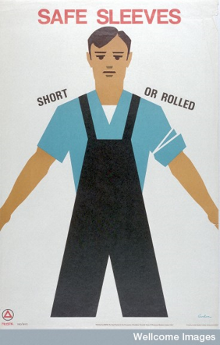
Lecture 15: Work and Health
- Effect of industrialisation on health
- Population growth and urbanisation caused overcrowding, insanitary conditions, poverty and squalor in urban centres.
- People living in Britain: 1800 – 11 million/1850 – 21 million.
- People living in London: 1800 – 1 million/1850 – 2.4 million
- Contemporaries aware of the hardships faced by the urban working poor. See Charles Thackrah, The Effects of the Principal Arts (1831); J.P. Kay, The Moral and Physical Condition of the Working Classes (1832); P. Gaskell, The Manufacturing Population of England (1833); E. Chadwick, Report on the Sanitary Conditions of the Labouring Population (1842); Dr C. Holland, Diseases of the Lungs from Mechanical Causes (1843). Also in literature: C. Dickens, Hard Times (1854); E. Gaskell, North and South (1855).

- Working Conditions and Health (The Factory System)
- Factory was a site of discipline, danger and immorality (Derek Fraser, Welfare State)
- Some exceptions – New Larnark (late 18th century); Saltaire, West Yorkshire (1850). Here Robert Owen and Titus Salt set up factories with housing for workers, schools, social areas, and hospitals in the setting of the countryside.
- State legislation introduced from the early 19th century: 1802 Health and Moral Apprentices Act; 1819 Peel’s Act; 1833 Factory Act; 1842 Mines Act; 1844 Factory Act; 1867 Factory Act Extension Act; 1878 Factory and Workshops Act; 1883 Preventing Lead Poisoning Act; 1891 Factory Act; 1895 Factory and Workshop Act. See Antony S. Wohl, Endangered Lives (1984).

- Success of 19th Century legislation?
- In the 19th century the impact of legislation was minimal – still favoured employers over employees although some improvements for women and children.
- Occupational disease becoming and increasing problem. Eg. ‘Phossy jaw’ and matchmaking.
- Legislation started to have more impact after the 1870s. Emergence of the idea that active management of workers conditions and health was necessary to the management of productive labour (Steve Sturdy). BUT - reform was delivered unevenly and was localised.
Early 20th century
- Women’s work was opposed – ‘motherhood’ and raising the next generation seen as women’s proper ‘occupation’. Yet, for many family’s women’s financial contribution was important.
- Children continued to work – ‘half timers/little mothers’. Conditions and pay were poor.
- Some new legislation introduced: 1901 Factory and Workshops Act; 1909 Trades Boards Act; 1911 National Insurance Act.
WW1
- Factory acts relaxed due to war time emergency and labour shortage. Meant that safety was compromised.
- Munitions work revealed specific dangers of working with chemicals. Eg. Canary girls.
- Some developments in welfare provision – Health of Munitions Workers’ Committee as well as canteens and health classes.
Interwar
- Standards still low – worsened in the Depression.
- Conditions for unemployed also bleak. See H. Beales and R. Lambert (eds), Memoirs of the Unemployed (1934) [these were published in the Listener Magazine (1733); W. Brierley, Means-Test Man (1935); London’s Pulse – Medical Health Officer Reports [Wellcome website]. Start of the association between unemployment and clinical depression?
- 1937 Factory Act – raised standards of safety, health and welfare.
- Industrial medicine emerges as a part of industrial welfare – factory as potential site of health (Vicky Long)
WW2
- Safety, health and welfare at work was made a priority – Ernest Bevin appointed Minister of Labour and National Service.
- Factories (Medical and Welfare Services) 1940 – extended medical supervision, welfare, nursing and first aid.
- Workplaces become sites of health care promotion – posters, films, leaflets. Provision of canteens. (see reverse)

