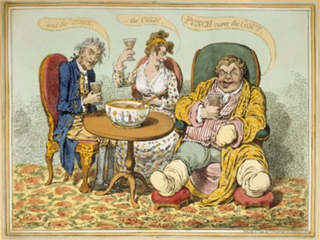
Lecture 17: Keeping Young, Keeping Alive: Middle Age
- Conceptions of middle age and ageing have changed in 20th century due to increasing life expectancy.
- 1900 – men 47, women 50; 1971 – men 68, women 72; 2015 – men 79, women 83.
- Today someone in the 40s is still considered to be relatively ‘young’. The Guardian (2013) reported that women giving birth after 40 has increased 4 times in the last 30 years.
Patterns of Disease, Illness and Health
- Theory of epidemiological transition (Abdel Omran) – phase of development witnessed by a sudden and stark rise in population growth produced by medical innovation.
- 3 main stages: 1. Shift away from pestilence and famine – new dangers from dearth and epidemic (18th century). 2. Receding threats from pandemics – medical science (19th century). 3. Decline in degenerative diseases – rise of chronic conditions (20th century).
- Led to the belief that chronicity was a ‘20th century’ health problem. Now critiqued by several historians (Porter, Zweiniger-Bargielowska).
- Friendly Societies records – show increasing frequency of chronic diseases. Often different to primary causes of death. Friendly Societies insurance provisions starting to struggle with increasing number of pay outs being requested by ageing population with a range of chronic health problems - associated with industrial labour. Led to the National Insurance Act 1911.

Chronicity
- Term used to describe long term illness or complaint. Some historians argue that chronicity is a ‘modern’ health problem. Others argue this is an oversimplification – origins of many ‘modern’ chronic diseases emerge in the 18th century.
- TB – most common chronic disease in the 19th/20th century. Respiratory disease that attacked the lungs. The decline was referred to as consumption. Popular idea that it was caused by physical weakness and nervousness – led to a certain ‘romanticisation’ of the disease.
- Diabetes – increasingly common (especially type 2) in the 20th century. Caused by problems with blood sugar level and associated with unquenchable thirst, copious urination and wasting. First known means of ‘treating’ the disease (insulin) developed in the 1920s. Classic example of a ‘chronic’ health problem.
- Cancer – recognised as a disease in the 18th but not frequently diagnosed (except breast cancer). Identified cases of deaths from cancer grew from 1840s. In 1840 identified as the cause of death in 1 in 129; by 1894, 1 in 23. Caused by better diagnosis and better public knowledge (Dr Arthur Newsholme). Link between smoking and cancer made in the 1950s.

Public Health Responses/Health Education
- Health education programmes (aimed at the middle aged) increased in 1950s as potential ‘solution’ increasing rates of chronic disease. New research associating smoking with lung cancer (Richard Doll and Austin Bradford) and heart disease and exercise (Jerry Morris – bus conductors/drivers). Health problems of middle age had a strong link with occupational health.
- 1968 – health education council formed. Promoted health through poster campaigns, leaflets and films.
- Health education still chiefly aimed at the middle aged – trying to prepare them for old age. See http://www.theguardian.com/society/2016/mar/07/middle-aged-people-targeted-in-new-public-health-england-phe-campaign

