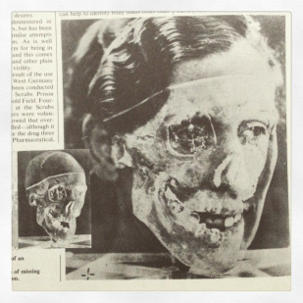
Lecture 20: Death in Modern Britain
- Historical interest in death first emerged in the 1980s. Much of this research has suggested a shift from religious to medically understood and managed death in the 20th century.
- Julie Marie Strange argues that the modern history of death is best envisaged as ‘a linear chronology whereby a sacred and community-centered culture eventually gave way to a privatized and sanitized culture of death’.
- Philip Aries, The Hour of Our Death (1981):
    - Enlightenment rationalised death;
    - Romanticism sentimentalised and commercialised death;
    - After 1870s there was decline in the idea of the importance of a ‘good’ death;
    - After mid-20th century death was ‘secularised’.
Death
- Definitions of death depend on context – different biological/spiritual definitions. A social process as well as biological event.
- Until WW2 seeing death was common as most people died at home. Infant and maternal mortality was high, and death from infectious disease still common.
- The idea of the ‘good death’ was important concept from middle ages through to the Victorian era. Based on Christian concepts of meeting/preparing yourself to meet God. Death anticipated and prepared for (emotionally, socially, financially and domestically).
- Suicide – considered a sin and described as ‘self-murder’. Church denied burial and funeral rites. Some historians suggest it was secularised in early 19th century but it was still a crime until 1961.
Burial and Cremation
- Burial – traditionally people were buried near churches in the centre of towns. In 19th century there were sanitary concerns about overcrowded graveyards. 1852 Metropolitan Burial Act – local governments opened up public cemeteries.
- Cremation became more popular after mid-20th century. 34.7% of people cremated in 1960; 74.44% in 2008.
Material culture of death
- Rich material culture relating to death. Victorians had a morbid fascination with grave robbing and murder.
- Technological and scientific advances (photography, autopsy, chemical testing) led to developments in forensics.
- In Victorian art and literature death was romanticised. See Henry Peach Robinson, Fading Away (1858). Romantic and classical styles were also used in funerary monuments.
- Victorian funerals were extremely elaborate affairs. Strict rules about funerary/mourning clothing and jewellery – especially for women.
Class and Death
- Often argued that the poor couldn’t afford the ‘luxury of grieving’ (David Vincent) but this has been disputed by Julie Marie-Strange who suggests the poor were simply more familiar with death.
- Importance of good burial v. important for working classes.
World War 1
- Decline in mortality in 1870s and 80’s. Also decline in religion and Evangelical fervour.
- WW1 marked a change in ideas of death – end of ideas relating to the ‘good death’.
- Bereavement never more widespread – mourning became public with new forms of remembrance, tomb of unknown solider, armistice day etc.

