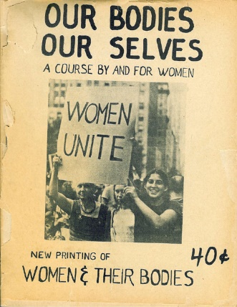
Lecture 12: Women, Medicine and the Life Cycle
- ‘The theme of women, health and medicine warrants not a single chapter but an entire volume in order to sum up the state of scholarship in this diverse, energetic and multifaceted area’. H. Marland, Oxford Handbook of the History of Medicine (2011).
- Emerged from second wave feminism 1960s/70s – encouraged women to think about their health and bodies differently, and critiqued relationship between women and the medical profession – Our Bodies Ourselves (1978).
Historiography
- Joan Scott, ‘Gender: A Useful Category of Historical Analysis’, American Historical Review, 91 (1986): critiqued interchangeability of ‘women’ and ‘gender’ as terms and argued that ‘gender’ represented a useful analytical category to explore social, cultural and political relations.
- Scholarship has depicted women as being prone to ideologically driven interventions – domesticity, patriarchal society, empire etc. Also demonstrated the ways in which women’s bodies were presented as ‘defining’ of women’s social and cultural functions and roles.
- Thomas Laqueur, Making Sex: Body and Gender from the Greeks to Freud (1989) - one sex/two sex model.
- Others argue that power relations between men and women are not clear cut and argue that women needed to be given greater ‘agency’ by historians (Ludmilla Jordanova).

Victorian Doctors
- Victorian doctors were very interested in female health. This was not just caused by patriarchal society but also growing professional interest in the ‘diseases of women’, specialisation of obstetrics and gynaecology, importance of women as a client group and doctors vested stance on gender difference – connected to female education, women doctors and suffrage (Anne Digby).
- Obstetrics and gynaecology presented women’s health as problematic and ‘sickness’ to an extent unavoidable – due to ‘weak’ female nature.
- Female sexuality was ‘pathologised’. Eg. Prostitutes presented as a public health problem.
- Female sexuality was p’sychiatrised’. Eg. unruly women were presented as being mentally unstable and sexual behaviour was linked to diagnosis. Hysteria = female sexual arousal; Mania = overtly sexual behaviour.
- Recent research suggests that gender played less of a role in psychiatric diagnosis that has been previously suggested - e.g. Akihito Suzuki, Mark Micale, John Starrett Hughes, Martin Stone.
Female ‘Diseases’
- Puerperal insanity (postnatal depression) first defined by Robert Gooch in 1820 – accounted for 10% of admissions into asylums. Seen as being likely to reoccur – linked to biology, strains of childbirth, worries about motherhood, poverty and domestic problems. See Hilary Marland, Dangerous Motherhood: Insanity and Childbirth in Victorian Britain (2004).
- Hysteria – epidemic in the Victorian period. Had a variety of ‘social’ and medical causes linked to over work and education. Some suggestion it was used a form of protest against patriarchy.
Women’s Health in the 20th century
- Interwar – Medical Research Council (1924) found poverty and family ill-health was product of the ‘failure of mothers’. Report on Maternal Morbidity in Scotland (1935) found 57% of antenatal deaths were caused by women not attending clinics and not following advice. BUT Women’s Health Inquiry Committee found that enormous amount of ill health was hidden among married women – recommended higher wages, better social service provision for children, family allowances, improved maternal health services, extension of National Insurance to women.
- World War 2 and NHS – 1945 Family Allowances were introduced and women’s access to care improved although there were still inequalities caused by gender, class, locale and ethnicity (Roberta Bivins, Contagious Communities: Medicine, Migration, and the NHS in Post War Britain (2015).

