Call: EUTopia CoLeCo Legal History 2026-2027: Law and Image
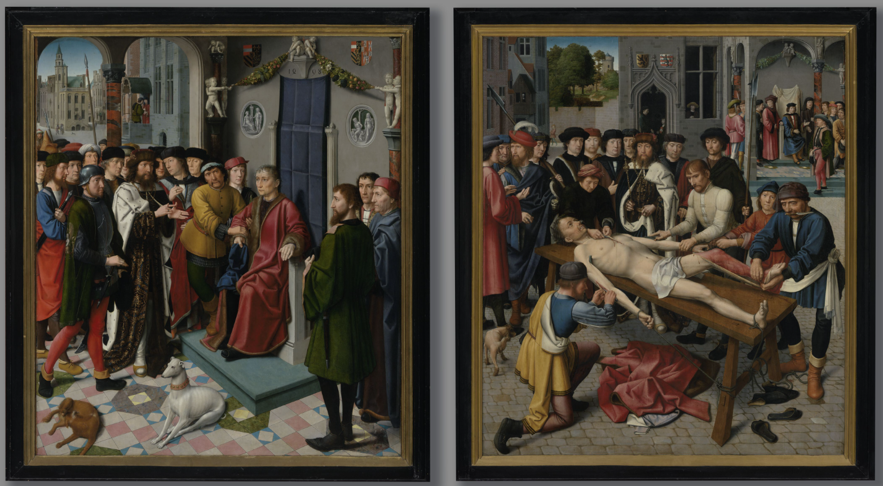
(image: the judgment of Cambyses, or what happens to a bad judge, by Gerard David, Groeningemuseum Brugge; source: Topstukkencollectie Vlaamse Overheid)
Since 2021, students and academic staff from the Vrije Universiteit Brussel (VUB), the University of Ljubljana, CY Cergy Paris Université, Universitat Pompeu Fabra (Barcelona), NOVA University Lisbon, and the University of Warwick have been working together in a unique hybrid learning environment. The Connected Learning Community combines online and hybrid meetings with a physical peak event and the publication of student research on the EUTopia CoLeCo Blog.
For the 2026–2027 academic year, we invite you to explore the theme Law and Image. At first sight, this may seem like a thoroughly contemporary topic. We live in a world shaped by images: short videos, streaming platforms, social media, and visual communication influence how we understand law, politics, and society. Yet the relationship between law and images is far older. Throughout history, images have been used to communicate legal principles, legitimise political authority, assert territorial claims, represent justice, and commemorate institutions and individuals. In societies with limited literacy, visual communication was often one of the most powerful legal and political languages available. The image of subaltern actors, women, depictions of transgressors or of morally valued behaviour can inform us on the place of justice within society. We encourage you to think about and pursue these topics in connection with the respective communication technologies that had enabled the creation and spread of the relevant visual imagery and in the first place. Before the dawn of artificial intelligence, which brought with it, among other things, the (re)newed premise of inherent doubt regarding the trustworthiness of image and text, similar effects were not unfamiliar with the introduction of every other communication technology in the past, albeit taking root with a promise of it being in fact truer to the reality. Think of photography and film from the nineteenth century, printing and mass reproduction from the sixteenth century, manuscripts before that and of course painting, sculpture and architecture with its outer and inner symbolism (think of Lady Justice in its numerous variants) accentuating the performativity of juridical and legislative actions taking place inside and outside them.

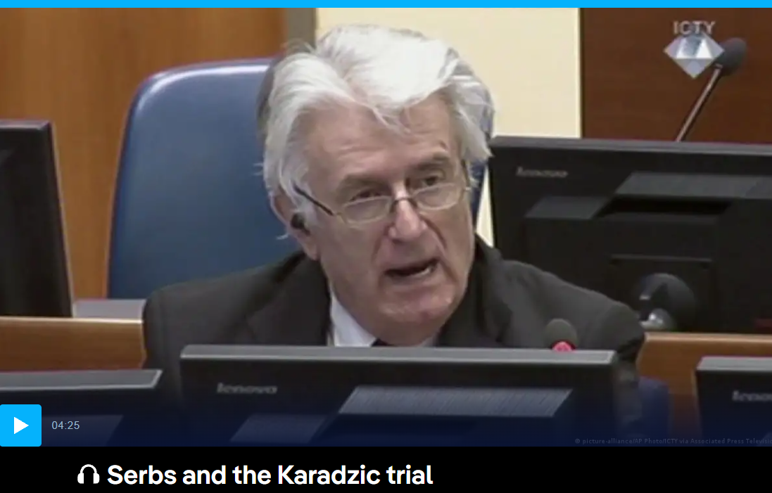
(Image: closing statement by Radovan Karadzic at the ICTY [still]; source: Deutsche Welle)
The highlight of the programme will be a five-day Blended Intensive Programme (BIP) hosted by CY Cergy Paris Université in February 2027, where students and staff from across the EUTopia alliance will meet in person. In preparation for the peak event, small international teams of five to eight students from each partner university will work under the guidance of their local professor or lecturer, while meeting regularly online with participants from across the network.
At the heart of the EUTopia Connected Learning Community is the student. You take the lead in shaping your own topic. Working together with your peers, you will develop a project that combines academic rigour with innovative forms of digital communication. It is essential to work on a legal source or legally relevant source, using appropriate academic heuristics and correct referencing.
Rich digital repositories such as Europeana and Gallica provide access to millions of digitised sources: legislation, case law, legal scholarship, reports on famous court cases, architectural drawings for courthouses, paintings, statues, photographs, posters, and much more. These collections offer a unique opportunity to study not only the written law, but also the visual culture through which legal ideas, institutions, and authority have been represented across time.
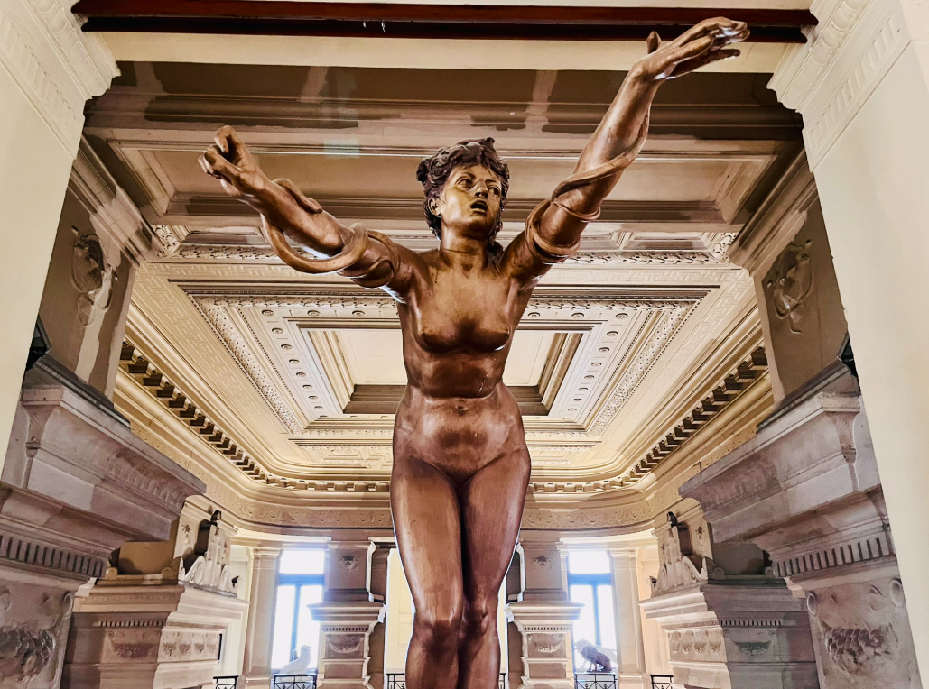
(image: Leopold II’s Palace of Justice, Brussels, 18 November 2025)
Along the way, you will gain insight into the legal traditions of the countries and regions represented within the network. By engaging with different legal cultures, perspectives, and historical experiences, you will also develop a deeper understanding of your own legal system. After all, it is often through comparison with others that we come to appreciate the distinctive features of our own traditions.
Get in touch with Rosie Doyle on R.Doyle.1@warwick.ac.uk by Thursday 22 October at 5pm with a draft title and an abstract of no more than 200 words for your proposed project. (There is some useful advice on writing abstracts on the ICUR website here: https://www.icurportal.com/resources-for-students/writing-and-submitting-your-abstract/writing-an-abstract-for-icur/) Experiences of previous generations of students (peak event reports, source analyses and papers, videos, presentations) can be consulted on our blog: https://eutopialegalhistory.blogspot.com.

