Covert Surveillance of Shoppers via Nectar Cards

Retail loyalty schemes originally started during the American Civil War, when local stores started to issue redeemable copper tokens to supplement the shortage of hoarded coins. These evolved into promotions such as S&H green stamps, and the concept was adopted in the UK in 1958 as Green Shield stamps. These were avidly collected here throughout the next few decades. Each purchase carried a proportional number of stamps which could be saved in a collection book and eventually traded for items in the catalogue (Figs 1 and 2).
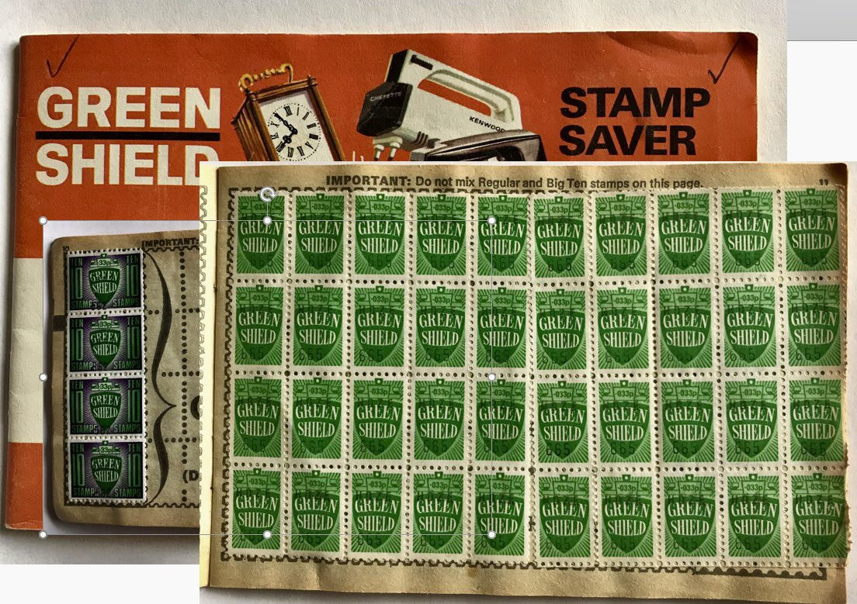
Figure 1. Green Shield Stamp Book and Stamps c. 1960s
Source unknown
https://www.silversurfers.com/nostalgia/green-shield-stamps-did-you-collect-them/
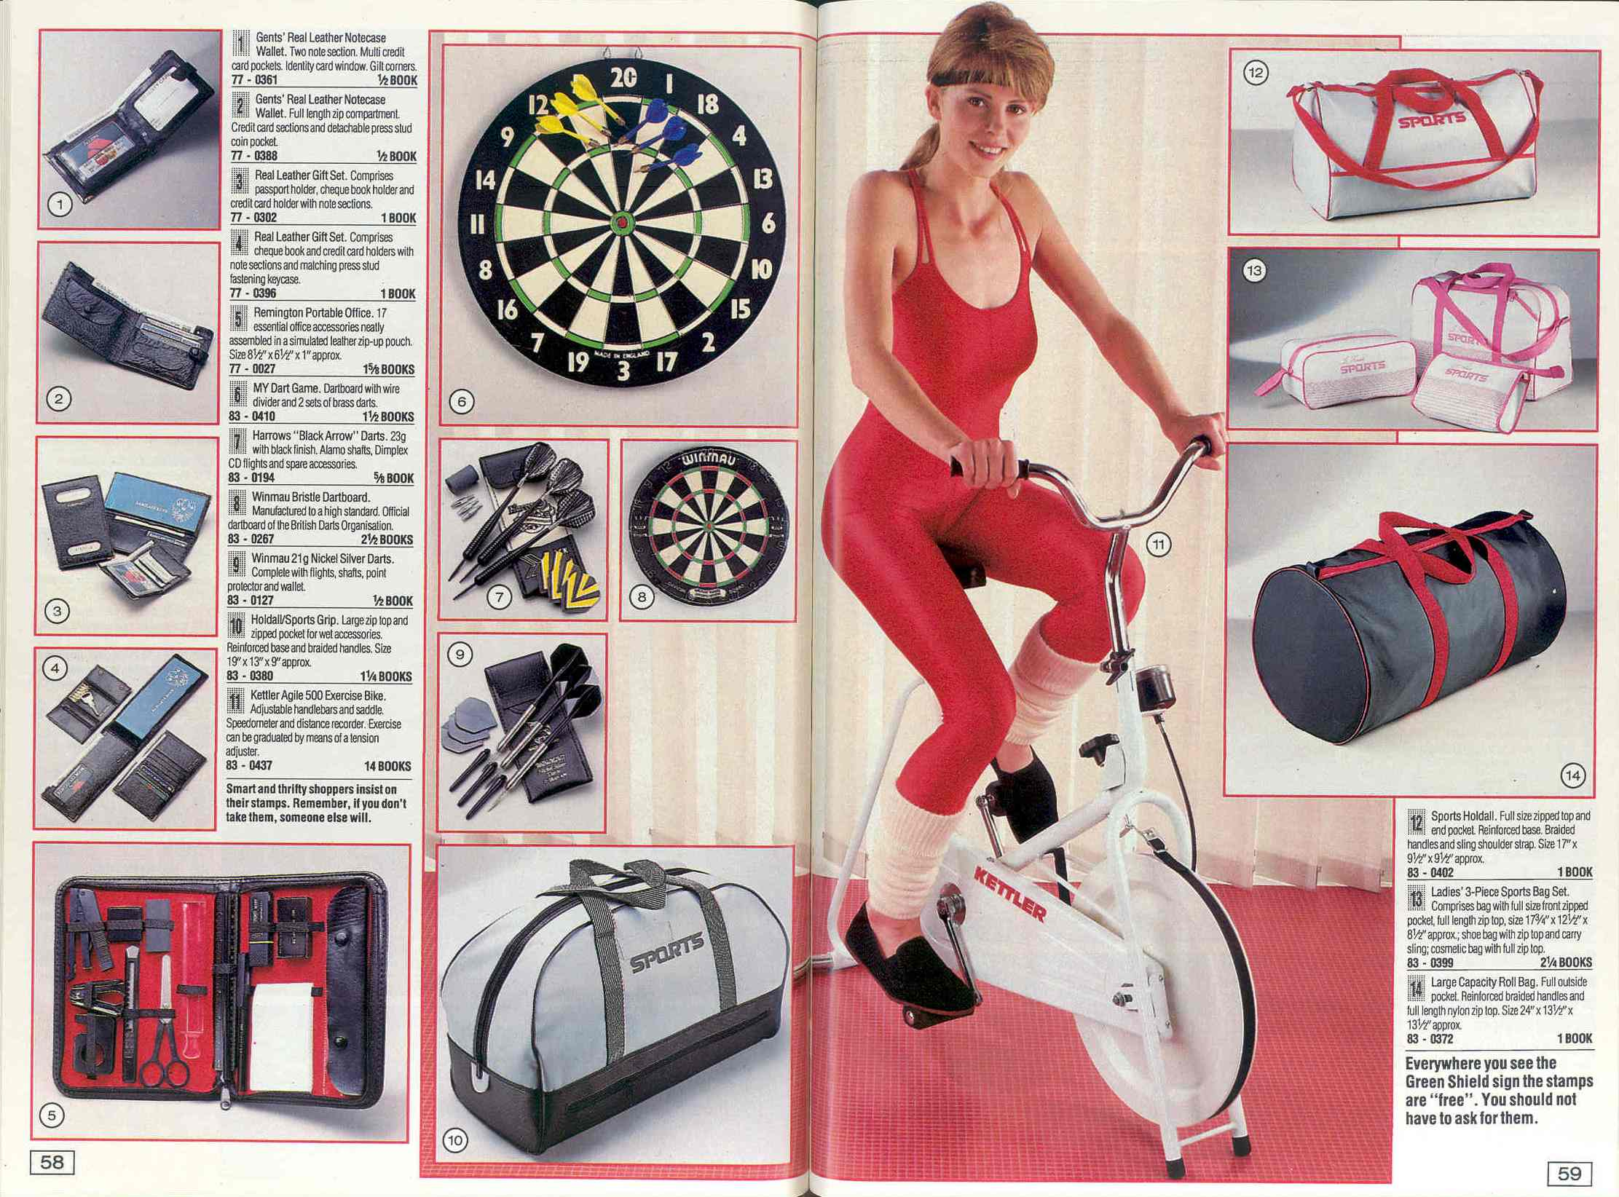
Figure 2. Green Shield Stamps catalogue, about 1987
Tyne &Wear Museum. TWCMS 2011.1370
https://blog.twmuseums.org.uk/double-dividends/11_1370e/

This popularity perhaps reflected the post-war economy, with wartime rationing still a vivid memory, saving stamps to get something ‘free’ must have been irresistible. I heard of a kitchen mixer bought with stamps over sixty years ago, still in regular use until 2018, so these were good-quality items. Green Shield’s catalogue was relaunched as Argos in July 1973, although sales of stamps ceased in 1983, and discontinued in 1991. Alternative loyalty schemes such as airmiles emerged in the nineteen-eighties and were adopted by hotel chains, car rentals, and loyalty schemes such as Nectar, the topic of this essay.
Following Green Shield’s success, in 1995 Tesco launched the first UK supermarket loyalty scheme - Clubcard - which pioneered linking each member’s shopping behaviour to their card: In Clubcard’s first year five million customers signed up. Sainsbury’s trialled their own ‘me too’ loyalty scheme, but could not compete with Clubcard’s success, so launched Nectar in 2002, in collaboration with those of BP, Debenhams and Barclaycard: clearly from its inception data sharing was baked into the scheme. These schemes were all-encompassing: In 2016 eighty-nine percent of adults in the UK held loyalty cards although this declined to fifty-six percent in 2022. This is gendered, as most members of UK schemes are women.
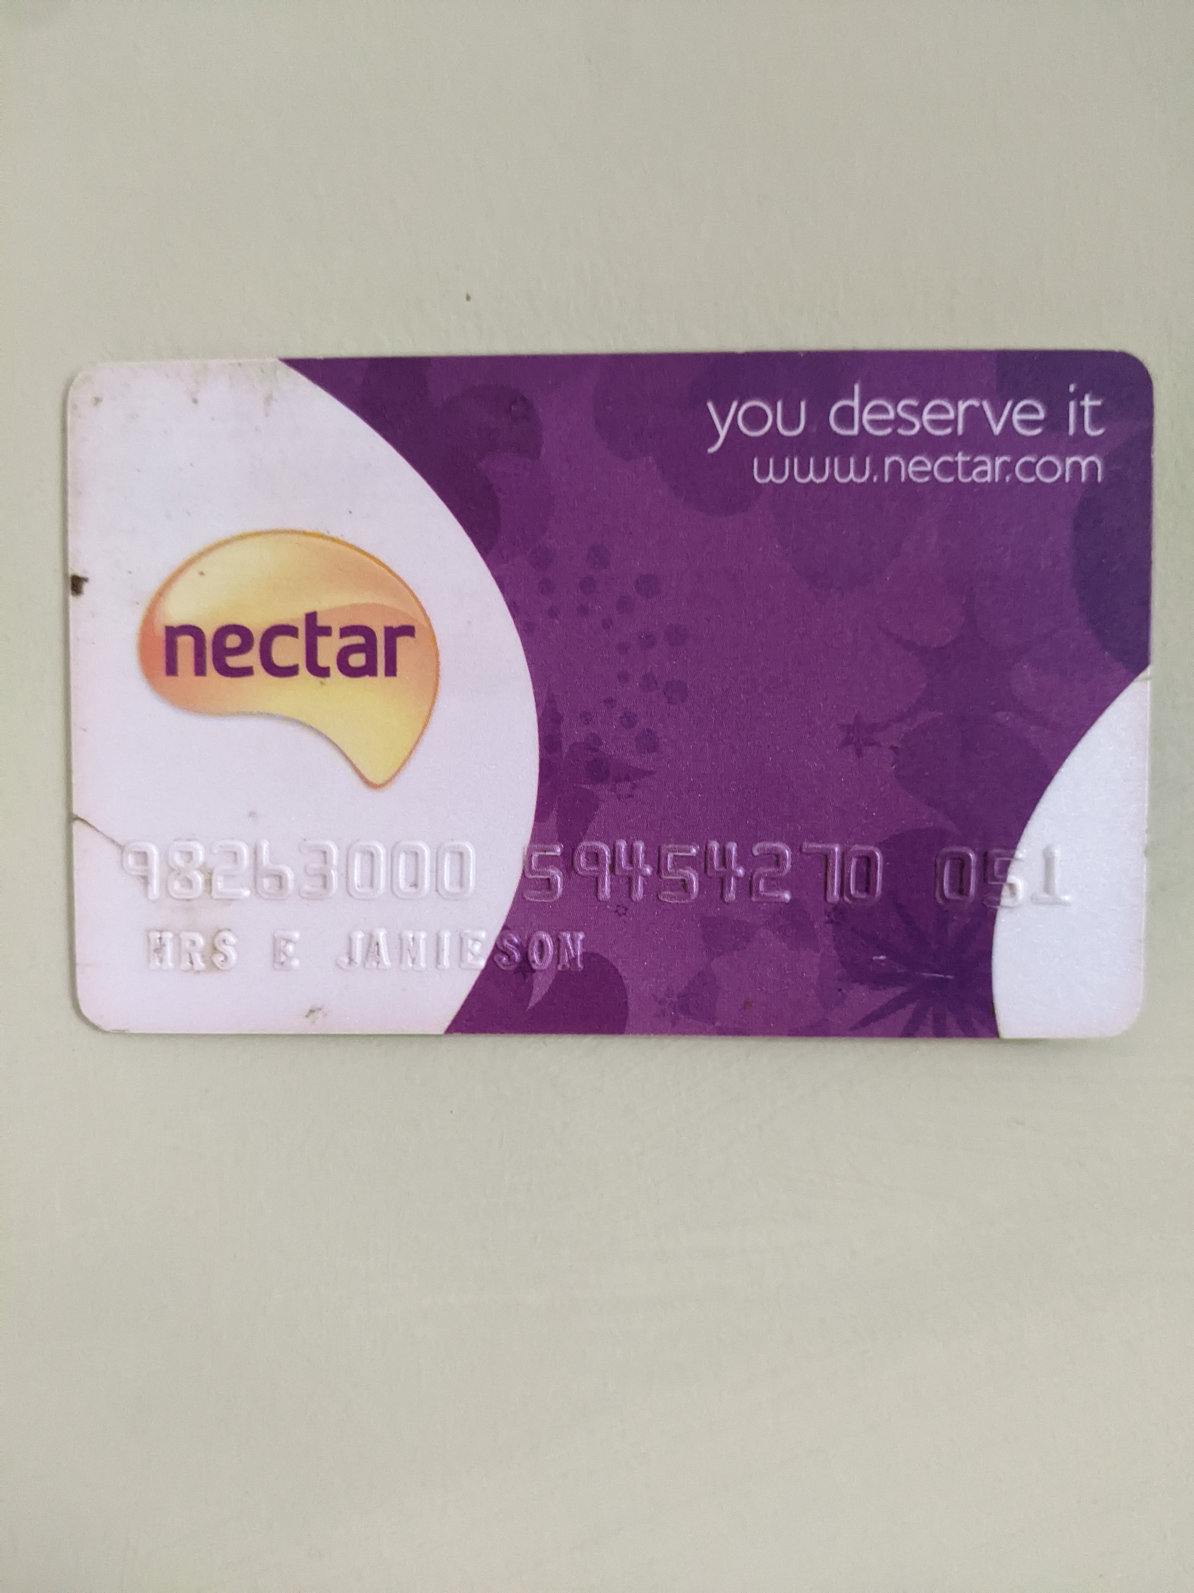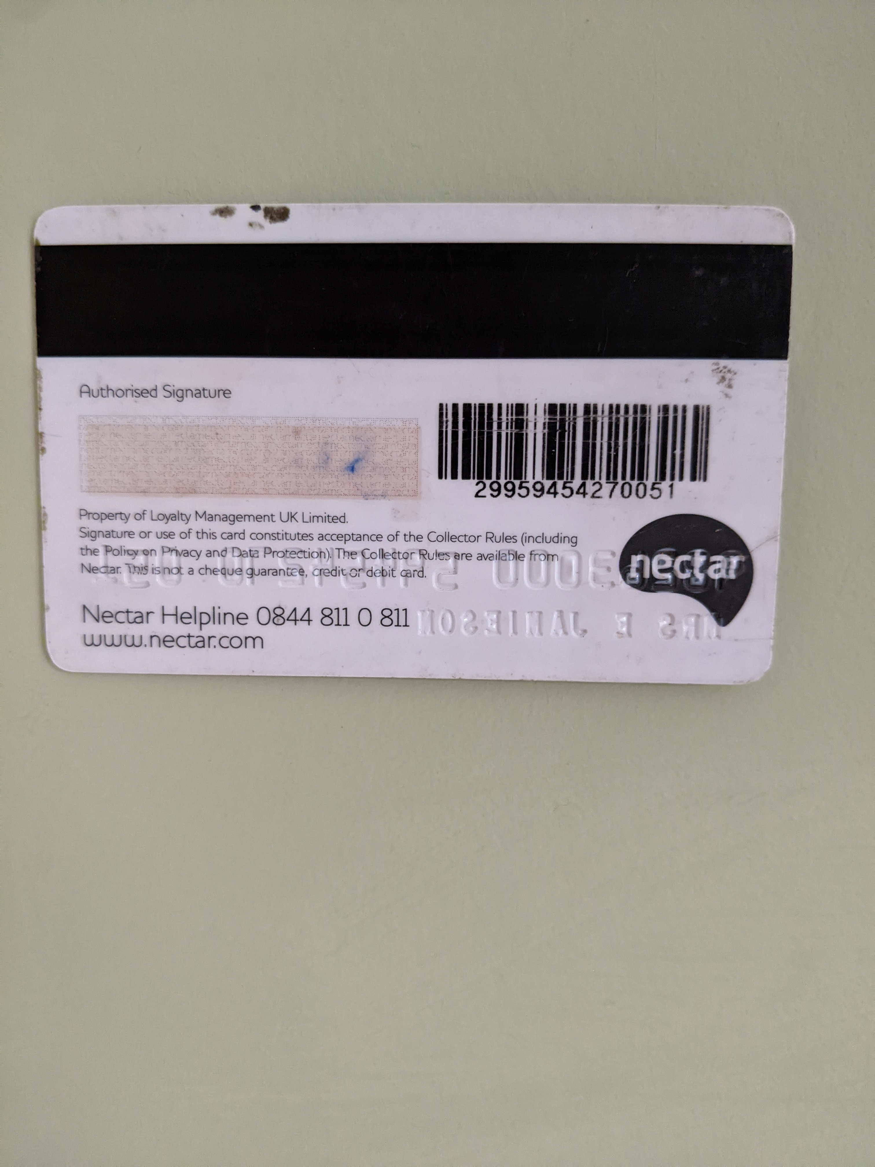
Figure 3. Personal Nectar Card front and reverse,
Personal Photo, 20 Oct 2022.

Figure 3 shows the front and back of my own Nectar Card. I used to carry this all the time, but now I use a digital version on my mobile, for convenience. It is stored along with other cards on the Stocard app which keeps them easily available in one place: while useful, I am shocked to realise that Stocard carries its own privacy issues: it shares users’ data apparently almost indiscriminately and very widely (see Appendix).
My card measures 85.6 mm by 53.98 mm high, conforming to the 2003 standard agreed for bank and other cards across 162 countries under the International Organisation for Standardisation. Interestingly this size matches Pythagoras’s Golden Mean which is seen as ‘comfortable’ for the human eye. Bank cards’ size evolved from business cards, which in turn emerged from the fashion for calling cards, key upper-class social accessories from the eighteenth century onwards, part of Britain’s rigid social etiquettes.
I enrolled with Nectar when it was launched in 2002: I was an early adopter, but did no research into Sainsbury’s rationale. My card has survived wallet thefts and many tribulations, perhaps reflected in its battered appearance. Its logo evidences a replacement after 2007, and the surface of its raised membership number (superseded on modern cards with surface printing) has worn off. Embossed numerals date back to when payment cards were processed by a manual slider machine, to ‘print’ the information onto transaction records. My card’s branding is as obsolete as the embossing, and the strap line ‘You deserve it’ apparently mirrors L’Oréal’s catchphrase ‘Because you’re worth it’, pitching Nectar membership as a personal reward, perhaps attempting to alleviate the monotony of food and household shopping. Nectar’s branding has changed regularly, (see Fig. 4) and now aims to appeal to ‘a digitally savvy audience’ and is intended to give it ‘a touch of “cheeky personality”’.
 |  | 

Figure 4. Nectar Logos, left to right: 2002-7, 2007-19, 2019 to present,
https://logos.fandom.com/wiki/Nectar

The back of my card with its worn-out signature reveals its real purpose: the magnetic strip and bar code link this card to me, enabling Sainsbury’s and partner retailers (Fig. 5) to harvest valuable data on my shopping habits and more. Each time I record my shopping via Nectar (giving away yet more personal data), I receive ‘rewards’ of two points or 1p per £1
American Express Habitat
Argos ICI Dulux Decorator Centres
Brakes Nectar Connect
British Airways Nectar Hotels
Caffe Nero Sainbsbury’s
Daily Mail Sainsbury’s Bank
DFDS Sainsbury’s Energy
eBay Sky & Sky Store
Esso The Mail
Eurostar Viking-Direct
Expedia VUE Cinemas
First Group

Figure 5 Nectar Scheme Partner Retailers
https://www.nectar.com/ about/privacy-and-legal/participating-companies

spent which are broadly only redeemable at Sainsbury’s. This imbalance is astonishing given the compound value of the data I give, across all Nectar’s participating retailers. Using Nectar entitles me to use a handheld scanner as I shop, streamlining the data collection process while helping Sainsbury’s reduce their till staff. Nectar gives me a relatively small payback: my current balance is 10,378 points (£51.93): inertia and my busy life mean I usually redeem my points annually against our expensive Christmas shops. I value hand scanner access disproportionately – its convenience outweighs my reservations about overt surveillance (at the moment).
Coll among others referenced Foucault in describing loyalty schemes as a retail panopticon with which consumers freely engage, apparently unaware that in joining a scheme they have effectively volunteered to be surveilled. ‘Power is tolerable only on condition that it masks a substantial part of itself. Its success is proportional to its ability to hide its own mechanism’. However, Nectar’s shoppers do not feel watched, partly because they cannot access the its processes: when I asked Nectar to provide data held on me I received just the personal data I submitted, with none of the granular detail of my shopping habits it gleaned over two decades. However, it clearly holds reams of fine detail about our (I share membership with my husband) shopping, lifestyle, disposable income, health and fertility, collated from what Lyon calls ‘the trail of electronic footprints’ we leave when shopping. Card-holding shoppers are effectively just as permanently visible to Nectar as the prisoners in Foucault’s panopticon, but as the surveillance is concealed probably most scheme members are oblivious to what is happening to them. New Nectar applicants have to opt out of having online marketing tailored to their shopping habits, indicating that data is likely passed on to social media platforms multiplying the surveillors (see Appendix).
Card holders willingly enlist in loyalty schemes, so they are ‘effectively participating in their own surveillance’, handing over a mass of personal data. Smith and Sparks point out how most shoppers seem unaware of how much data they give away, and detail how various data sources are aggregated to provide microscopic insight into an individual. They show how these schemes challenge every aspect of customers’ personal privacy: our right not to have our information divulged; to be free from surveillance when making personal decisions and from physical surveillance of our public and private actions. They accessed anonymised data held by a loyalty scheme (not Nectar, so probably Clubcard) and in a hair-raising analysis, compiled a highly detailed dossier on one customer, down to her dietary habits, personality traits, holiday plans, personal relationships, health issues, even to the length of her hair. Expand this process to cover Nectar’s multiple retailers and their potential to swap and aggregate shopper’s data seems unlimited and probably unlimitable. Nectar’s lengthy terms of use list the data they and partner retailers collect: name, address, phone number, transactions, what bought, where, cost, offers engaged with, point redemptions, interactions with app and website, location. They also state that they will conduct profiling to make predictions re card holder interests, shopping habits and characteristics, and conduct targeted online advertising. The opt-out options are 24 clicks down the web page, effectively deterring most customers: for all the admirably clear language used.
I experience profiling in action within the Nectar app: if I buy, say, some plant spray, I probably receive a nudging discount voucher to buy other gardening supplies the following week; I have clearly never opted out from tailored digital marketing, having enrolled so long ago. However Nectar is not only used for customer promotions, Sainsbury’s also use data to make stock decisions: although Grape Nuts cereal had low sales, its buyers were identified as both high spenders and loyal, which outweighed the sales figures and it is still stocked. Retailers use aggregated data analytics (apparently anonymised) to plan where to open new stores, for example although such data usage is not covered by privacy legislation, as it cannot be associated with individual customers. Depressingly even non-members’ data is used: all retailers can track card payments so they know when and where any card-using buyer is shopping – there seems no way to escape from surveillance.
Lyon states that each incremental expansion of surveillance has a rationale that tends to be accepted by its subjects, making them complicit. However he also points out that any system is limited by the cooperation (or not) of its subjects. This seems to depend on how much they know: my previously naïve engagement with Nectar’s covert data collection processes may well cease now that I realise its entire implications. I look forward to seeing how much effort Nectar put into re-enrolling me.

Word count 1502 including captions and title, excluding appendix and bibliography

APPENDIX

Current Nectar Card Optout for Digital Advertising
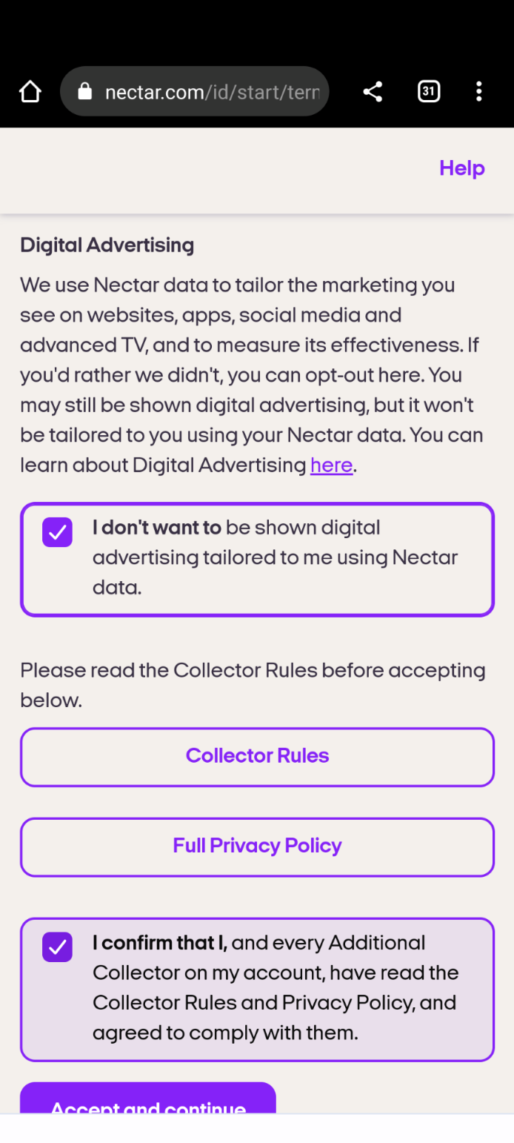

Stocard Data Permissions
Which data is processed and how this is used is based on if you use the app without explicit consent to this data protection statement (see section 2 a) to c)) or you have given consent to the processing of your personal data within the app (see section 2 d) to h)).
Mixpanel in California to collect technical data from our app and website in a pseudo-anonymous manner so that we can better understand how users interact with our app. Mixpanel is used to be able to better understand and track activities within the app as well as to inform you based directly on your activities.
Firebase (Google) analytics Events are recorded such as the initial opening of the app, uninstallation, update, crash or frequency of use of the app. The events can be used to record other user interests as well, for example, for certain functions of the applications or certain topic areas. User profiles can also be recorded, which can be used as a basis for the illustration of advertising customized for users.
AppsFlyer allows for different evaluations regarding the success of our advertising campaign and the installation of the app. Our app sends anonymous data and information that the app was started to AppsFlyer for this purpose. An anonymous advertising ID serves as a pseudonym. Only statistical analyses are created through AppsFlyer. We, therefore, do not have any information about the user's identity.

Facebook The Facebook SDK allows different types of evaluations on the installation of the app and regarding the success of the advertising campaign. Additionally, individual activities (events) from the user within the app can be analyzed to be able to define the target group for advertising campaigns in a more precise and better manner. Our app sends anonymous data to Facebook and the information that the app was started for this purpose.

BIBLIOGRAPHY

Coll, Sami, ‘Discipline and Reward: The Surveillance of Consumers through Loyalty Cards’, Geschichte und Gesellschaft, 42 (2016), pp. 113-143

Davenport-Hines, Richard, ‘Tompkins, (Granville) Richard Francis (1918-1992), businessman’, Oxford Dictionary of National Biography. 23 Sept 2004, <https://0-www-oxforddnb-com.pugwash.lib.warwick.ac.uk/view/10.1093/ref:odnb/9780198614128. 001.0001/odnb-9780198614128-e-51347?rskey=7aD8nc&result=2>, accessed 25 Oct 2022.
Ferguson, Donna, ‘How supermarkets get your data – and what they do with it’, The Guardian, 8 June 2013, online, <https://www.theguardian.com/money/2013/jun/08/supermarkets-get-your-data>
Foucault, Michel, The History of Sexuality: Vol. 1 An Introduction (London: Allen Lane, 1979)
Green, Claire, ‘Calling Cards and Visiting Cards: A Brief History’, <https://hobancards.com/blogs/thoughts-and-curiosities/calling-cards-and-visiting-cards-brief-history> , 12 Sept, 2016
Lyon, David, Surveillance Society: Monitoring everyday life, Open University Press, (Buckingham: 2001), online, <https://tinyurl.com/2p9a2fx5>
Monro, Sarah, ‘Nectar card tips and tricks’, Money Saving Expert.com, 1 Sept 2022, <https://www.moneysavingexpert.com/shopping/sainsburys-nectar-points-boosting/>
Parker, Garrett, ‘The Reason Why Virtually All Credit Cards are the Same Size’, Money Inc, online, 8 April 2020, <https://moneyinc.com/why-all-credit-cards-are-the-same-size/>
Sabanoglu, Tugba, ‘Share of Adults who are a member of a loyalty program in Great Britain from 2018-2022, by sector’, Statista, <https://www.statista.com/statistics/325591/loyalty-scheme-memberships-in-great-britain-uk-by-sector/>
Smith, Andrew and Leigh Sparks, Leigh, ‘Making Tracks: Loyalty Cards as Consumer Surveillance’, in E - European Advances in Consumer Research, 6 (2003), pp. 368-373. <https://www.acrwebsite.org/volumes/11294/volumes/e06/E-06>
Snoad, Laura, ‘DesignStudio rebrands loyalty scheme Nectar with a “cheeky personality”’, It’s Nice That, online, 18 Oct 2019, <https://www.itsnicethat.com/news/designstudio-nectar-rebrand-graphic-design-181019>
Vizard, Sarah, ‘Loyalty cards aren’t convincing British consumers to shop’, Marketing Week, online, <https://www.marketingweek.com/loyalty-cards-nielsen/>

Website and Android App pages
Nectar.com mobile app, <https://www.nectar.com/ about/privacy-and-legal/participating-companies>
Stocard.com Privacy Policy <https://stocardapp.com/en/de/privacy>
Tesco plc, Corporate, Our History, <https://www.tescoplc.com/about/our-history/>

Illustrations
Green Shield Stamp Book and Stamps c. 1960s
Source unknown
<https://www.silversurfers.com/nostalgia/green-shield-stamps-did-you-collect-them/>

Green Shield Stamps catalogue, c. 1987
Tyne &Wear Museum. TWCMS 2011.1370
<https://blog.twmuseums.org.uk/double-dividends/11_1370e/>

Nectar Card front and reverse,
Personal Photo, 20 Oct 2022.

Nectar Logos, 2002-7, 2007-19, 2019 to present,
<https://logos.fandom.com/wiki/Nectar>

Informal personal conversation with author, (Southam 14 Oct 22).
Richard Davenport-Hines, ‘Tompkins, (Granville) Richard Francis (1918-1992), businessman’, Oxford Dictionary of National Biography. 23 Sept 2004, <https://0-www-oxforddnb-com.pugwash.lib.warwick.ac.uk/view/10.1093/ref:odnb/9780198614128. 001.0001/odnb-9780198614128-e-51347?rskey=7aD8nc&result=2>, accessed 25 Oct 2022. .
Corporate, Our History, Tesco PLC, <https://www.tescoplc.com/about/our-history/>, accessed 23 Oct 2022.
BBC News, ‘UK to get ‘biggest loyalty card scheme’, 5 June 2002, online, <http://news.bbc.co.uk/1/hi/business/2026217.stm>, accessed 23 Oct 2022.
Sarah Vizard, ‘Loyalty cards aren’t convincing British consumers to shop’, Marketing Week, <https://www.marketingweek.com/loyalty-cards-nielsen/>, online, 7 Dec 2016, and Tugba Sabanoglu, ‘Share of Adults who are a member of a loyalty program in Great Britain from 2018-2022, by sector’ Statista, online, 8 July 2022, <https://www.statista.com/statistics/325591/loyalty-scheme-memberships-in-great-britain-uk-by-sector/>, accessed 23 Oct 2022.
Andrew Smith and Leigh Sparks ,’Making Tracks: Loyalty Cards as Consumer Surveillance’, in E - European Advances in Consumer Research, 6 (2003), pp. 368-373. (Article downloaded from <https://www.acrwebsite.org/volumes/11294/volumes/e06/E-06>, with no page numbers, accessed 21 Oct 2022.
Garrett Parker, ‘The Reason Why Virtually All Credit Cards are the Same Size’, Money Inc, online, 8 April 2020, <https://moneyinc.com/why-all-credit-cards-are-the-same-size/>, accessed 14 Oct 2022.
Claire Green, ‘Calling Cards and Visiting Cards: A Brief History’, <https://hobancards.com/blogs/thoughts-and-curiosities/calling-cards-and-visiting-cards-brief-history>, online, 12 Sept, 2016, accessed 15 Oct 2022.
Laura Snoad, ‘DesignStudio rebrands loyalty scheme Nectar with a “cheeky personality”’, It’s Nice That, online, 18 Oct 2019, <https://www.itsnicethat.com/news/designstudio-nectar-rebrand-graphic-design-181019,> accessed 15 Oct 2022.
Sarah Monro, ‘Nectar card tips and tricks’, Money Saving Expert.com, online, 1 Sept 2022, <https://www.moneysavingexpert.com/shopping/sainsburys-nectar-points-boosting/>, accessed 22 Oct 2022.
Sami Coll, ‘Discipline and Reward: The Surveillance of Consumers through Loyalty Cards’, Geschichte und Gesellschaft, 42 (2016), pp. 113-143.
Michel Foucault, The History of Sexuality: Vol. 1 An Introduction (London: Allen Lane, 1979), p. 86.
David Lyon, Surveillance Society: Monitoring everyday life, Open University Press, (Buckingham: 2001), ebook, <https://tinyurl.com/2p9a2fx5>, p. 115.
Lyon, Surveillance Society, p. 44.
Smith and Sparks, ‘Making Tracks’.
Personal Nectar app page, <nectar.com/account>, accessed 21 Oct 2022.
Donna Ferguson, ‘How supermarkets get your data – and what they do with it’, The Guardian, 8 June 2013, online, <https://www.theguardian.com/money/2013/jun/08/supermarkets-get-your-data>, accessed 14 Oct 2022.
Lyon, Surveillance States, p. 44.
Nectar.com/permissions in-app phone screen, accessed 14 Oct 2022.
https://stocardapp.com/en/de/privacy, accessed 10 Oct 2022

