Applying History to Curation
2110254
HI2H9: Surveillance States: Biometrics from the Border to the Bathroom
Word count: 997
November 2022

Object
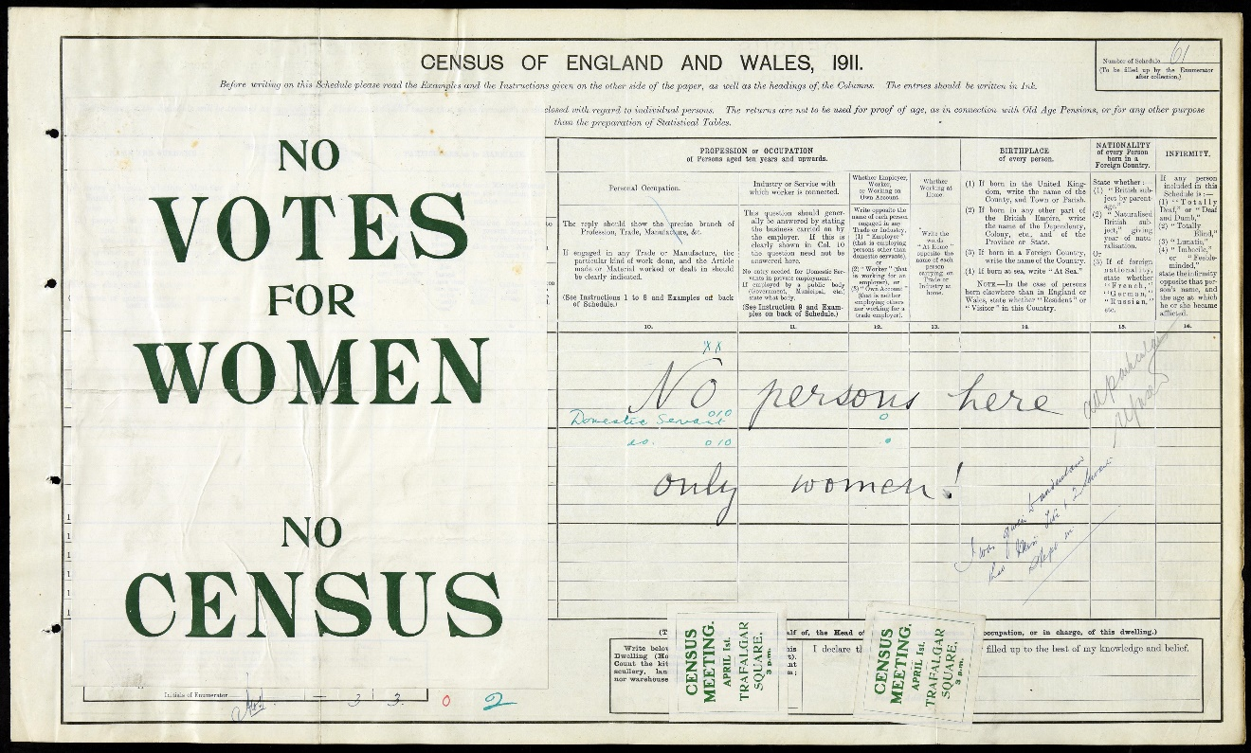

On the night of 2 April 1911, census enumerators of the British government collected the details of households as scheduled. Thin and pale, the paper forms carried the strong determination, anger and bitterness of thousands of suffragists. They had demanded woman’s voting right for years with countless protests and even hunger strike, but the British government did not change at all. In 1911, they called for boycotting the census. One of them wrote on her form, ‘No persons here, only women!’
According to the National Archives, this census form was collected in London in 1911. As Evelyn Ruppert suggested, census embodies states’ intervention and surveillance of individual. Therefore, this census form illustrates the state’s surveillance of population, as well as the tension between authority and general public.
First and foremost, this census form collects personal information about occupation, birthplace, nationality and infirmity. Respondents are advised to read the detailed examples and instructions before answering. For example, respondents should write “Employer”, “Worker” or “Own account” in the occupation column. They shall express nationality by “British subject by parentage”, “Naturalised British subject” or foreign nationality, and state infirmity by specific terms like “Totally Deaf” and “Lunatic”.
The private information regarding nationality and physical condition must be exposed to the government. Thus, the government could approximately know the respondents’ daily lives like whether they needed to travel for work. Besides, this form prohibits individual expression and respondents must answer in certain format. They must define themselves as the specific categories created by the government. It shows that the government attempted to classify the population into different groups, so it could know the percentage or number of native British, foreigners or disabled people in population. As a result, the census allows the government to understand and surveil the population on both micro and macro level. Society thus becomes “legible”.
In addition to watching over the population, the government can impose different policies using the data. For instance, it can decide who is eligible for citizenship according to the respondents’ nationality, and adjust social welfare expenditure according to the number of disabled people. As these policies determine everyone’s rights and responsibilities, the use of data in policy making is a form of intervention towards individuals. The population thus becomes object of governance and surveillance.
It should be noted that the governments of different places and times classify population differently. For example, the British census asked fewer details on nationality and did not ask about infirmity in 1901. In 2021, more questions like education level and how to travel to work were asked. The significant increase in questions illustrates that the state’s surveillance through census have become more intense over time. Therefore, this census form is distinctive, demonstrating how the British government carried out surveillance by collecting personal data and classifying population specifically in 1911. It also enables comparison with the census before and after 1911, thus helping us understand how census evolves over time.
In spite of the strict requirements, the information collected in census might be inaccurate. On this form, the respondent wrote “No persons here, only women!” instead of her personal information, and covered part of the table with a label indicating “No vote for women no census”. Although the government officer remarked that she was a domestic servant, her birthplace, nationality and infirmity were unknown. In fact, numerous personal accounts of the suffragists recorded that “thousands of women” boycotted the census in 1911. Since the government could not collect a complete set of data from every person, the census result might fail to reflect British demography accurately. It shows that although census is the most large scale central collection of data, the result may be inaccurate. It is because the accuracy highly depends on whether the respondents cooperate. If they are unwilling to write correct information, or mistakenly write the wrong one, the surveillance on population would be less effective.
While the government collects information from the people, the people can affect the outcome of census. It demonstrates that data collection is a politically interaction between those is counting and being counted. On this census form, the political interaction not only undermines the accuracy of the census, but also illustrates the tension between the government and civil society at that time. The statement of “No vote for women no census” infers that women did not enjoy voting right and the suffragists protested through census. This census protest emerged in 1911 because the suffragists believed that that women, who could not vote, were not considered person. Following the government’s perception on women, women should not be enumerated as well. The suffragists understood how the government used the census to identify population, thus applying the mechanism to emphasise that women, as legitimate citizens, deserved voting rights. They turned census into a tool to challenge the government over the meaning of citizenship.
As an important evidence of the British suffragists’ civil disobedience in 1911, this census form shows that surveillance is not only a top-down exercise of power. The government monopolises the collection, storage and usage of data during census, so it symbolises an exercise of state power over the population. Hence, when the civil society is discontent with the government, it may choose not to cooperate as a resistance to authority. Resistance can be seen in other forms of surveillance too, such as breaking the surveillance device or moving to an unserveiled place. Therefore, public’s reaction to surveillance also present the tension and interaction between the government and the people.
Although this census form reflects British government’s surveillance over population in different perspectives, it cannot present the full picture of the census in 1911. The label with slogan covers some questions and guidance, and some instructions are on the other side of the page. Despite the missing information, this census form is effective in showing how surveillance is facilitated by data collection and symbolises political interaction between state and people. After all, power and resistance are always central in human history.
Bibliography
Primary source:
The National Archives, ‘Census Boycott’ <https://www.nationalarchives.gov.uk/education/resources/suffragettes-on-file/census-boycott/> [9 October 2022]

Secondary source:
Census 2021, ‘Census 2021 paper questionnaires’, 26 June 2020, <https://www.ons.gov.uk/census/censustransformationprogramme/questiondevelopment/census2021paperquestionnaires> [Accessed 18 October 2022]

Gilliom, John, Monahan, Torin, ‘Everyday Resistance’ in Routledge Handbook of Surveillance Studies, ed. by Kirstie Ball, Kevin Haggerty and David Lyon (London: Routledge, 2012), pp.405-411.

Liddington, Jill, Vanishing for the Vote: Suffrage, Citizenship and the Battle for the Census (Manchester: Manchester University Press, 2014)

Ruppertm, Evelyn, ‘Seeing Population’, in Routledge Handbook of Surveillance Studies, ed. by Kirstie Ball, Kevin Haggerty, David Lyon (London, Routledge; 2012), p.209-216.

Serra, Gerardo, ‘“Hail the Census Night”: Trust and Political Imagination in the 1960 Population Census of Ghana’, Comparative Studies in Society and History, 60 (2018), 659-687.

The National Archives, ‘Census Records’, <https://www.nationalarchives.gov.uk/help-with-your-research/research-guides/census-records/> [Accessed 18 October 2022]

The National Archives, ‘Census Boycott’ (Example of a non-militant protest in the census for South Kensington, London, 1911) <https://www.nationalarchives.gov.uk/education/resources/suffragettes-on-file/census-boycott/> [9 October 2022]
Evelyn Ruppertm, ‘Seeing Population’, in Routledge Handbook of Surveillance Studies, ed. by Kirstie Ball, Kevin Haggerty, David Lyon (London: Routledge, 2012), p.214.
Gerardo Serra, ‘“Hail the Census Night”: Trust and Political Imagination in the 1960 Population Census of Ghana’, Comparative Studies in Society and History, 60 (2018), 661.
Ruppertm, ‘Seeing Population’, pp.212, 214, 215.
The National Archives, ‘Census Records’, <https://www.nationalarchives.gov.uk/help-with-your-research/research-guides/census-records/> [Accessed 18 October 2022]
Census 2021, ‘Census 2021 paper questionnaires’, 26 June 2020, <https://www.ons.gov.uk/census/censustransformationprogramme/questiondevelopment/census2021paperquestionnaires> [Accessed 18 October 2022]
Jill Liddington, Vanishing for the Vote: Suffrage, Citizenship and the Battle for the Census (Manchester: Manchester University Press, 2014), pp.209, 211.
Serra, ‘“Hail the Census Night”’, 664.
Liddington, Vanishing for the Vote, p.210.
Ibid., p.2.
John Gilliom and Torin Monahan, ‘Everyday Resistance’ in Routledge Handbook of Surveillance Studies, ed. by Kirstie Ball, Kevin Haggerty and David Lyon (London: Routledge, 2012), pp.407, 408.

