HI31V - ‘ONE WORLD: A HISTORY OF GLOBALIZATION, 1750-2050’

Week 13. Global Capitalism: Globalization and the World Economy

Reactions of the Wall Street slump

http://www.economist.com/node/12327393?story_id=12327393
The Economist, Nov 23rd 1929
IT'S an ill wind that blows nobody any good. The fall of Bank rate on Thursday by another half per cent is an outward and visible sign that the dramatic and precipitous slump of the last three weeks in Wall Street has definitely relieved the pressure on the world's money markets which the New York situation has been exerting so continuously for the last two years. Very few could have dared to hope, when Bank rate was raised to 6½ per cent on September 26th, that it would be back again at 5½ per cent in less than two months. That advance, indeed, was a by no means negligible factor in turning into the opposite direction the tide of funds which had been flowing so strongly towards New York, and in causing the edifice of American speculation to totter. But that it would collapse so completely was hardly to be expected. In the event the financial strain has been lifted, and money rates have fallen to such an extent that for the last two weeks, Bank rate, which fell to 6 per cent on October 31st, has been ineffective, three months' bills having fallen this week to a bare 5 per cent. In the circumstances the Bank had no alternative but to lower its rate. Indeed, some people had thought that it should be even bolder and reduce the rate to 5 per cent.
....
The slump on the New York Stock Exchange, which has resulted in this great change in the monetary outlook, is one of the spectacular episodes of financial history. A prolonged upward movement, the extent of which is illustrated by some graphs which we print in a later column, has been built up over a series of years on the amazing and unexampled prosperity of America. But some two years ago the speculative movement seemed to lose all touch with reality; and in spite of occasionally vigorous but more often half-hearted, measures by the banking authorities of the United States, speculative fever spread throughout the nation and carried prices, mainly with the aid of borrowed money, to fantastic heights. ...
Highly coloured stories of devastating ruin and of paralysis of economic life must, as always in such cases, be heavily discounted; but it is natural that people should be asking themselves how widespread and of what character will be the economic reactions of this slump. The question acquires added importance from the fact that in its later stages the Wall Street movement pervaded the whole world by drawing money, not merely from all corners of America, but from every continent. ....
But while the direct effects are not of really serious importance to this country, the influence on the economic situation here depends on more general considerations than the technical position at the time of the slump and, above all, on the answer to the question which everybody is asking but no one is prepared to answer, namely, what will be the economic effect of the slump on business in the United States? It has many times been pointed out that the present slump differs from most of its predecessors in the fact that it has not been accompanied by industrial over-production or rising commodity prices resulting from an expansion of credit. .... The question presents itself rather in this form: Can a very serious Stock Exchange collapse produce a serious setback to industry when industrial production is for the most part in a healthy and balanced condition? ...
If we are justified in assuming that the setback in American industry will only be temporary, we may look forward to steady development in 1930, free from the incubus that has of late been hampering world conditions.

Echoes of the Depression: 1929 and all that

How today’s financial crisis resembles the one that happened three-quarters of a century ago, and how it does not

The Economist, Oct 2nd 2008
EASY credit, some say, was one problem. It was amplified by newfangled, flighty financial techniques, notably buying assets with borrowed money and watching leverage work its arithmetical magic. And underneath it all was a breezy, unthinking optimism, that prices could only ever go up. This was a perfect recipe for a runaway boom—and for a ruinous bust.
Substitute “houses” for “assets” in the paragraph above, and you might be reading a rough description of the blowing-up and bursting of America's property bubble. Insert “shares”, and you might be back in the late 1920s. Whereas the fancy financial ideas of the 2000s comprised securitisation, credit-default swaps, collateralised-debt obligations and all their weird cousins, the innovation of choice before the crash of 1929 was the investment trust, a company whose purpose was to speculate in other companies' shares, using the wonders of leverage to multiply the returns (and, in the end, the losses).
In strange territory almost any map will do, no matter how incomplete or out of date. In trying to pick a way through today's financial crisis, there are plenty to pore over. Among them is one drawn in Sweden in the early 1990s, another from Japan in the same decade and an American one from a few years before that. By far the scariest, though, is that sketched in the years beginning in 1929. Frequent reference is made to it (see chart).
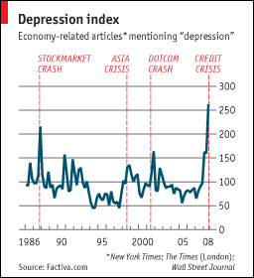
But the map of the Depression provides only an incomplete guide to how the American economy got to where it is now. The parallels between the speculative mania that ended in October 1929 and the housing bubble are seductive but misleading. Today's banking and credit-market crisis, and all the damage it may do to the real economy, can be traced to the property boom and subprime bust. In fact, although scholars still rake over the causes of the Depression, few think the 1929 crash contributed much. An economic slowdown was already under way before the stockmarket collapsed. And although loose monetary policy helped pump up the recent property bubble, there is much more debate about its contribution to the 1920s boom.
Where study of the Depression is more helpful, though, is in steering clear of deeper trouble. In the early 1930s deficit finance was a heresy: in 1931, as bank runs were wrecking America's financial system, President Hoover wanted to balance the federal budget, which in those pre-New Deal days was small beer anyway. (He failed.) Monetary policy was also too tight—the main reason, argued Milton Friedman and Anna Schwartz in a brick of a book 45 years ago, why downturn became Depression.
It is no bad thing, then, that as an academic Ben Bernanke studied the Depression in earnest—looking in particular at how an impaired banking system had made the slump longer and deeper. At a conference in 2002, to honour Friedman on his 90th birthday, the chairman of the Federal Reserve (then a governor) addressed him and his co-author. “Regarding the Great Depression,” Mr Bernanke said. “You're right. We did it. We're very sorry. But thanks to you, we won't do it again.”
A less obvious lesson is that early in the Depression it was not clear how bad things were going to get—or, given the paucity of economic data, even how bad they were. A year after the crash, many Americans thought that they were in the midst of a usual, if painful, downturn—not as bad, surely, as 1921, when the economy contracted by a quarter in a single year. Indeed, rural areas, home to 44% of Americans in 1930, had long been in bad shape: farming had been in a slump since the early 1920s.
But worse was to come. A wave of bank failures broke late in 1930. Another lot followed in 1931: a run on Creditanstalt, an Austrian bank, set off a chain of events that took Britain off the gold standard and raised fears that America might follow. Foreigners and domestic depositors alike demanded gold from American banks. Nor was that the last downward turn. Compare then and now: a year after the credit crisis began last August, America's economy seemed to be standing up well. Today it looks much less secure.
The map's political features also bear examination. Gaps are dangerous—especially between presidencies. Between Franklin Roosevelt's first election victory in November 1932 and his inauguration in March 1933 America's economy spiralled even further down. In February another rash of bank failures broke out. The crisis ended—and the bottom of the slump was reached—only with a federal bank holiday, declared by Roosevelt within days of taking office. Hank Paulson, treasury secretary in 2008, thinks the financial system cannot wait until 2009 for a rescue plan.
The Depression also acts as a warning of the pitfalls of congressional politics. The Bush administration found out all about those this week. There were echoes, perhaps, of 1930. That year yielded the Smoot-Hawley tariff act, the product of a special session of Congress called by Hoover to address the economic troubles. The tariff helped give the world economy a downward shove. A thousand economists wrote to oppose it. (Hoover disliked it too, but chose not to veto it.)
Is 2008 a repeat of 1929 or 1930? Look not at the road ahead but the immediate surroundings, and the question seems absurd. America's economy may be just entering recession; between 1929 and 1933 it shrank by more than a quarter. Some economists fear that unemployment, now a touch over 6%, might reach 10%; in 1933 it was about 25%, and many of those in work were on short time and short pay. Americans are not banging at the doors of banks demanding their money, nor queuing around the block for soup and bread. America is not yet a land of Hoovervilles—or Bushvilles—inhabited by those turfed out of jobs and homes. Nor should it be allowed to become one.

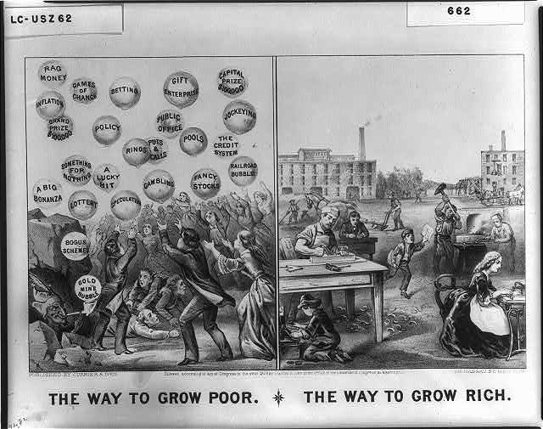

1873: The way to grow poor, the way to grow rich, New York : Published by Currier & Ives, c1875. Library of Congress LC-USZ62-662 (b&w film copy neg.)
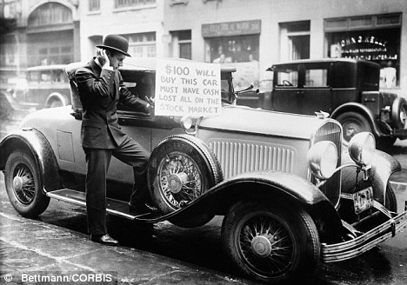
1929

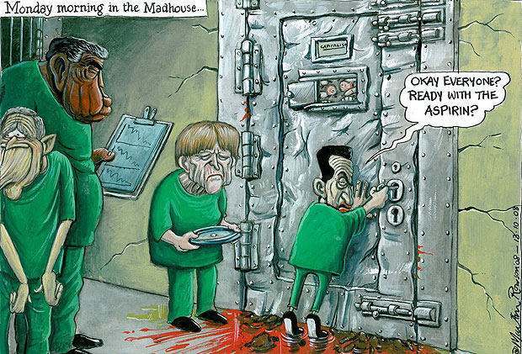

Copyright © Martin Rowson 2008 (13 October)

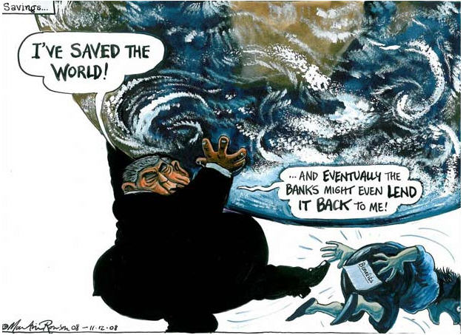

Copyright © Martin Rowson 2008 (11 December)

